EXPLORATORY STUDY OF FEMALE NCAA ATHLETE USER NEEDS,
HAMSTRING COMPRESSION SLEEVE PROTOTYPE
DESIGN AND EVALUATION

by

Sarah Megivern

A thesis submitted to the Faculty of the University of Delaware in partial fulfillment of the requirements for the degree of Degree in Master of Science in Fashion and Apparel Studies

Spring 2024

© 2024 Sarah Megivern
All Rights Reserved

EXPLORATORY STUDY OF FEMALE NCAA ATHLETE USER NEEDS
AND PROTOTYPE DESIGN AND EVALUATION OF A HAMSTRING
COMPRESSION SLEEVE

by

Sarah Megivern

Approved:
Adriana Gorea, Ph.D.
Professor in charge of thesis on behalf of the Advisory Committee

Approved:
Huantian Cao, Ph.D.
Chair of the Department of Fashion and Apparel Studies

Approved:
Debra Norris, Ph.D.
Interim Dean of the College of College of Arts and Sciences

Approved:
Louis F. Rossi, Ph.D.
Vice Provost for Graduate and Professional Education and
Dean of the Graduate College

ACKNOWLEDGMENTS
I would like to acknowledge and give a huge thank you to my advisor Dr. Gorea for her continued support, guidance, and expertise. Thank you to committee members Dr. Cao, Dr. Hall, and Professor Cobb for their support and guidance throughout this process. I would like to thank Dr. Lu for his guidance and encouragement to pursue this graduate degree, and his continued support throughout my two years during my graduate career.
I would also like to thank Dan Watson who is the Deputy AD for sports performance and campus recreation at the University of Delaware for helping me coordinate equipment and time to utilize the Whitney Athletic Center for data collection.
I would like to thank all my friends who continued to encourage me through this long process. I would also like to give a special thanks to my parents for their constant love and support in all that I do. I would also like to thank all the participants for their time and energy. Without them I would not have been able to have such a thorough study.

TABLE OF CONTENTS
LIST OF TABLES iv
LIST OF FIGURES v
ABSTRACT vii
- INTRODUCTION 2
- LITERATURE REVIEW 7
2.1 Anatomy of hamstring muscles 7
2.2 Delayed Onset Muscle Soreness (DOMS) 8
2.3 Female NCAA Athletes and Lower Extremity Injuries 10
2.4 Kinesio Technology (KT) tape 12
2.5 Compression Garments 14
2.5.1 Fit and Sizing 16
2.5.2 Design and Product Development 17
2.5.3 Aesthetics 18
2.5.4 Materials and Properties 18
2.6 Materials and Methods 23
2.7 The User Centered Design (UCD) Process 24
2.8 Literature Review Summary 25
2.9 Conceptual Design Framework 27
- METHODS 29
3.1 Stage 1: Specify 29
3.1.1 Participants 29
3.1.2 Survey Design 30
3.2 Stage 2: Determine 31
3.3 Stage 3: Create 34
3.4 Stage 4: Evaluate 37
- RESULTS 49
4.1 Stage 1: Specify 49
4.2 Stage 2: Determine 58
4.3 Stage 3: Create 62
4.4 Stage 4: Evaluate 64
4.5 Stage 5: Assess 79
- DISCUSSION 87
5.1 Summary of Findings 87
5.2 Significance 91
5.3 Limitations 92
- Conclusion 95
REFERENCES 98
APPENDICIES 111
- IRB board action for Initial User Needs Survey 111
- Female NCAA athlete User Needs Survey 111
- Prototype Sketches and Notes 116
- Sizing Guide 119
- Low odor mineral spirits and silicone caulking gun 119
- IRB actions for field tests 120
- Demographic Survey 120
- Pre-Screening Survey 121
- A-skip and B-skip Demonstration 122
- CS Comfort Survey 123
- Changes in Health Survey 124
- Soreness Survey 124

LIST OF TABLES
Table 1. General criteria for selecting materials for activewear (Yip & Chan, 2020) 21
Table 2. Protocol for each session and type of data collected 37
Table 3. Textile tests Averages and Standard Deviations (SD) 56
Table 4. One Way ANOVA analysis of different fabrics and their properties 58
Table 5. Pairwise Comparison of Hamstring Peak Force Between Control and CS Legs 63
Table 6. Tests of Within-Subjects Effects for hamstring peak force 64
Table 7. Test of Between-Subjects Effects for Hamstring peak force 65
Table 8. Pairwise Comparison of Quad Peak Force Between Control and CS Legs 66
Table 9. Tests of Within-Subjects Effects for Quad Peak Force 67
Table 10. Tests of Between-Subjects Effects for Quad Peak Force 68
Table 11. Pairwise Comparison of Jump Height Between Control and CS Legs 70
Table 12. Tests Within-Subjects Effects for Jump Height 70
Table 13. Tests of Between-Subjects Effects for Jump Height 71
Table 14. Pairwise Comparison of Max Power Between Control and CS Legs 73
Table 15.Tests Within-Subjects Effects for Max Power 74
Table 16. Test of Between-Subjects Effects for Max Power 75
Table 17. Qualitative Answers from CS Comfort Survey 77
Table 18. Session 1-4 Soreness Survey averages and Standard Deviations 79
Table 19. Paired Samples T-test 81
LIST OF FIGURES

Figure 1. Back view of Hamstring muscles locating the biceps femoris, Semitendinosus, and Semimembranosus (Starhealth, n.d.). 14
Figure 2. Kinesio Technology (KT)Tape on the back of the leg placed to support the hamstring muscles (kttape.com). 19
Figure 3. Structure of typical spacer fabric (Ghorbani et al., 2013) 28
Figure 4. Neoprene fabric structure (Worldbrace, n.d ). 28
Figure 5. UCD framework adapted after Morris et al. (2017) 34
Figure 6. Inside (top) and outside (bottom) of initial prototype 1 38
Figure 7. Inside (left) and outside (right) of initial prototype 2 38
Figure 8. The five fabrics selected for textile testing in order from left to right: (a) Ribbed Spandex Fabric, (b)Spacer with wicking, (c)Superflex heavy compression fabric, (d) Eco-Move Recycled Matte Nylon Spandex Tricot Fabric, and (e)Spacer scuba knit. 39
Figure 9. Fold over elastic finish with zigzag stitch 41
Figure 10. Velcro placement on CS prototype 42
Figure 11. Silicone paint application on the fabric surface inside the CS prototype 42
Figure 12. Close-up of Silicone mixture applied to the CS in KT tape hamstring formation 43
Figure 13. MicroFET 2 Wireless handheld dynamometer (Physioparts.com) 46
Figure 14. The researcher is measuring Hamstring Peak force on a volunteering participant 48
Figure 15. Researcher is measuring Quad Peak force on a volunteering participant 49
Figure 16. Participant completing single leg test with Sparta software 50
Figure 17. Kikuhime pneumatic pressure sensor (researcher’s image) 52
Figure 18. Front and back view of CS on participant 53
Figure 19. Distribution of responses to Question 12 57
Figure 20. Distribution of responses to Question 14 58
Figure 21. Distribution of responses to Question 19 60
Figure 22. Distribution of responses to Question 21 61
Figure 23. Distribution of Question 22 responses 62
Figure 24. Estimated Marginal Means for a) Air Permeability, b) Elongation, c) Weight, d) Thickness 66
Figure 25. Technical drawing of the final CS prototype and the corresponding measurements. 69
Figure 26. Back (top) and front (bottom) of assembled CS prototype for right leg 70
Figure 27. Variations of Estimated Marginal Means of HamPkFrce by Session. 71
Figure 28. Bar Graph of Variations of Estimated Marginal Means of QuadPkFrce by Session 75
Figure 29. Bar Graph of Variations of Estimated Marginal Means of JmpHght by Session. 79
Figure 30. Bar Graph of Variations of Estimated Marginal Means of MxPwr by Session 82
Figure 31. Pilling of binding on CS 100

ABSTRACT
This study delved into the recovery needs of female NCAA athletes concerning Delayed Onset Muscle Soreness (DOMS) in their lower extremities, aiming to develop a wearable device through a User-Centered-Design approach to assist in their recovery process. By surveying 36 female NCAA athletes, insights were gathered to inform the design of a hamstring compression sleeve prototype integrating Kinesiology tape. Fabric testing led to the selection of Spacer Scuba Knit as the optimal material. The efficiency of the design was evaluated through field testing that included physiological evaluations as well as evaluating perceived levels of soreness. Although no significant reduction in DOMS was observed through the physiological testing, there were many positive insights given about the device. This offers valuable insights for refining future iterations of the UCD framework, thereby enhancing athlete wellness and performance. Additionally, the research contributes to the broader understanding of DOMS recovery strategies.

INTRODUCTION
Since the 1970s, female engagement in sports rose dramatically in the United States; female high school sports participation surged by more than 600% during this time (Paul et al., 2023). This drastic increase was ignited by the implementation of federal law Title IX of the Education Amendments Act of 1972 which states "No person in the United States shall, on the basis of sex, be excluded from participation in, be denied the benefits of, or be subjected to discrimination under any education program or activity receiving Federal financial assistance". Although the number of women participating in sports has increased over the past few decades, there are still disparities in terms of participation rates, societal norms, and resource availability (Paul et al., 2023).
This study will be looking specifically at female athletes at the National Collegiate Athletic Association (NCAA) level. The NCAA is a member-led organization dedicated to the well-being and lifelong success of college athletes (NCAA.org). According to NCAA.org, the number of student-athletes competing in NCAA women's championship sports in 2021-22 was reported to be 226,212. That represents a 5% increase (10,726 student-athletes) from 2020-21, the largest percentage increase for women since 2000-01. The biggest increases for individual women's sports from 2020-21 to 2021-22 were soccer (up 2,030, or 7%), indoor track and field (up 1,562, or 6%), volleyball (up 1,107, or 6%), basketball (up 942, or 6%) and cross country (up 901, or 6%) (McGuire, 2023). Female athletes, especially those participating in sports that require a lot of running like track and soccer, frequently suffer from hamstring injuries (HSIs), which are linked to a prolonged healing time and a high rate of reinjury (Opar et al., 2012). Most of the research on HSI rehabilitation that has been published to date has involved male subjects. But compared to men, female athletes have inherent anatomical and biomechanical differences that affect how this demographic responds to HSIs and HSI rehabilitation. Guidelines for female athletes' HSI rehabilitation and injury prevention must take these differences into consideration (O’Sullivan, Preszler, & Tanaka, 2022).
Competitive team sport athletes often use high-intensity interval training (HIIT) in their training regimens. Sports that involve high-intensity intervals, frequent sprinting, and changes in direction and velocity, like basketball, rugby, and soccer, can cause considerable muscle injury and long-term functional impairments (Keane et al., 2015). The hamstrings have a notable propensity to relapse following an initial strain, while also appearing to be particularly vulnerable to delayed onset muscle soreness (DOMS) after bouts of eccentric activity (Croisier, 2004). For both seasoned athletes and beginners, delayed onset muscle soreness (DOMS) is usually a common occurrence (Cheung et al., 2003). DOMS is categorized as a type 1 muscular strain injury and shows as tenderness or stiffness when moving or contacting the affected area. (Cheung et al., 2003). While efficient recovery lowers injury rates and can enhance performance, developing and putting into practice efficient recovery strategies presents a challenge for professionals working with track and field athletes (Bezuglov et al., 2021).
Hamstring injuries (HSIs) often result in athletes frequently experiencing chronic symptoms as well as most having to endure lengthy recovery periods (Silvers-Granelli et al., 2021; Heiderscheit et al., 2010). This specific injury represents over 39% of all reported sports injuries, and implications can include extensive time loss due to injury, ranging from 17 to 90 days, and vast treatment interventions and rehabilitation (Silvers-Granelli et al., 2021; Roe et al., 2018; Camp et al; 2018; Jones et al., 2019). There is a well-established prevalence of HSIs specifically in female sports like soccer, track and field, and field hockey (Silvers-Granelli et al., 2021; Mullins et al., 2022; Coetzee 2020). Looking at track and field specifically, Chandran et al.’s empirical study categorizing injuries in female track and field athletes found that the most common specific injury was hamstring tears (Chandran et al., 2021). This information underscores the importance of finding a solution that can protect athletes from this sort of injury while also looking to enhance their performance.
From all different levels of sports, compression garments (CGs) have been widely adopted by athletes across the whole competitive spectrum to help them enhance certain aspects of both athletic performance and recovery (Leabeater et al., 2022). Compression shorts or tights, which are popular choices among athletes whose training includes an extensive amount of running, are such examples of CGs (Bringard et al., 2006). Athletes and sports teams favor CGs despite conflicting scientific evidence supporting their efficacy. Several researchers found that up to 71% of elite athletes slept in CGs at least once a week (Leabeater et al., 2022; Driller & Brophy-Williams, 2016). Macrae et al. (2011) study concluded that despite a low incidence of negative consequences, the available empirical data suggests that wearing these clothes has few physiological or performance effects. In addition to this, contradictory results have been reported in numerous recent papers based on the impact of CGs on running performance and perception of varying running intensities and durations (Engel et al., 2016).
An alternative to wearing CGs for muscle recovery is Kinesio technology (KT) taping. Elastic taping is a well-liked technique for recovery because of its theoretic advantages such as boosting blood flow, draining excess fluid, improving muscle awareness, strengthening muscles, fixing muscle problems, and lessening pain by dulling nerve signals (Kase, 2003). For athletes with injuries, using KT tape can give them a big advantage over other types of tape because it offers these benefits. KT tape has the ability of stretching up to 140% of its initial length, and its weight and thickness are comparable to those of skin (Ozmen et al, 2016; Kase, 2003). Numerous studies demonstrated that KT tape reduces discomfort stemming from muscle soreness by improving muscular function, reducing muscle activity, and boosting lymphatic and blood flow (Kanik et al., 2019). The possible effects of KT tape on DOMS have not been thoroughly studied, with just a small number of studies having looked into it (Kirmizigil et al., 2019).
Given the presented findings and gaps in knowledge, the purpose of this study was to investigate the specific user needs of female NCAA athletes in regard to recovery from DOMS in their lower extremity muscles. By utilizing the UCD framework, user needs were addressed in the design of a hamstring compression sleeve (CS) prototype. The efficiency of the design was evaluated through field testing. Design criteria were developed from the gathering of themes that emerged from the review of literature, user surveys, and the designer’s own athletic background of competing in track and field at the NCAA Division 1 level. The results of this research will help guide industry designers and athletic trainers towards improving the hamstring CS design, leading to better training, performance, and overall wellness of NCAA female athletes. The data from this study will also contribute to the body of knowledge of DOMS recovery.

LITERATURE REVIEW
This chapter provides an overview of the anatomy of hamstring muscles, their level of susceptibility to DOMS, and the prevalence of lower extremity injuries of female NCAA athletes. It also discusses previous findings on CGs, specific materials used for their design, and evaluation methods to determine their suitability for various functions.

Anatomy of hamstring muscles
The hamstring, a crucial muscle group for athletes participating in sports that include high intensity running, is susceptible to various injuries, accounting for 26% of track-related injuries (Opar et al., 2012). These injuries are frequently observed in sprinting events, highlighting the demands these activities place on the hamstring muscles. While kicking, tackling, cutting, and slow-speed stretching can also lead to HSIs, running emerges as the primary contributor, especially in sports like soccer and rugby (Brooks et al., 2006). The circumstances leading to hamstring injuries align with instances where athletes surpass the mechanical limits tolerated by the group of muscles, particularly during high-intensity contractions.
Understanding the anatomy and susceptibility of the hamstring muscles is pivotal for effective injury prevention and management in female collegiate athletes. HSIs manifest as acute pain in the posterior thigh due to the disruption of hamstring muscle fibers (Opar et al., 2012). These injuries usually involve strains and commonly happen near where the muscle connects to the tendon. They often affect the outer part of the biceps femoris muscle, which is in the back of the thigh, shown in Figure 1 (Croisier, 2004). The biceps femoris are one of the muscle groups that helps bend the knee and extend the hip (Ivan, 2012). Hamstrings exhibit a unique sensitivity to DOMS after eccentric exercises and display a notable tendency to relapse after an initial strain (Croisier, 2004; Croisier, 2003).
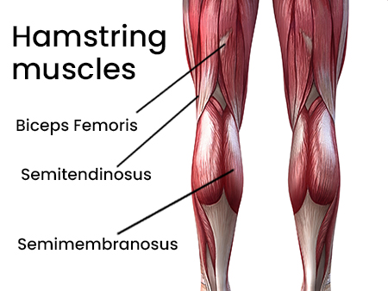
Figure 1. Back view of Hamstring muscles locating the biceps femoris, Semitendinosus, and Semimembranosus (Starhealth, n.d.).

Delayed Onset Muscle Soreness (DOMS)
DOMS is a prevalent issue among athletes, characterized as a mild muscular strain injury typically emerging after unaccustomed muscular exercise, particularly in the eccentric mode; DOMS is characterized by a dull ache, tenderness, stiffness, and weakness in previously engaged muscles (Croisier, 2003). Unaccustomed eccentric training serves as a common catalyst for DOMS, often arising with heightened exercise intensity or volume, alterations in exercise schedules, or the introduction of novel exercises. After engaging in unfamiliar physical activity, both seasoned and inexperienced athletes may feel soreness, primarily in their skeletal muscles (Cheung et al., 2003). The level of discomfort rises during the first 24 hours after stopping an exercise routine, peaks between those 24 and 72 hours later, then gradually decreases and vanishes by the time it reaches the 5-day mark (Ozmen et al., 2016). Key factors such as exercise intensity and duration significantly contribute to the clinical symptoms of DOMS, encompassing reduced muscle strength, restricted movement, pain, mild tenderness, stiffness, swelling, and dysfunction in adjacent joints (Xue, 2023; Heiss et al., 2019; Tseng et al., 2016).
While classified as a mild injury, DOMS significantly impacts exercise performance, representing one of the most common causes of performance impairment (De Oliveira, 2023). Repeated eccentric contractions during competition and training can lead to muscle damage, involving the destruction of structural proteins in muscle fibers and/or connective tissue, resulting in tissue inflammation, heightened DOMS, and perceived fatigue (Xue, 2023). The complexity of DOMS highlights the need for comprehensive understanding and effective strategies to manage and mitigate its impact on athletes' training and performance.

Female NCAA Athletes and Lower Extremity Injuries
According to NCAA.org, the number of student-athletes engaging in NCAA women's championship sports witnessed a remarkable 5% increase, with 10,726 student-athletes joining the ranks compared to the previous academic year (McGuire, 2003). This surge marks the most substantial increase for women since the 2000-2001 season. Specifically, individual women's sports, such as soccer, indoor track and field, volleyball, basketball, and cross country, showcased significant growth rates, with increases ranging from 6% to 7% from 2020-21 to 2021-22 seasons. Female NCAA track and field athletes have experienced a notable surge in participation, reflecting a broader trend seen in NCAA women's championship sports during the 2021-22 academic year. The comprehensive study conducted by Chandran et al. (2021) revealed that, during the study period, the predominant injuries among female NCAA track and field athletes were concentrated in the thigh (19.3%), lower leg (18.5%), and foot (12.9%) regions, constituting the largest proportion of the 1,368 Track and Field injuries analyzed in this study (Chandran et al., 2021). The study further identified specific injuries, with partial or complete hamstring tears emerging as the most common, accounting for 9.1% of the reported cases (Chandran et al., 2021). These findings shed light on the anatomical areas prone to injury within the track and field context, emphasizing the significance of targeted injury prevention and management strategies for female athletes in this sport.
Despite the statistically significant evidence of men being more likely to suffer from HSIs than women (Cross et al., 2013), the frequency of HSIs in female collegiate soccer participants was found to be 0.6 injuries per 1000 exposure hours, with evidence of intermediate certainty (Mullins et al., 2022). The excessive training load of competitive team sport athletes often involve high-intensity interval training (HIIT) regimens. Keane et al. (2015) reported that sports that involve HIIT, frequent sprinting, and changes in direction and velocity, like basketball, rugby, and soccer, can cause considerable muscle injury and long-term functional impairments. HIIT consists of brief to long (~5–300 s) intense work bouts broken up by active or passive periods of recovery (Wiewelhove et al., 2015). Sport training is more than just recreational activity exercise because it aims to bring athletes as close to their genetic limits that are within reach (DeWeese et al., 2015). To reach this maximum potential, endurance athletes usually alternate phases of rigorous training with rest and recuperation. Overuse injuries can result from inadequate rest, which can impair skeletal muscle tissue growth and regeneration (Bezuglov et al., 2021).
These overuse injuries can sometimes also be referred to as Exercise Induced Muscle Damage (EIMD). EIMD is characterized by several signs and symptoms, such as increased discomfort in the muscles, inflammation, the systemic appearance of intramuscular proteins, and an accompanying decline in physical performance (Keane et al., 2015). Howatson and Milak (2009) have demonstrated that even a single team sport specific HIIT session increases muscle injury and pain in the following days post HIIT workout. While functional overreaching is the goal of effective training programs, athletes should avoid excessive overload and inadequate recovery. This can cause a decline in performance, and the possibility of overtraining, if training stress and recuperation are not balanced over an extended period of time (Meeusen et al., 2013). DOMS is one of the most common side effects of high training loads and is followed by a brief loss of muscular strength.
The primary subjective sign of recovery for many athletes at various levels is most likely the reduction of DOMS length and severity. When undergoing treatment, athletes with DOMS who must continue exercising regularly are recommended to decrease the time and intensity of the uncomfortable exercises (Bezuglov et al., 2021; Cheung et al., 2003). There aren’t many existing studies that exclusively consider sex differences pertaining to the effects of DOMS. One study by Chen et al (2019) tested the effects of caffeine intake and sex differences on DOMS mitigation. While there was no significance found based on the exclusive variable of sex on all muscle performance results, it was suggested that caffeine supplementation may benefit males and enhance their physical performance when affected by EIMD as well as attenuate their DOMS at a faster rate than females (Chen et al., 2019).

Kinesio Technology (KT) tape
Xue et al. (2023) conducted a study revealing that KT tape and CS share similar mechanisms of action, holding significant implications for reducing DOMS and preventing further muscle damage. KT tape, an ultra-thin and breathable tape with exceptional elasticity, originated in 1973 through the ingenuity of Dr. Kenso Kase in Japan (Figure 2).
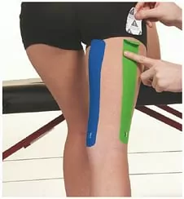
Figure 2. Kinesio Technology (KT)Tape on the back of the leg placed to support the hamstring muscles (kttape.com).

Widely applied in the realms of skeletal muscle limitation and sports injury, KT tape optimizes skin, blood, and lymph flow, and is recognized for its ability to: (1) support injured muscles and joints, (2) enhance muscle strength, (3) improve muscle function, (4) inhibit muscle tension, and (5) alleviate pain (Williams et al., 2012). Functioning by lifting the skin and purportedly exerting a pulling force of 120%- 140%, KT tape aids in the relief of pain and recovery. Xue et al. (2023) reaffirmed the efficacy of s KT tape in significantly reducing DOMS pain, outperforming CS in recovery effectiveness. Furthermore, KT tape has demonstrated a positive impact on flexibility, a crucial element in preventing sports injuries, by maintaining quadriceps femoris flexibility compared to baseline measurements. Kase, 2003; Handler & Ginty, 2021).
When combined, KT tape and CS synergistically mitigate DOMS pain, expedite isokinetic muscle strength recovery, and shorten overall recovery time (Xue et al., 2023). However, both KT tape and CS treatments need to be customized for the athlete’s specific body size and training needs.

Compression Garments
Research on lower extremity compression garments (CGs) has primarily centered on their effects on post-exercise recovery and performance enhancement, as explained by Frank et al. (2021). Their findings reveal that most athletes, over 80%, employ CGs with a primary goal of preventing re-injury, with almost half emphasizing secondary sports injury prevention as the foremost reason. Notably, nearly 90% of those aiming to reduce recurrent injuries reported perceived positive effects of CG use for this purpose (Franke et al., 2021). Moreover, athletes using CGs for recovery or sports performance improvement, perceived faster recovery (over 80%) and sports performance improvement (over 70%) (Franke et al., 2021).
The mechanisms behind the benefits of CGs in enhancing recovery remain unclear but may involve alterations in venous and muscle blood flow (O'Riordan, 2021; Hill et al., 2014; Kraemer et al., 2004). Compression on the muscles was found to increase venous blood flow, facilitating the removal of myofibrillar proteins from the muscle, which helps in the recovery process after EIMD (Weber et al., 2021). When athletes exercise, especially during high intensity or resistance training, microscopic tears in the muscle fibers can occur, leading to muscle soreness and inflammation (Croisier, 2003). Myofibrillar proteins, such as actin and myosin, are key components of muscle fibers and are released into the bloodstream as a result of this damage (Saghiv 2020). Removing these proteins from the muscle helps to alleviate inflammation and promote the repair and regeneration of the muscle tissue. This process is essential for muscle growth, adaptation, and overall recovery from exercise (Hill et al., 2014). By facilitating the removal of these proteins, compression techniques like wearing CGs or massage can potentially accelerate the recovery process and reduce the duration and severity of muscle soreness (O'Riordan, 2021).
Additionally, compression may enhance blood flow post-exercise, aiding recovery by increasing nutrient delivery. Despite these benefits, the contribution of psychological factors to the performance enhancing effects of compression on exercise performance and recovery outcomes is currently unknown (O’Riordan, 2021). Noteworthy, studies by Xue (2023), Engel et al. (2016), Rider et al. (2014), and Ali et al. (2011) have reported that compression sleeves (CS) can promote recovery from DOMS. Leabeater et al. (2022) found positive benefits of CGs for recovery on subsequent bouts of endurance and resistance exercise. The principle of CGs aligns with compression therapy, where a known amount of pressure aids the return of venous blood to the heart, based on the Laplace equation (Venkatraman, 2015). Compression therapy's effectiveness has been well-documented, with historical use dating back to the 19th century for medical ailments (Venkatraman, 2015). Athletes have increasingly adopted CGsover time, as an beneficial aid for performance improvement and recovery (Gokarneshan, 2017). However, limited research has delved into identifying the performance effects and related physiological mechanisms associated with these garments (Kyzymchuk, 2023).

Fit and Sizing
The level of efficacy of CS is dependent upon the right amount of pressure applied to the athlete’s body, which is attained through the correct fit of the garment as well as use of fabrics with appropriate mechanical properties (Brubacher, 2020). Ensuring the proper fit and sizing of CS is key to maximizing their effectiveness and comfort. Their engineered graduating pressure on specific areas of the body helps blood circulation and muscle support (Perrey, 2008). Gokarneshan (2017) highlighted the importance of achieving the fastest venous flow, revealing that an optimal mercury pressure gradient of 18mm at the ankle, 14 mm at the calf, 8 mm at the knee, 10 mm at the lower thigh, and 8 mm at the upper thigh is conducive to efficient venous circulation. Gupta (2011) emphasized that the effectiveness, safety, pressure distribution, and retention of compression garments significantly impact user health, with pressure performance (magnitude and durability), serving as key indicators.
Doan et al. (2003) conducted a study on compression shorts, custom-fitted based on individual measurements of waist, hip, thigh, knee girth and inseam. These compression shorts were designed to be highly compressive (15% smaller than the athlete’s measurements), with a unique material composition of 75% closed cell neoprene and 25% butyl rubber, ensuring lightness, strength, compressive ability, and impact absorption. The garment's tailored fit and specific material properties contributed to their effectiveness in promoting optimal venous flow and pressure distribution.

Design and Product Development
CS design and product development represent the intersection of functionality, innovation, and user-centered considerations (Gokarneshan, 2017). The efficacy of CS as functional garments is determined by a complex interplay of multiple components, as outlined by Gokarneshan (2017): (1) garment's fit and construction, (2) the inherent structure and physical properties of its materials, (3) the specific size and shape of the targeted body area, and (4) the nature of the sport activity involved. These factors collectively determine the extent of pressure generated by the compression garment (Doan et al., 2003). Beyond pressure performance, Xiong and Tao (2018) emphasized that various physical characteristics, such as air permeability, heat dissipation, moisture transmission, and tactile qualities, significantly impact the overall comfort of CS. Barker (2002) expressed that comfort must be understood in the context of the entire range of human physiological and psychological reaction, rather than simply a consequence of the physical characteristics of materials and garment elements. Ertekin et al. (2018) reported on the increasing importance placed on the holistic experience of CGs wearers, necessitating an integrative approach that considers both performance-related aspects and the broader aspects of user comfort and satisfaction.
Regular feedback from users, coupled with advancements in medical and sports science, continually inform the iterative design process of CGs, fostering the creation of products that not only meet the functional requirements, but also align with the evolving user expectations and lifestyle demands (Jhanji, 2021).

Aesthetics
While the primary purpose of CS is to enhance blood circulation, support muscles, and aid in recovery, attention to aesthetics plays a pivotal role in user satisfaction and adherence to regular wear (Engel et al., 2016). CS are available in a diverse range of colors, patterns, and designs, allowing users to express their personal style and preferences. Manufacturers often consider not only the technical aspects of compression performance but also the visual appeal to cater to a broader audience (Rahulan et al., 2015). Aesthetic considerations become particularly relevant in sports and fitness contexts, where athletes may seek training aids that seamlessly integrate with their team uniforms or personal workout attire (Seçkin et al., 2023). There are many criteria worth considering when looking at this specific female athlete demographic. Most individuals would like to see their sports and compression garments to have extremely high quality, comfort, and style (Rahulan et al., 2015; Barker, 2002; Seçkin et al., 2023), but it is important to keep the customer in mind when designing something that becomes one with the body.

Materials and Properties
The selection of materials for CS is a critical aspect that profoundly influences their functionality and comfort. The CS’s most notable feature is its elastic mechanical capabilities, which allow it to effectively operate as a membrane stretching on the human body's curvy shape. To do this, elastic fabrics, particularly knitted fabrics, are made using elastic fibers and yarns that have strong extensibility and elastic recovery (Xiong & Tao, 2018). For comfort reasons, knitted fabrications are preferred not only because of their elasticity, but also their air permeability, and lightweight properties (Ertekin et al., 2018; MacRae, 2011).
The stretch properties of knitted fabrics are an important mechanical characteristic of CS materials that directly affect pressure on the body (Gokarneshan, 2017). The degree of stretch varies according to the knitted fabric’s structural characteristics. Because of the knit loop formation, knitted materials are known to have better stretchability by nature; this property can be enhanced by utilizing specific types of fibers, such as elastane fibers (Ertekin et al., 2018; Gokarneshan, 2017). Elastane's remarkable quality is its great elongation, which can exceed 500%, and its elastic recovery, which can reach over 95% (Abdessalem et al., 2009).
The elastane yarn count significantly impacted all of the parameters that were measured in a study by Ertekin et al. (2018) that looked at the physical, strength, and thermal comfort characteristics of elastic knitted fabrics made using various elastane yarn counts and elastane rates. The weight, thickness, bursting strength, and puncture resistance of the textiles knitted using coarser elastane yarn were all higher. Higher thermal conductivity and thermal absorptivity, as well as lower air and relative water vapor permeability, were found in fabrics with coarser elastane yarn when it came to thermal comfort. The textiles with full plated elastane or coarser elastane yarn showed lower relative water vapor permeability and lower air conductivity and absorptivity values, according to the thermal comfort attributes (Ertekin et al., 2018). For this reason, continuous filament yarns made of elastomeric or spandex fibers have been used for CS design. This includes segmented polyurethane fibers, polyester ether fibers, polyester fibers like poly (butylene terephthalate) (PBT) fiber and polytrimethylene terephthalate (PTT) fiber, olefin based elastomeric fibers, and bio-component fiber (Hu et al., 2008). During their field trial, Kandhavadivu & Gopalakrishnan (2021) found that usage of medium and higher elasticity fabrics showed a reduction of 90% in the muscle movement, resulting in a 9% increase in the performance of the volunteer during running and cycling.
Sensorial comfort is equally important for the thermal comfort of CS. The sensation of the fabric against the skin as a result of the skin-fabric interaction is known as ‘sensory comfort’, and this sensation is a result of the fabric's mechanical, surface, and structural characteristics (Yip & Chan, 2020). When compared to natural fibers, regenerated fibers tend to have a more uniform surface that may feel smoother to the wearer. They also tend to manage moisture better and exhibit higher durability (Yip & Chan, 2020). The hydrophilic properties of regenerated fibers are advantageous for sportswear because they allow moisture to be absorbed from the skin and wicked away. This helps keep the wearer dry and comfortable while engaging in physical activity. Therefore, this characteristic can further improve performance and general comfort during exercise by controlling sweat and preserving a lower body temperature (Jhanji, 2021).
Historically, the most popular types of fibers used in sportswear have been cotton and wool. Because they are hydrophilic, they can take in perspiration when exercising. Many studies have found that thermal conductivity, moisture wicking, and breathability are properties that are key to regulating heat and moisture for next to skin worn garments (Barker, 2002; Jun et al., 2009; Matusiak, 2010; Parsons, 2014).
Many CS designs on the current market are made using Neoprene, a spacer type of fabric using the DuPont’s brand name for polychloroprene. The rubber-like, versatile petro-chemical based material that gained prominence in the 1950s for its application in surfing wear, has the ability to trap air within its structure, establishing an insulating barrier, and reducing thermal conductivity between disparate temperatures (Ghorbani et al., 2013). Over time, it was discovered that Neoprene membrane exhibits resistance to water, saltwater, chemicals, and light. As a synthetic elastomer with flexibility and stretchability, Neoprene became instrumental in the creation of various aquatic sportswear, including swimsuits, sports bras, and diving suits. All polychloroprene materials are molecularly identical, but the variations in manufacturing processes can change the physical properties of the end result fabric (Hatfield et al., 2021).
In the sports apparel market, Neoprene membrane is commonly combined with other elastic fabrics, like polyester or nylon knit fabrics, through gluing or stitching, resulting in spacer fabric sheets with thickness varying between 3-7mm, that enhance Neoprene's flexibility for improved garment fit (Ünal & Eren, 2018) (Figure 3 and 4).
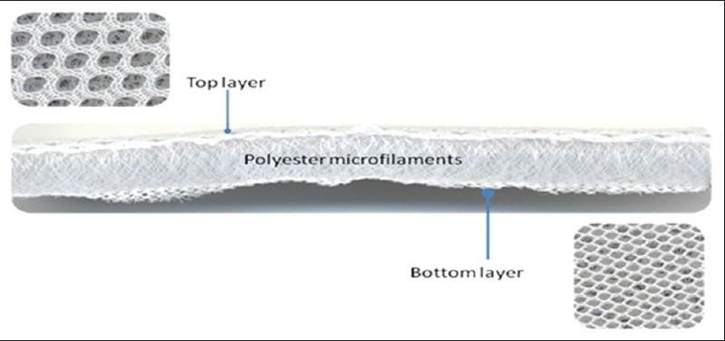
Figure 3. Structure of typical spacer fabric (Ghorbani et al., 2013)
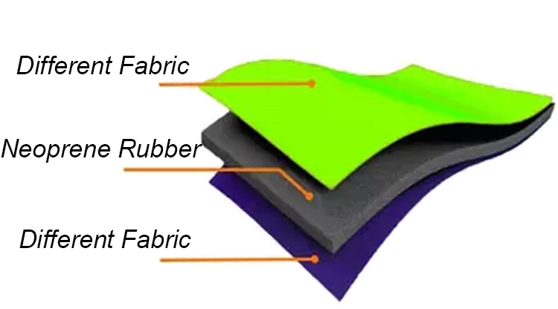
Figure 4. Neoprene fabric structure (Worldbrace, n.d ).

Yip & Chan (2020) summarized the general material criteria they found for activewear, as shown in Table 1, and designers use various fabric testing and evaluation methods to choose the best fitting materials for CS design.

Table 1. General criteria for selecting materials for activewear (Yip & Chan, 2020)
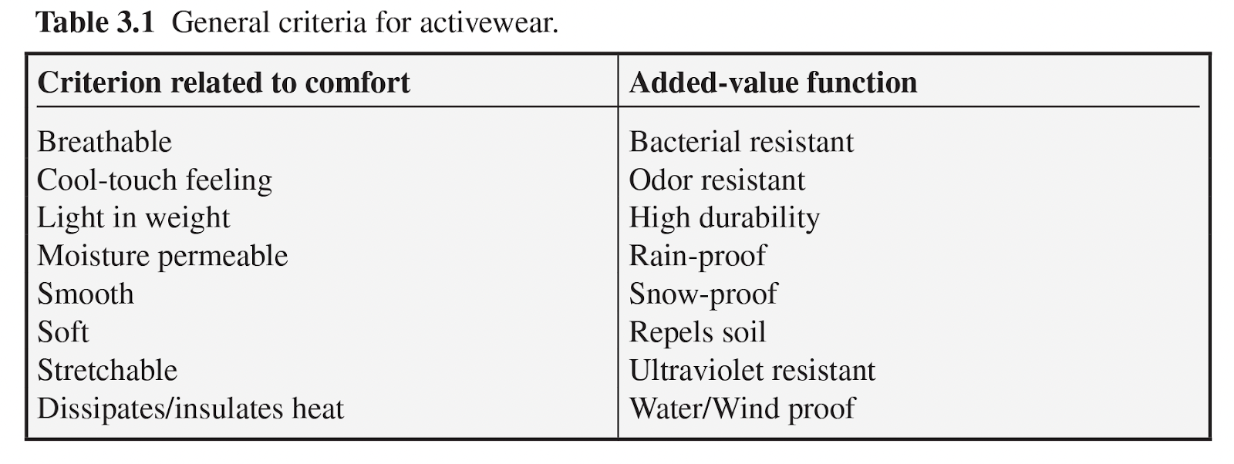

Materials and Methods
Textile testing for elongation is a critical aspect of evaluating the mechanical properties of stretch fabrics and materials. Elongation refers to the ability of a textile to stretch or extend under applied force, providing insights into its flexibility and resilience. Various methods, such as the strip method or constant rate of extension (CRE) test, are employed to measure elongation accurately. During testing, a sample of the textile is subjected to controlled tensile forces, and the resulting elongation is measured. This data is crucial for assessing the material's performance in real-world scenarios, such as garment manufacturing or industrial applications, where elongation is a key factor (Ertekin et al., 2018).
Textile testing for air permeability is a pivotal process in assessing the breathability and ventilation properties of fabrics. The rate of airflow through a fabric when there is a pressure differential on either surface is known as air permeability, and it is primarily influenced by the porosity of the fabric in addition to its thickness (Choudhury et al., 2011). Since air permeability helps move moisture vapor from the skin to the outside atmosphere, it is a significant indicator of fabric comfort. It is assumed that the major way vapor moves across fabric gaps is through air diffusion from one side of the fabric to the other (Karaguzel, 2004). Airspace typically makes up a sizable amount of the total volume occupied by a fabric because of the way yarns and textiles are made. The dispersion of this airspace affects several significant fabric characteristics, including warmth, wind and rain protection, and the effectiveness of filtration in work attire (Mavruz & Oğulata, 2010). A knitted structure's physical characteristics, including bulk density, moisture absorbency, mass transfer, and thermal conductivity, are influenced by its porosity (Dias & Delkumburewatte, 2008). Lower air permeability results indicate that the fabric has tighter weaves or is more densely knit, which can help enhance compression and provide better support to the muscles. This can be particularly beneficial in athletic compression sleeves where the fabric should ideally apply consistent pressure and support to the muscles without allowing excessive airflow that may decrease the garment's effectiveness (Choudhury et al., 2011).

The User Centered Design (UCD) Process
The term "user-centered design" was first coined in the 1980s by Donald Norman's research lab at the University of California, San Diego (UCSD) (Abras & Preece, 2004). In his book, The design of everyday things, Norman argues that designers need to acknowledge the user's interests and wants, while emphasizing the design's utility. He provides four fundamental guidelines for what a design ought to be: (1) it should be simple to ascertain what can be done at any given time; (2) provide quick access to information about the system's current condition, including its conceptual model, possible courses of action, and outcomes; (3) pay attention to the natural mappings that occur between the intended outcomes and the necessary activities, (4) state interpretation between the actions and their consequences, and between the visible data and the system (Abras & Preece, 2004; Norman, 1988).
User-Centered Design (UCD) is both a philosophy and a systematic approach that prioritizes individuals by placing them at the forefront, emphasizing cognitive factors throughout their interactions with various elements. It encompasses a dual focus on enhancing both usefulness and usability (Dwivedi et al., 2012). While UCD can be defined in multiple ways, its defining characteristic lies in its unwavering emphasis on the user, ensuring the incorporation of the user's perspective at every stage of the design process (Dwivedi et al., 2012). In the field of sportswear design, the designers must take into account the needs of the wearer, the surrounding environment, and the fabric's ability to adapt to these factors (McLoughlin & Sabir, 2018). Morris et al. (2017) utilized the UCD framework to methodically design and evaluate a prototype of a nursing sports bra prototype. Morris et al. (2017) organized their UCD process into the following steps:(1) specify context of use (2) determine goals for success (3) create a design solution (4) evaluate the design solution and (5) assess the system.

Literature Review Summary
The literature review highlighted several gaps in knowledge related to NCAA female athlete injuries, athlete performance, and the use of CGs in the context of reducing muscle fatigue associated with DOMS. For starters, most of the existing literature focuses on male sports participants. It has been proven in many studies that females have different user needs based on their anatomy, compared to men, which affects their susceptibility to injury as well as their ability to recover. Therefore, what has been shown to work as a solution to male injuries cannot be directly translated to aid female recovery. With the considerable rise in female sports participation, especially sports where the athletes are highly susceptible to hamstring injuries, it is important to be shaping the research around women in these sports.
The studies focused on investigating the technology and mechanisms surrounding lower extremity CGs, with a focus on the effectiveness of CS and KT tape in reducing DOMS, demonstrate the positive impact of KT tape on DOMS pain reduction and recovery effectiveness when combined with a CS (Xue et al., 2023). However, the challenges of achieving optimal pressure gradients for efficient venous circulation emphasize the importance of achieving appropriate fit and sizing of CS for the specific athlete body, activity level based on sport, and environment.
A research gap was found for the lower extremity CS needs of females who are competitive NCAA athletes. This gap was rooted in a lack of scientific evidence that there is a significant change in recovery times for people who suffer from DOMS dependent upon the recovery methods that are currently being used. There are also no studies that look at incorporating KT tape into the inner workings of a CS and how it could affect the wearer/ athlete. Lastly, while many studies have explored the topic of DOMS and the recovery process, the way that DOMS is induced in previous studies is not relevant to the training of NCAA level athletes, so there is no way to translate findings that exist to this demographic. Therefore, the following research questions were developed for this study:
RQ1: What are the user-needs of female NCAA athletes for CS design aimed at reducing hamstring injuries and recovery time from DOMS?
RQ2: How does a prototype design that satisfies NCAA female athlete user-needs look like when incorporating the science between KT tape and CS?
RQ3: How does incorporating the science behind KT tape in a custom-made CS affect the recovery time of DOMS, and to what extent is the prototype successful in reducing the impact of DOMS?

Conceptual Design Framework
In the current interdisciplinary mixed methods experimental study, a UCD framework was adapted from Morris et al. (2017) (Figure 5). The framework guided the comprehensive examination of NCAA female athlete user-needs, followed by qualitative and quantitative analysis of surveys, material performance and field-testing sessions. These methodologies were instrumental in collecting data pertaining to users' preferences and requirements when it comes to compression sleeves. The functional testing sessions underwent qualitative evaluations through participant surveys, incorporating both closed and open-ended questions. This holistic approach allowed for a nuanced understanding of user-needs, desires, and experiences, aligning with the core tenets of UCD philosophy.
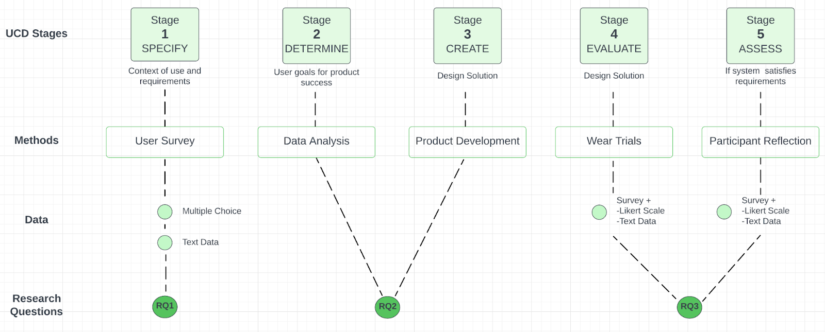
Figure 5. UCD framework adapted after Morris et al. (2017)

METHODS

Stage 1: Specify
RQ1: What are the user-needs of female NCAA athletes for CS design aimed at reducing hamstring injuries and recovery time from DOMS?
This preliminary step aimed to gather user-needs data via Qualtrics Survey distributed to current and recently graduated female NCAA athletes at University of Delaware, through group chats on Facebook, GroupMe, Instagram, and Snapchat. Institutional Review Board (IRB) at University of Delaware approved the survey study with Exempt status on November 17, 2023 (Appendix A). The survey data was analyzed using Excel software for analyzing the quantitative data, as well as tabulating frequencies and grouping the qualitative content into themes.

Participants
The criteria for survey participant selection were women between the ages of 18-24 who are currently or have recently graduated (1-2 years) from competing in an NCAA sport at University of Delaware. Access to the group chats and social media pages was requested and granted through personal communications with the researcher. Fifty-nine participants started the survey, but 36 responses were recorded as complete and further analyzed.

Survey Design
The survey consisted of 26 questions focusing on the participant’s injury history, previous experience with DOMS and how it affects their training, and the characteristics that they find important in a CS (Appendix B). Qualitative feedback was encouraged by prompts that asked to “Please list/specify”. At the end of the survey, participants had the option to volunteer for the rest of the study by sharing their email addresses. The survey was open for two weeks in the months of November and December 2023.
User-needs and design criteria for a CS prototype were determined by integrating the themes analyzed from the qualitative data with the quantitative findings. Eight questions from the Stage 1 Survey required qualitative coding: “Please list all sports related injuries”, “After what kind of workouts are you MOST likely to experience DOMS in your hamstrings? (ie: Short sprints, long sprints, 200 meter sprints, weight lifting, etc.)”, “What workouts are you LEAST likely to experience DOMS in your hamstrings? (ie: drill work, shakeouts, etc.)”, “After what kind of workouts are you MOST likely to experience DOMS in your quad muscles? (ie: Short sprints, long sprints, 200 meter sprints, weight lifting, etc.)”, “What workouts are you LEAST likely to experience DOMS in your quad muscles? (ie: drill work, shakeouts, etc.)”, “Is there a specific type of sleeve/garment you use that helps prevent or relieve DOMS after a workout or competition? If so, please describe it.”, “Is there any other properties that you find important regarding an athletic compression sleeve worn around the hamstring/ quad while training/competing? If so, list them here and how important they are.”, “Is there anything else you'd like to share regarding your experiences with DOMS in the hamstring and quad areas or any additional comments related to your track and field training?”.

Stage 2: Determine
RQ2: How does a prototype design that satisfies NCAA female athlete user-needs look like when incorporating the science between KT tape and CS?
Once the design and material selection criteria have been established through Stage 1 data analysis, and based on how the respondents rated the level of importance of specific characteristics regarding a CS of the hamstring/ quad area, different materials were selected and tested. Based on the literature review, market research, and survey feedback, sketches of potential prototypes were drawn up (Appendix C) with callouts of different attributes of the sleeves.
Figures 6 and 7 depict two initial prototypes that the researcher assembled, to investigate which design would be perceived as most user friendly. This was based on the researcher’s perceived ease of use of the two prototypes. These baseline prototypes tested different sewing techniques to establish which would best simulate the characteristics of KT tape.

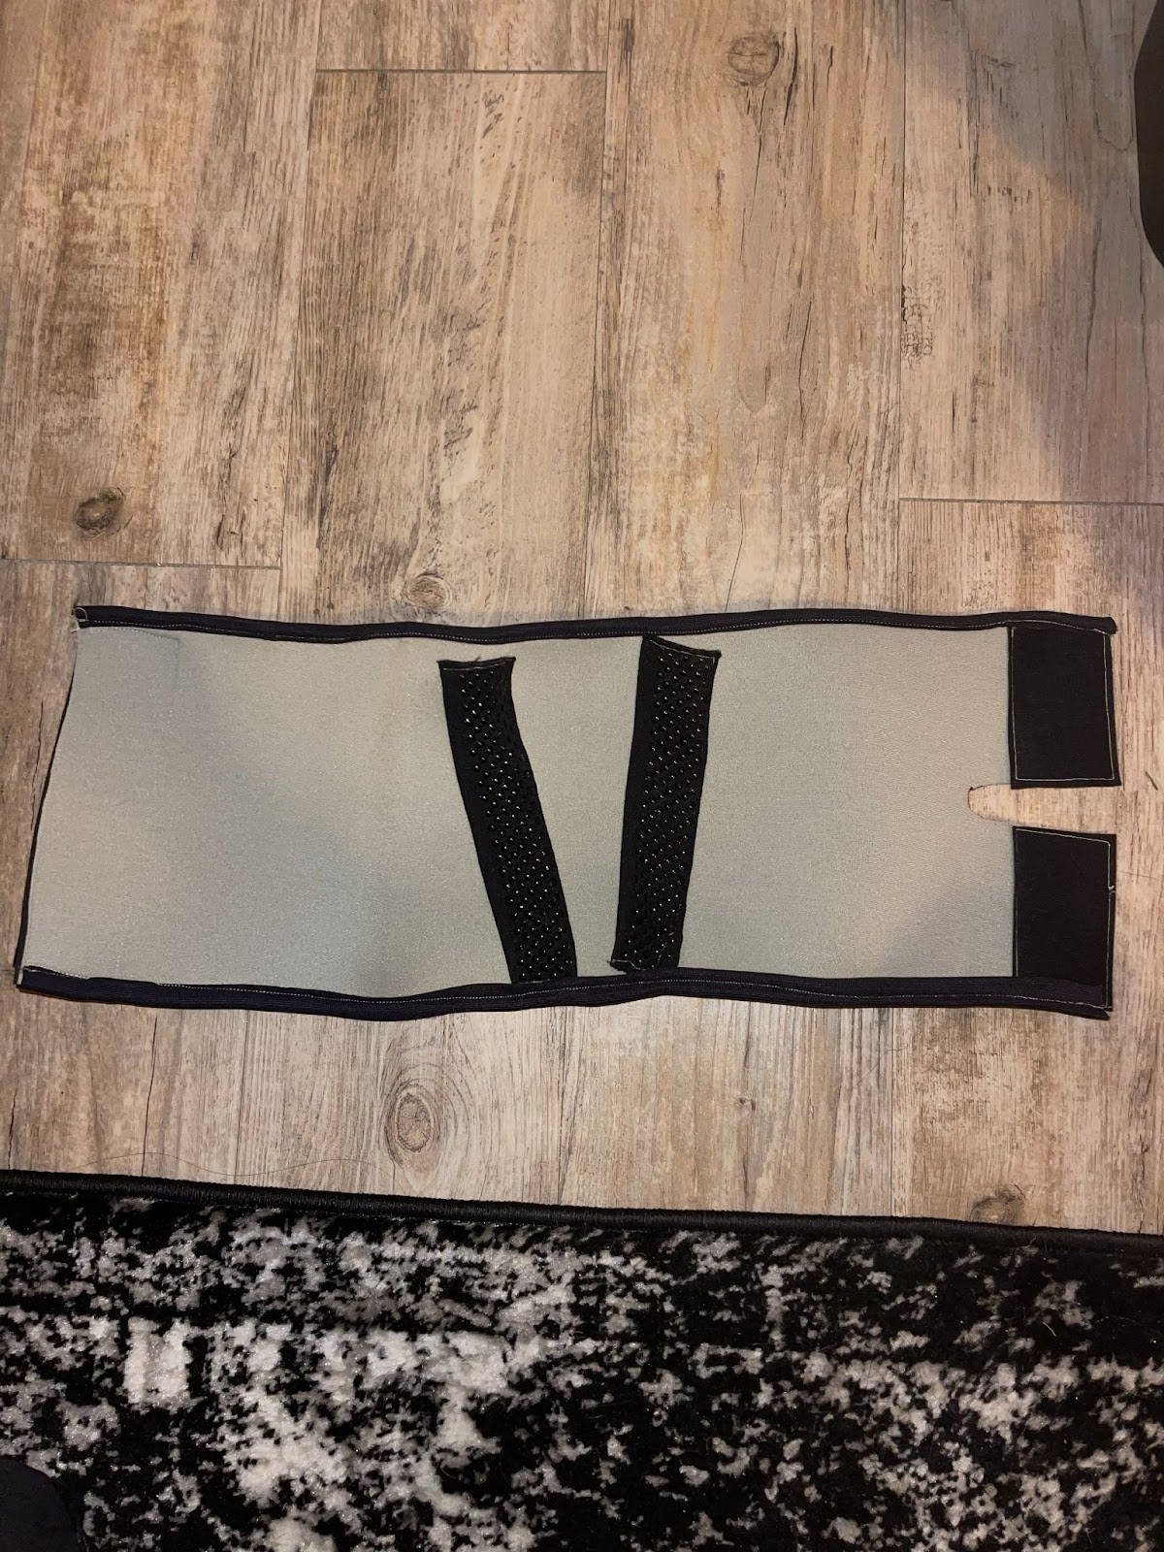
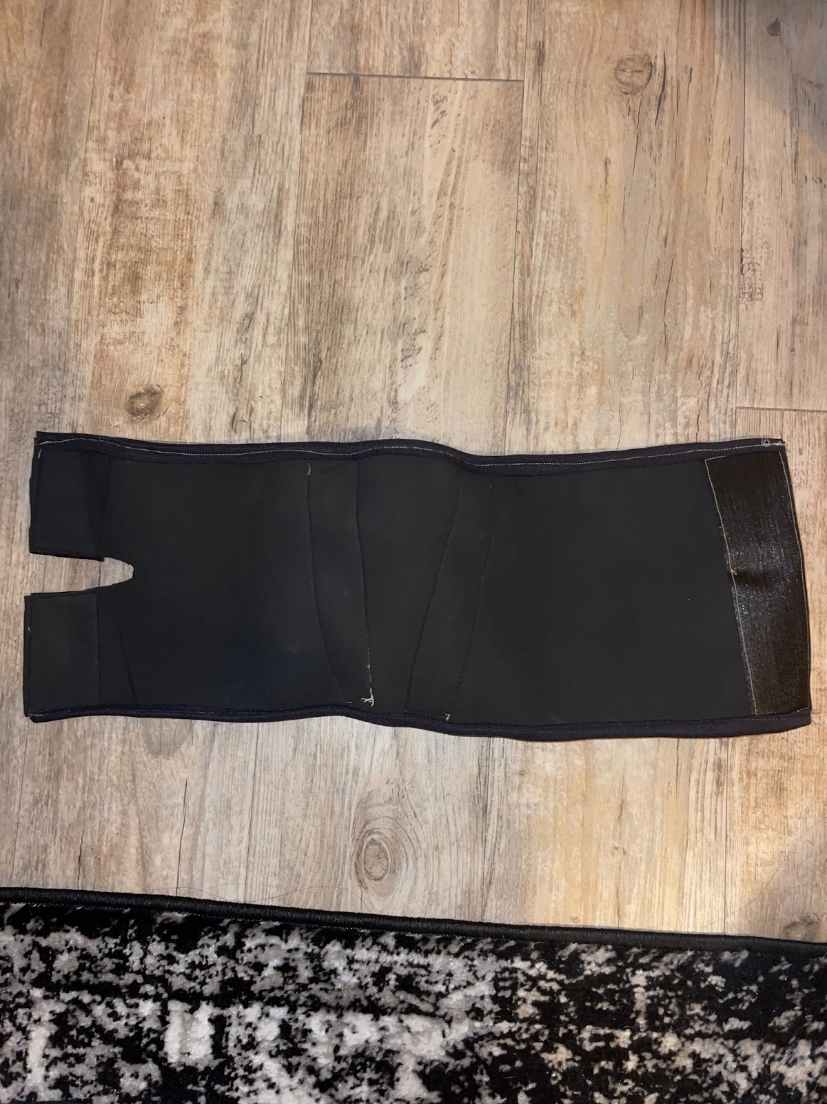
Figure 6. Inside (top) and outside (bottom) of initial prototype 1

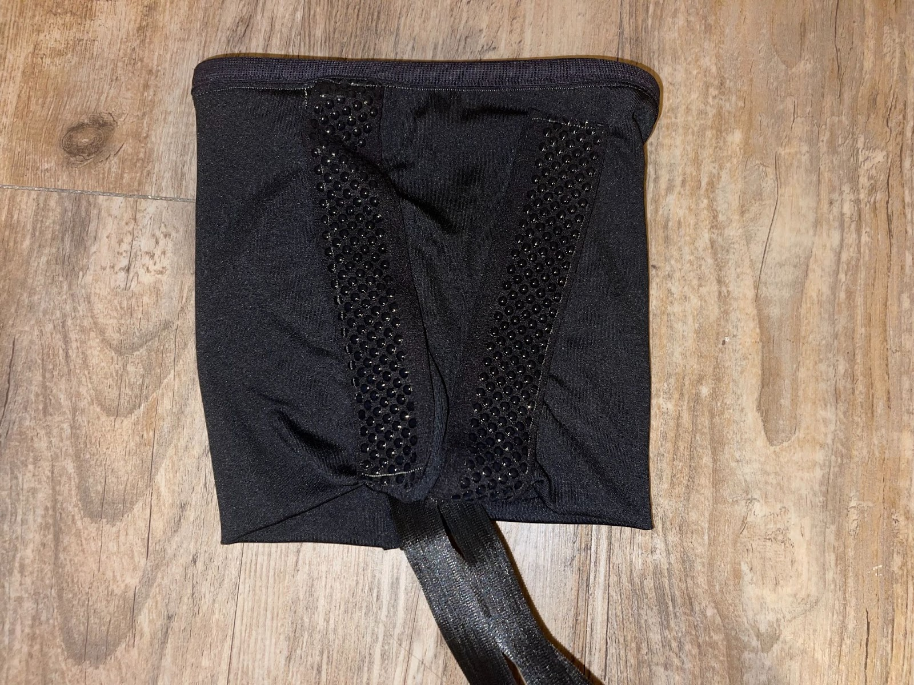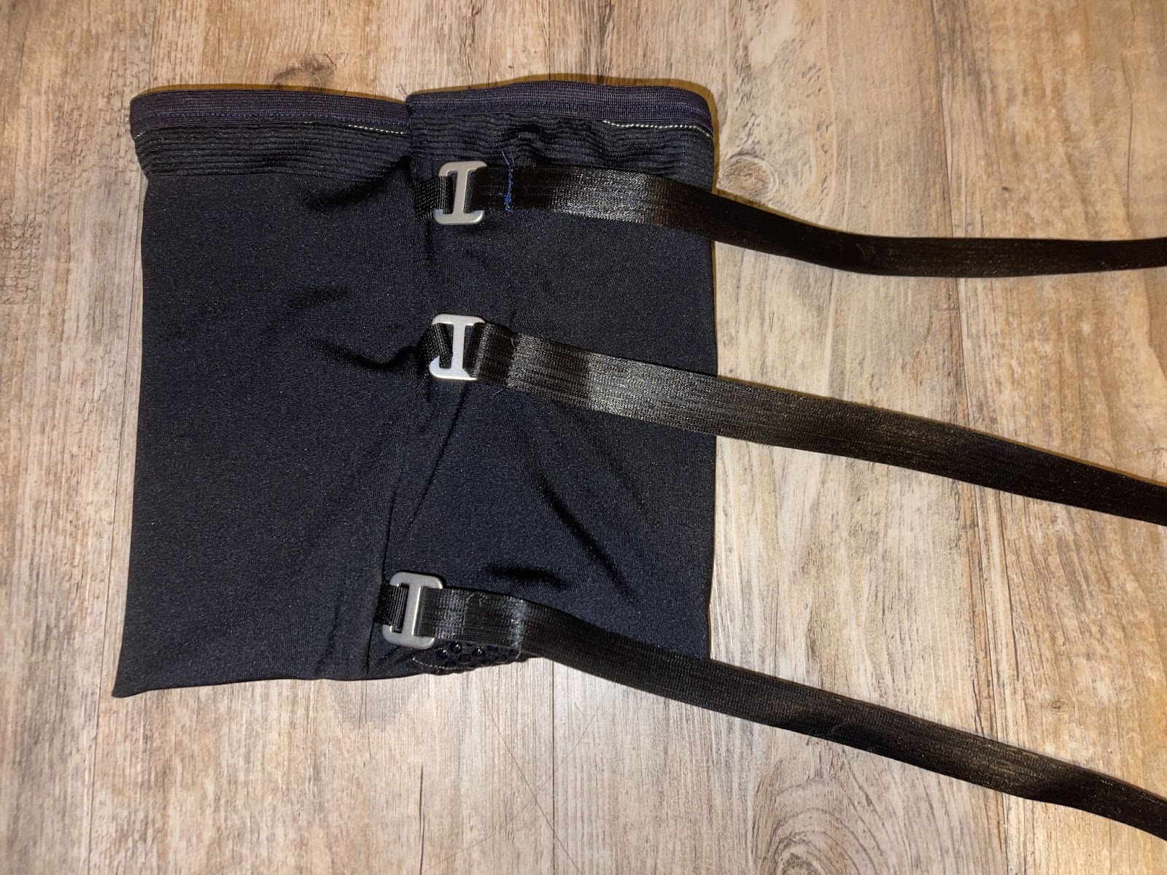
Figure 7. Inside (left) and outside (right) of initial prototype 2

To determine which fabric would be best to use, various fabric samples from Blue Moon Fabrics located in Los Angeles California were purchased. The samples were selected based on qualities such as 4-way stretch, soft hand, and compression capabilities. The final fabrics selected were: (1) Superflex Heavy Compression Spandex, (2) Spacer with Wicking, (3) Eco-Move Recycled Matte Nylon Spandex Tricot, and (4) Ribbed Spandex and (5) Spacer Scuba Knit (Figure 8)
(a)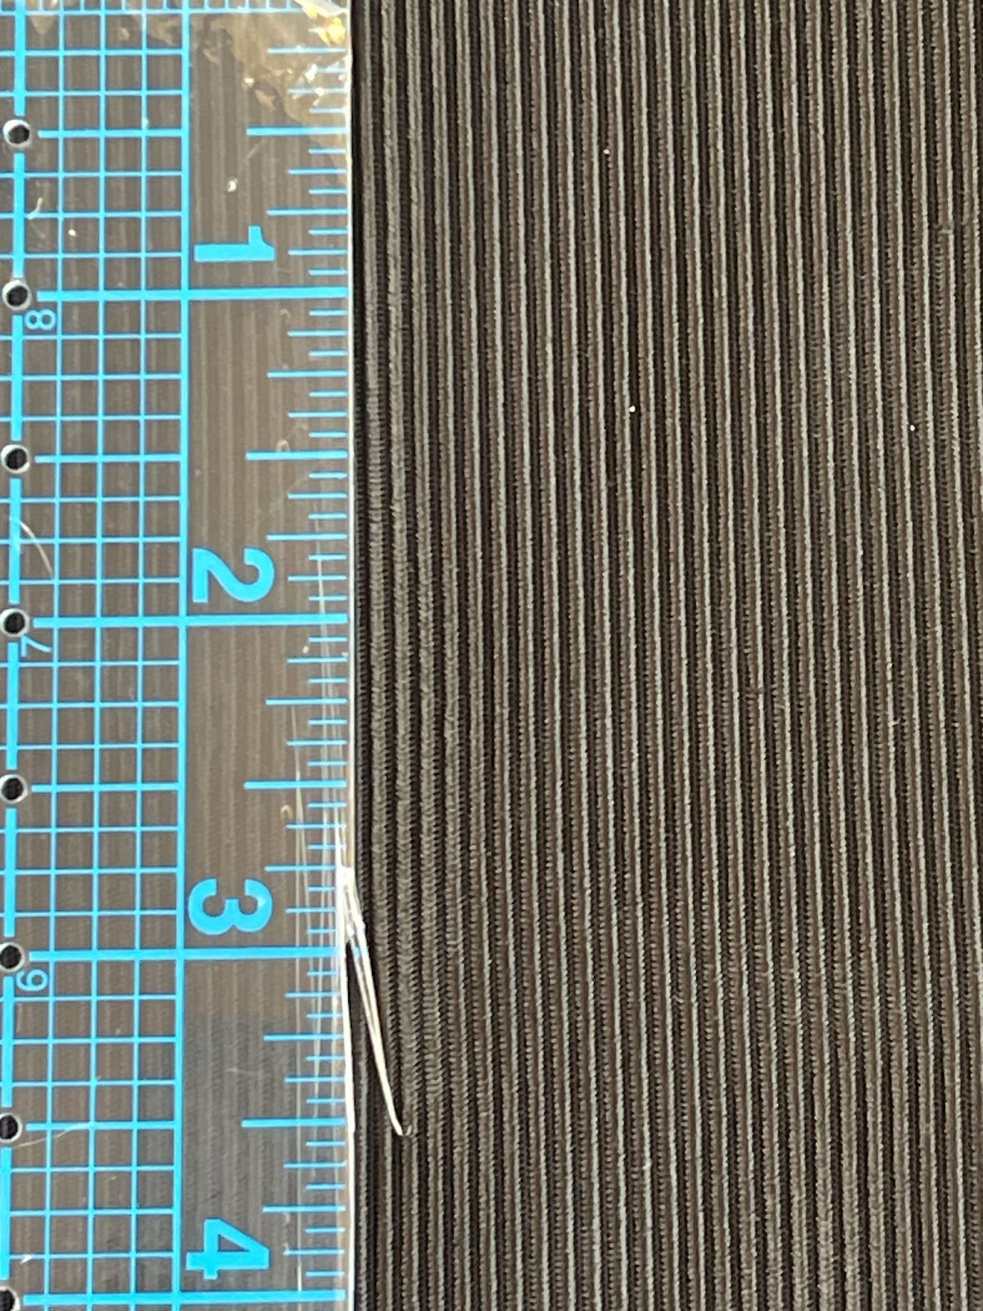(b)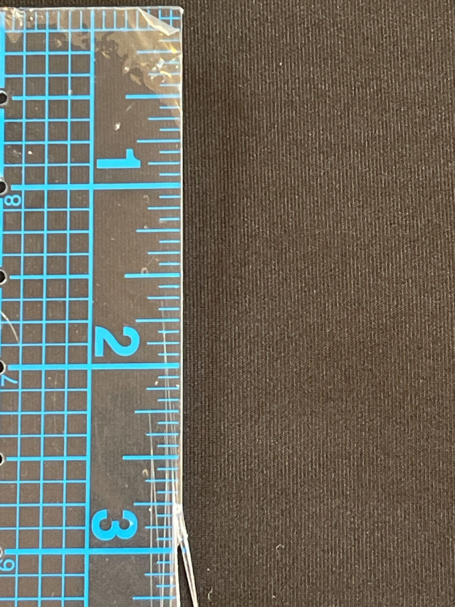(c)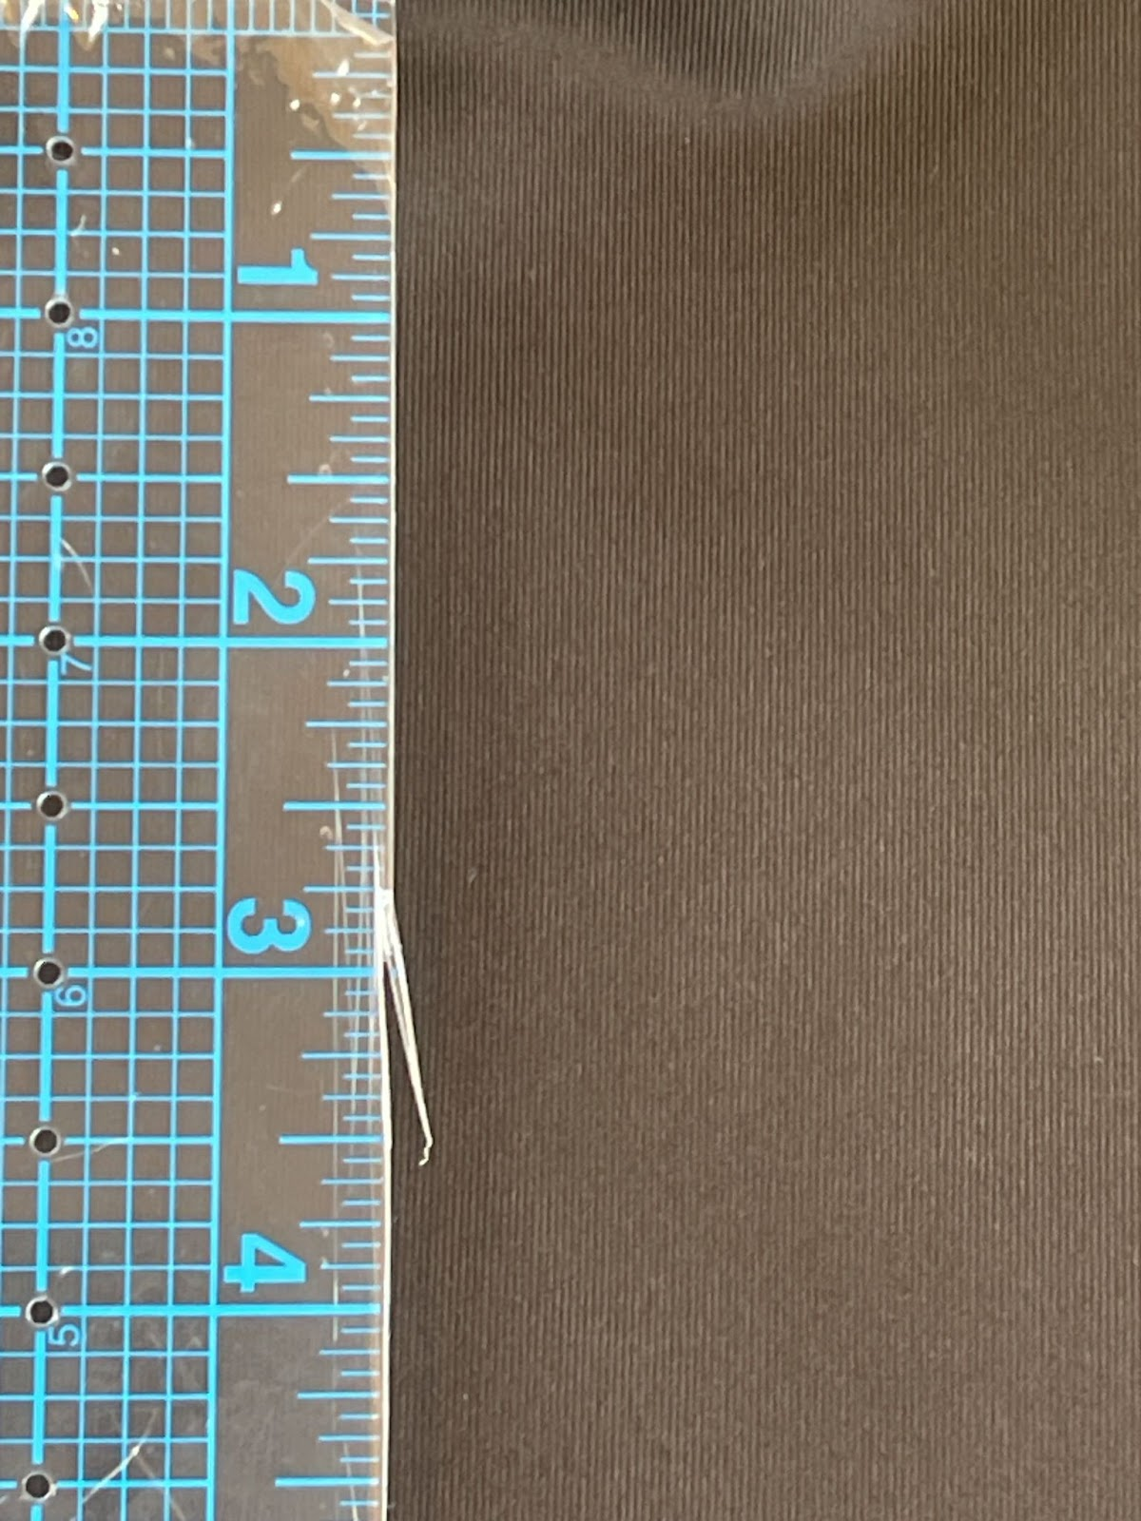(d)(e)
Figure 8. The five fabrics selected for textile testing in order from left to right: (a) Ribbed Spandex Fabric, (b)Spacer with wicking, (c)Superflex heavy compression fabric, (d) Eco-Move Recycled Matte Nylon Spandex Tricot Fabric, and (e)Spacer scuba knit.

Before conducting any measurements, all fabric swatches underwent conditioning in equipment set to standard atmospheric conditions: 21 ± 2oC, 65 ± 2% relative humidity (RH) for 24 hours, following the guidelines of ASTM D1776-20 (Standard Practice for Conditioning and Testing Textiles). Fabric thickness was determined using a Schroeder fabric thickness gauge in accordance with ASTM D1777-96 (Standard Test Method for Thickness of Textile Materials), with 10 replications of the thickness test. Fabric weights were measured following the procedures outlined in ASTM D3776-09 (Standard Test Methods for Mass Per Unit Area (Weight) of Fabric). Samples were taken from each of the fabrics using a GSM circular cutter and weighed on a Schröder fabric weight balance.
Air permeability tests were conducted following the established protocol outlined in ASTM D737-18 (Standard Test Method for Air Permeability of Textile Fabrics). An AVENO AG18B-Automatic Air Permeability Tester configured to maintain 200 Pa pressure difference across the tested fabric, covering an area of 20 cm2 was used. Ten measurements were taken, and the average and standard deviation (SD) for each fabric was recorded.
The tensile strength of each fabric (up to the point of breakage) was assessed using a Tinius Olsen H5KT Benchtop Tester. For each fabric, five swatches measuring 100mm x 200mm were cut in the wale direction, adhering to the ISO 13934 (2014) protocol. These fabric swatches were secured with a load range of 20, a test speed of 100 mm/min, and an extension range of 500. The reported breaking force (N) and elongation percentage until rupture (E) for each fabric represent the average measurement obtained from the five fabric swatches. SPSS version 29 for Mac 19.0 statistical package program was used in the data analysis of the fabrics.

Stage 3: Create
RQ2: How does a prototype design that satisfies NCAA female athlete user-needs look like when incorporating the science between KT tape and CS?
After examining the textile testing results and making a fabric selection for the design of a CS prototype, a range of sleeve sizes were constructed based on the size chart found at bauerfeind.com (Bauerfeind, n.d.) (Appendix D). Using this size chart as a reference, rectangles using the recommended height and width were cut, and then adjusted based on the stretch ratio of each fabric. The researcher used her leg as a reference when creating the first size. Since she wears a size Small, she referred to the suggested CS measurements found in the size chart, cutting down the width of the sleeve due to the high level of stretch of the fabric. The goal was to be able to wrap the sleeve around the leg and create enough pressure on the leg while also being able to overlap the fabric so the velcro would be able to fasten the CS. By using a Kikuhime pneumatic pressure sensor (TT Meditrade, 2023), the optimal pressure was determined to satisfy the above conditions, which was 8-10 mmHG (Gokarneshan 2017). All the other sizes were created by grading up the first size.
There were six total prototypes made. Three for the right leg, and three for the left leg. The sizes included small, medium, and large. After the sleeves were cut out, the first step was fitting and cutting a Velcro strip for adaptable fastening. The Velcro strip that was used was black, 4'' wide and cut to fit each size. It's a sew-on, hook and loop tape fastening nylon fabric tape. The hook part of the velcro was sewn onto either strap of the sleeve, and the loop part of the velcro was sewn onto the other side using a straight stitch (Figure 10). After the velcro was sewn on, in order to finish the edges of the sleeve, 1” fold-over elastic was sewn on using a zig-zag stitch (Figure 9).
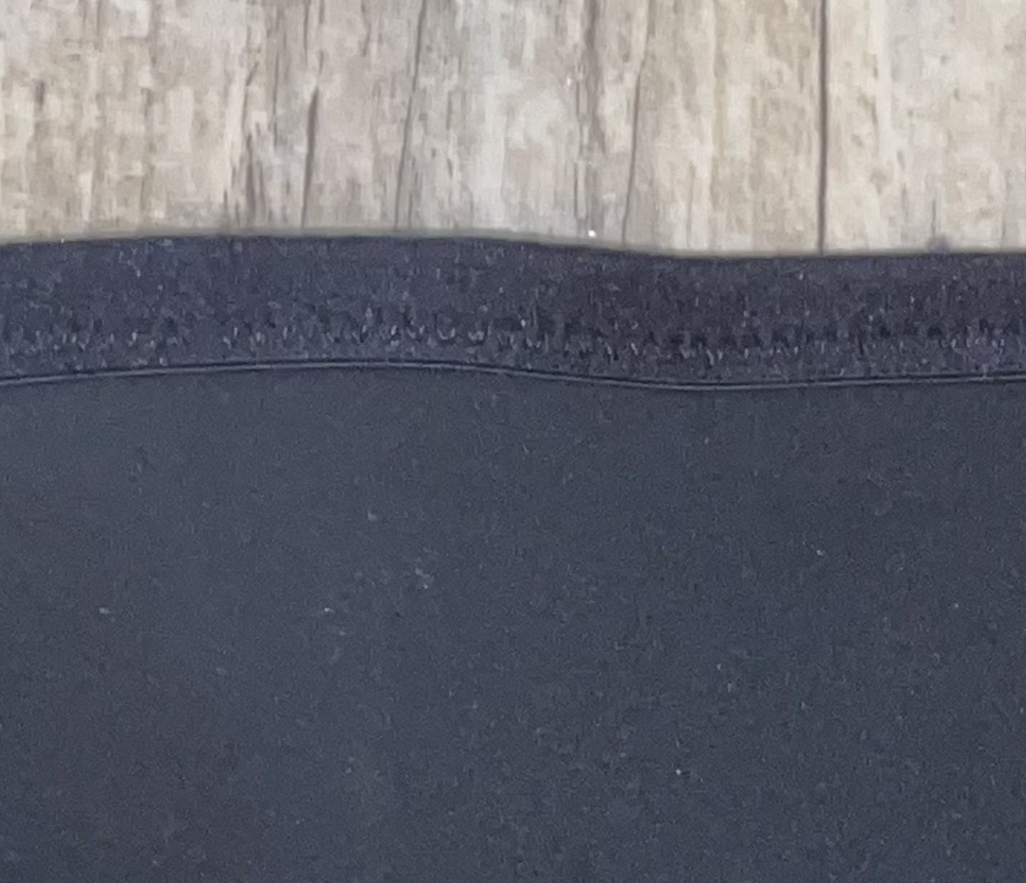
Figure 9. Fold over elastic finish with zigzag stitch

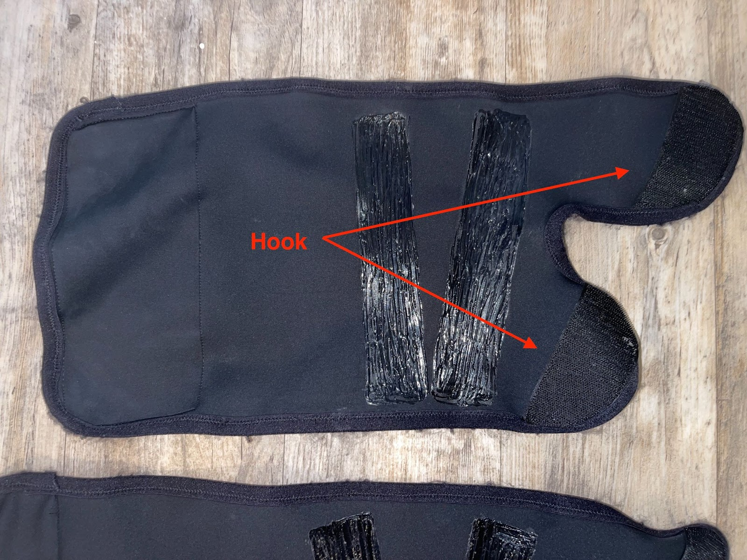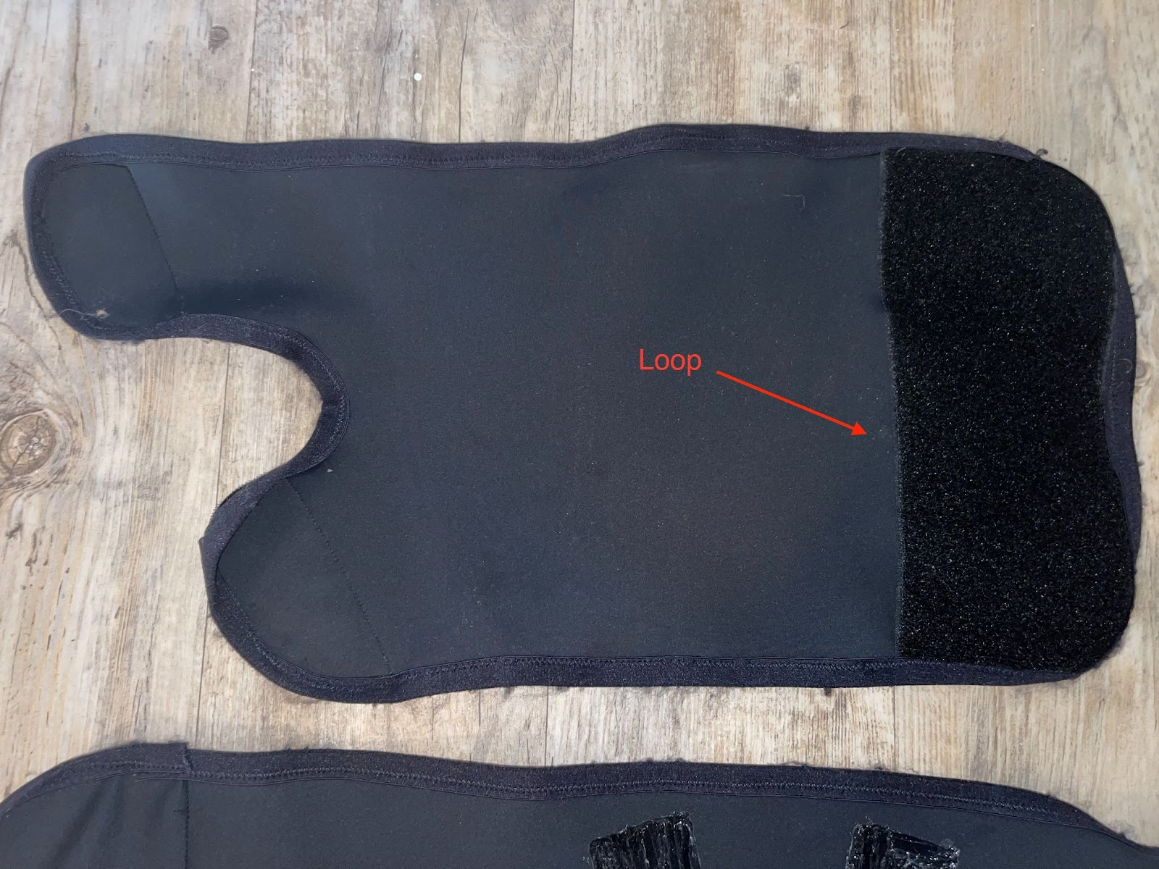
Figure 10. Velcro placement on CS prototype

To mimic KT tape, strips of silicone paint were attached to the inside of the sleeves. The paint mixture was made by combining 4 parts 100% silicone and 1-part low odor mineral spirits (Appendix E). The low odor mineral spirits were slowly added to a small amount of the silicone until the mixture reached a viscosity like that of honey. From there, it was applied using a Q-tip to the inside of the CS in a pattern that mimicked that of the application of KT tape, along the hamstring area, (Figure 11).
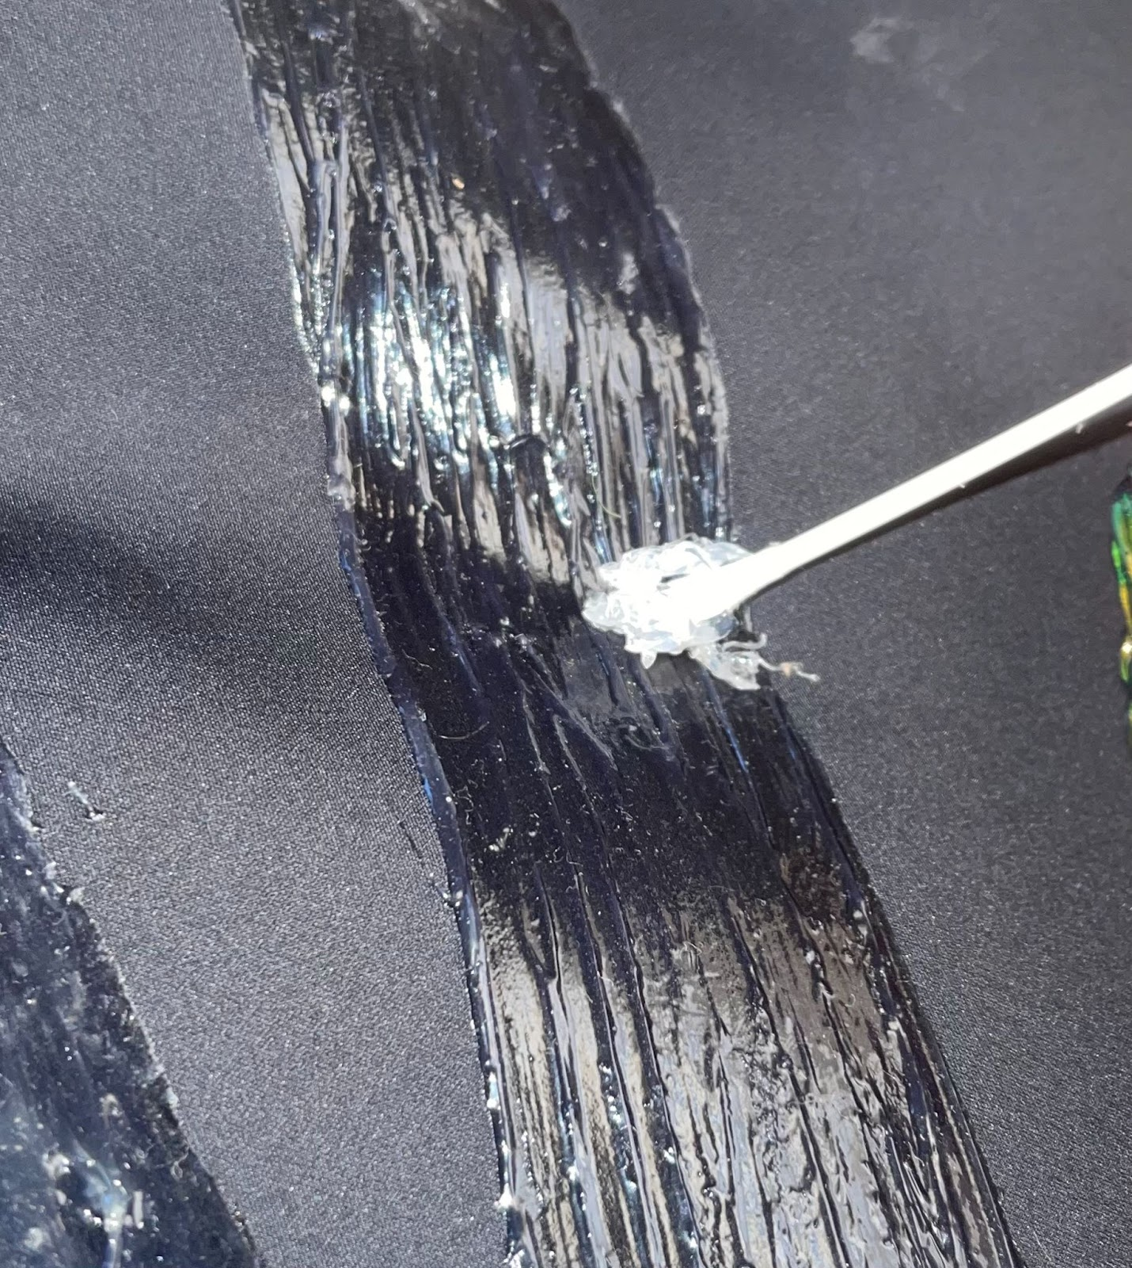
Figure 11. Silicone paint application on the fabric surface inside the CS prototype

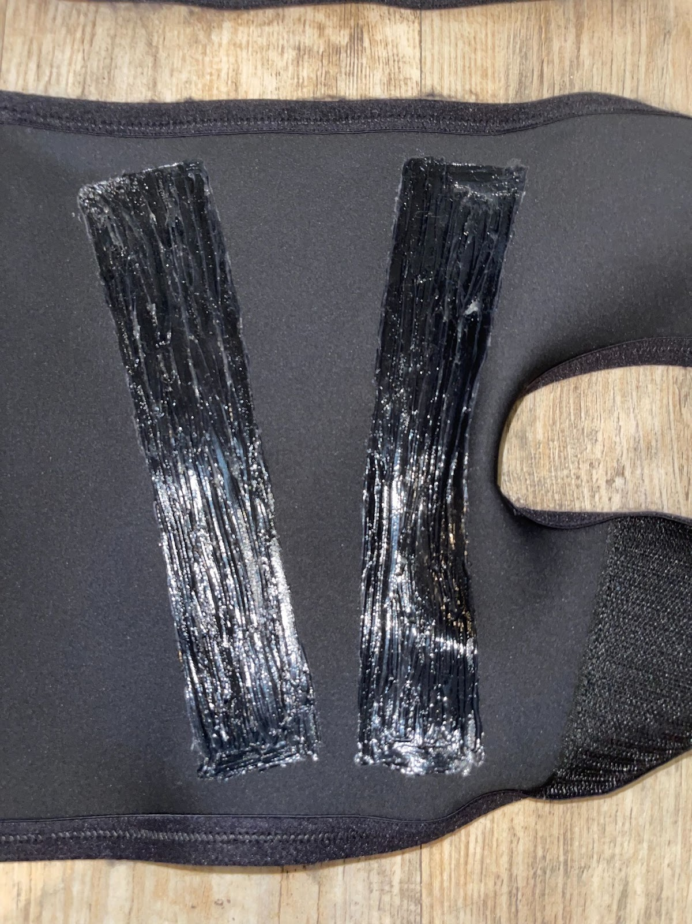
Figure 12. Close-up of Silicone mixture applied to the CS in KT tape hamstring formation

Stage 4: Evaluate
RQ3: How does incorporating the science behind KT tape in a custom-made CS affect the recovery time of DOMS, and to what extent is the prototype successful in reducing the impact of DOMS?
These stages tested the CS prototype design through a series of functional testing, a sprint protocol, and surveys. This was conducted over four different sessions. Session 2 was 24 hours after Session 1. Session 3 was 48 hours after session 1. Session 4 was 72 hours after session 1. The Institutional Review Board (IRB) at University of Delaware approved the survey study with Exempt status on February 29, 2023 (Appendix F).
Eight volunteer participants were selected from those who filled out the Stage 1 survey. All sessions were conducted in Whitney Athletic Center at the University of Delaware. The indoor track of the Delaware Field House was the facility where the sprint protocol was completed. Exclusion criteria included any health problems that would prevent the participants from safely completing the study protocol. The eight participants were coded as numbers 1-8. To compensate the participants for their time and participation in the study they were given a $20 Amazon gift card. The protocol for each session along with the type of data collected are shown in Table 2.

Table 2. Protocol for each session and type of data collected
Steps | Session 1 | Data Collected
1 | Gather consent
2 | Health and Demographic Survey | Age, race
 | Functional Testing
3 | Isometric Hamstring test | Peak force (lbs.) (HamPkFrce)
4 | Isometric Quad test | Peak force (lbs.) (QuadPkFrce)
5 | Sparta single leg jump test | Jump height (in.) (JmpHght) and Max Power (W/kg) (MxPwr)
 | Sprint Protocol
6 | Warm-up
7 | Don CS prototype
8 | Sprint Test
9 | Baseline Soreness Survey | Perceptions of soreness
10 | Comfort Survey | Perceptions of comfort
 | Session 2, 3, and 4
1 | Changes in health Survey
2 | Soreness Survey | Perceptions of soreness
 | Functional Testing
3 | Isometric Hamstring test | Peak force (lbs.)
4 | Isometric Quad test | Peak force (lbs.)
5 | Sparta single leg jump test | Jump height (in.) and Max Power (W/kg)

In step 1, all participants completed an informed consent (IC) that was locked in a secure location according to IRB protocol. This was followed by step 2 which included participants taking a Demographic (Appendix G) and Pre-screening Survey (Appendix H) to disclose possible risk factors of physical activity based on health history and current symptoms.
Steps 3-5 for all sessions consisted of the functional tests of the study (Isometric Hamstring Test, Isometric Quad Test, and Sparta Test). Isometric testing has been a widely utilized method in the field of exercise science to examine muscle function for over 40 years (Wilson & Murphy 1996). It usually entails a maximal voluntary contraction against an unyielding resistance—in this case, a handheld dynamometer that monitors the applied force—performed at a given joint angle. It is common practice to record both the maximum force and the force development rate. In both single and multi-joint test procedures, these tests have generally demonstrated great reliability (Wilson & Murphy 1996).
A hand-held dynamometer is a portable device used to measure muscle strength and force exertion. It typically consists of a handle with a force sensor mechanism at one end. The force sensor may utilize various technologies such as strain gauges or load cells to detect the amount of force applied to it (Wikholm & Bohannon, 1991). The measurement obtained from a handheld dynamometer in pounds represents the amount of force exerted by a muscle or group of muscles during a specific movement or task. The instrument used for this study was a MicroFET 2 wireless handheld dynamometer (Figure 13). The Single Leg Sparta Jump Test is a specific assessment used by Sparta Science to evaluate an athlete's movement patterns and identify their dominant characteristics within each leg (Kundu et al., 2022).
The data collected during the functional tests of Session 1 were compared to data collected during sessions 2, 3, and 4. Data from each functional test was associated with its own hypothesis.
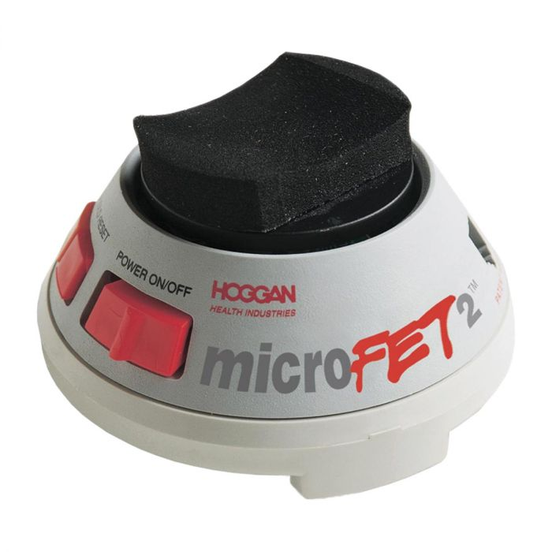
Figure 13. MicroFET 2 Wireless handheld dynamometer (Physioparts.com)

The first test within the functional testing sequence was the Isometric Hamstring Test. The data collected was used to test the following hypothesis:
H1: The leg that the participant wears the CS on will result in an overall higher hamstring peakforce average by Session 4 than the control leg.
The Isometric Hamstring Test measures the hamstring peak force which refers to the maximum amount of force that the hamstrings can generate during a specific movement or contraction of the leg. Figure 14 demonstrates the test which measured the hamstring peak force in each of the participants’ legs. To measure this, the following directions were executed:
- In a prone position, the participant had to bend the knee to around 90 degrees flexion.
- The hip and tibia were internally rotated while stabilizing the thigh down firmly on the table.
- The handheld dynamometer was positioned proximally in the direction of force into knee extension.
- The isometric test was performed at about 90 degrees to assess hamstring strength.
- A countdown was verbalized to the participant counting down from three, and after 1, the researcher said “go” and the participant pulled with max effort for three seconds.
- The test was repeated 3 times and the average of the three were taken. The peak maximal voluntary isometric contraction (peak force) was recorded in pounds (lbs.).
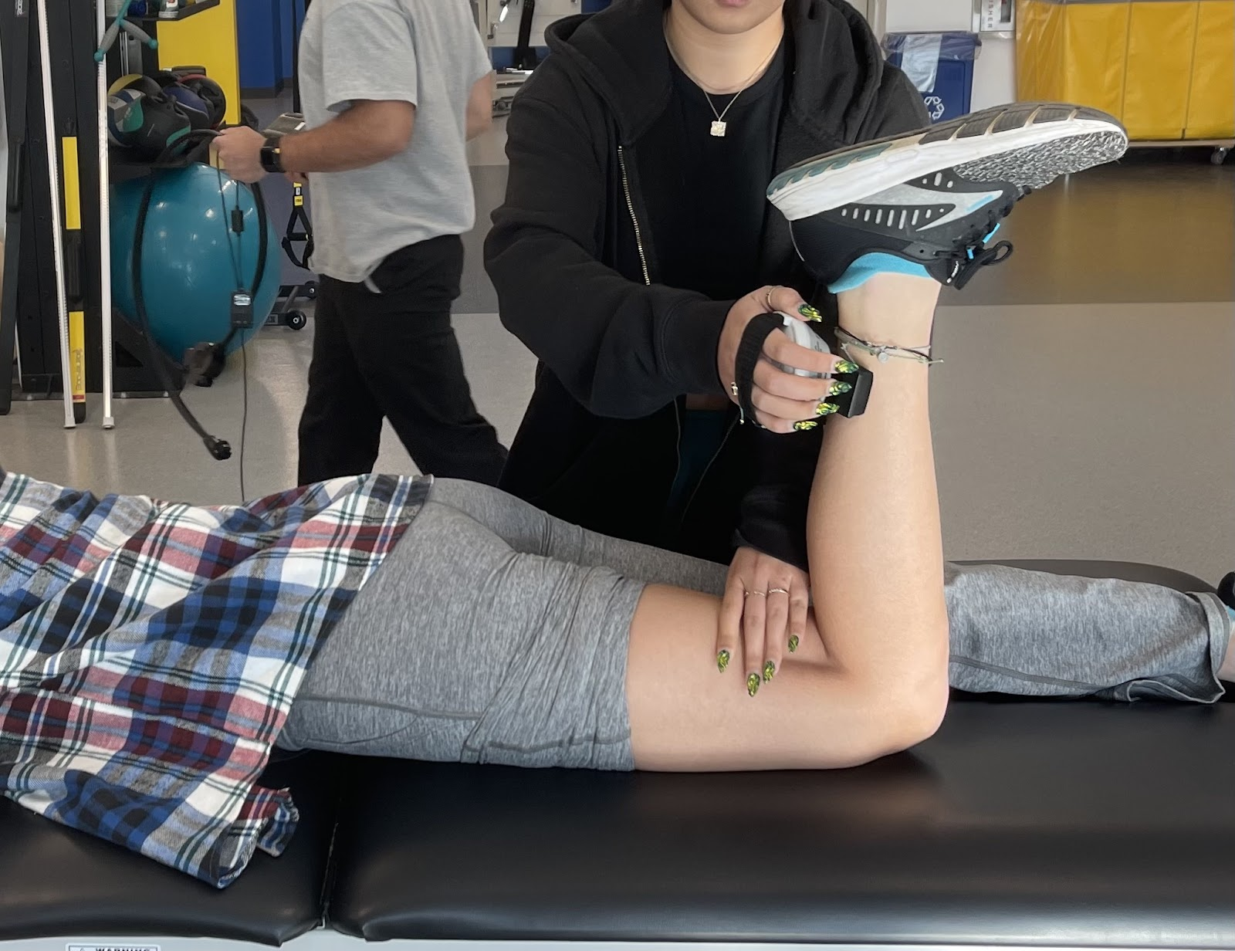
Figure 14. The researcher is measuring Hamstring Peak force on a volunteering participant

The second functional test that was performed was the Isometric Quad Test. The data collected was used to test the second hypothesis:
H2: The leg that the participant wears the CS on will result in an overall higher quad peakforce by Session 4 than the control leg.
The Isometric Quad Test measures the quad peak force which refers to the maximum amount of force that the quad muscles can generate during a specific movement or contraction of the leg. Figure 15 demonstrates the second functional test which measures the quad peak force of each of the participants’ legs. To measure this, the subsequent steps were followed:
- Sitting down, the participant bent the knee to about 90 degrees.
- The hand-held dynamometer was placed proximal to the direction of force which was outward knee extension.
- The hand that was not holding the dynamometer on the quad was placed closer to the knee to stabilize the leg, so it didn’t turn inward or outward.
- The isometric test was performed at 90 degrees to assess quad strength related to sprinting.
- A countdown was verbalized to the participant counting down from three, and after 1, the researcher said “go” and the participant pulled with max effort for three seconds. The researcher ensured that the participant maintained the joint angle throughout the contraction.
- The test was repeated 3 times and the average of the three were taken. The peak maximal voluntary isometric contraction (MVIC) (peak force) was recorded in pounds (lbs.).
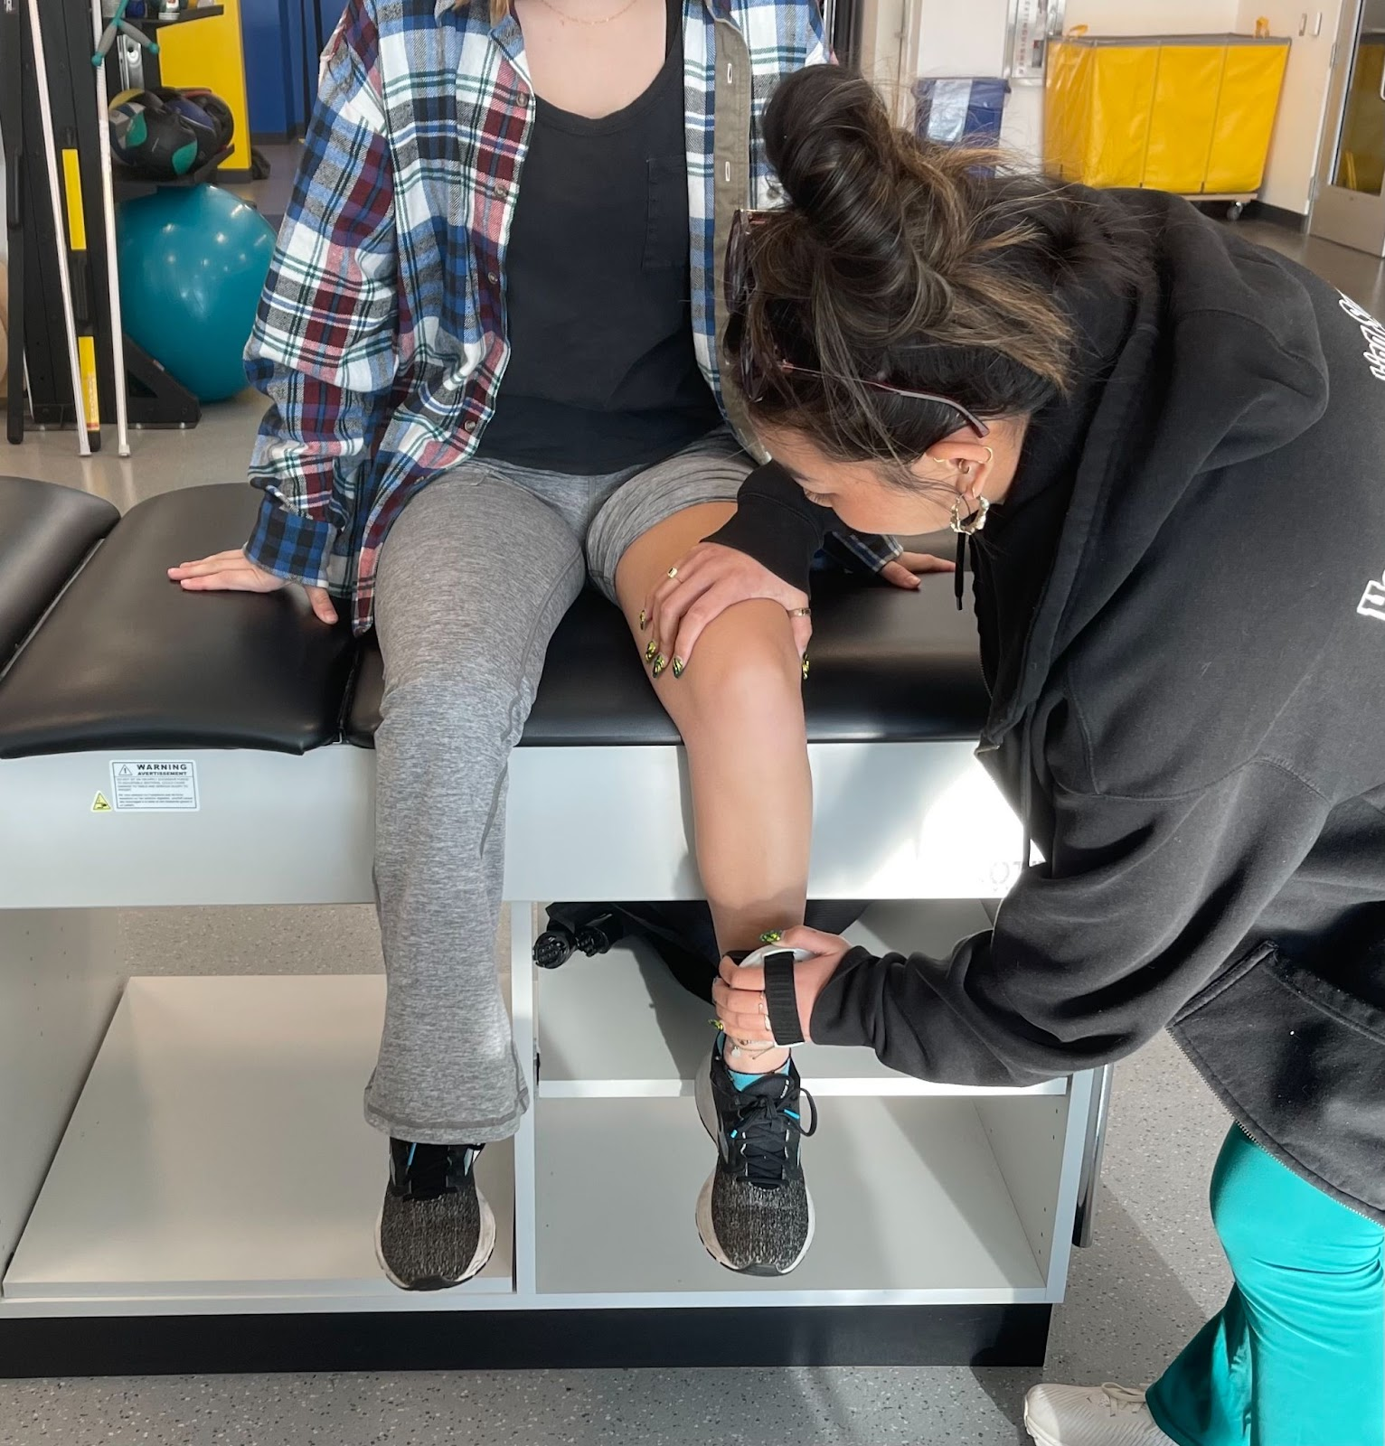
Figure 15. Researcher is measuring Quad Peak force on a volunteering participant

The Sparta Single Leg Jump Test measured the participants’ jump height in inches and max power in a power-to-weight ratio (W/kg). W/kg is used to measure the amount of power that is generated (Kundu et al., 2022). The participant stepped onto the Sparta force plate with both feet (Figure 16). The first action the participant was prompted with was to balance on their right leg. Then they were asked to prepare to jump by putting their arms up. Once the screen prompted the participant to jump, the participant swung their arms down and jumped by taking off and landing on their right leg. After successfully landing on their right leg, they balanced on both feet for a couple of seconds before being prompted to balance on their left leg. They repeated the same steps that they followed for the right leg. This protocol was repeated one more time for each leg. The results presented the researcher with the jump height of each individual leg.
The data collected pertaining to the participants’ jump height was used to test the third hypothesis:
H3: The leg that the participant wears the CS on will result in an overall higher jump height by session 4 than the control leg.
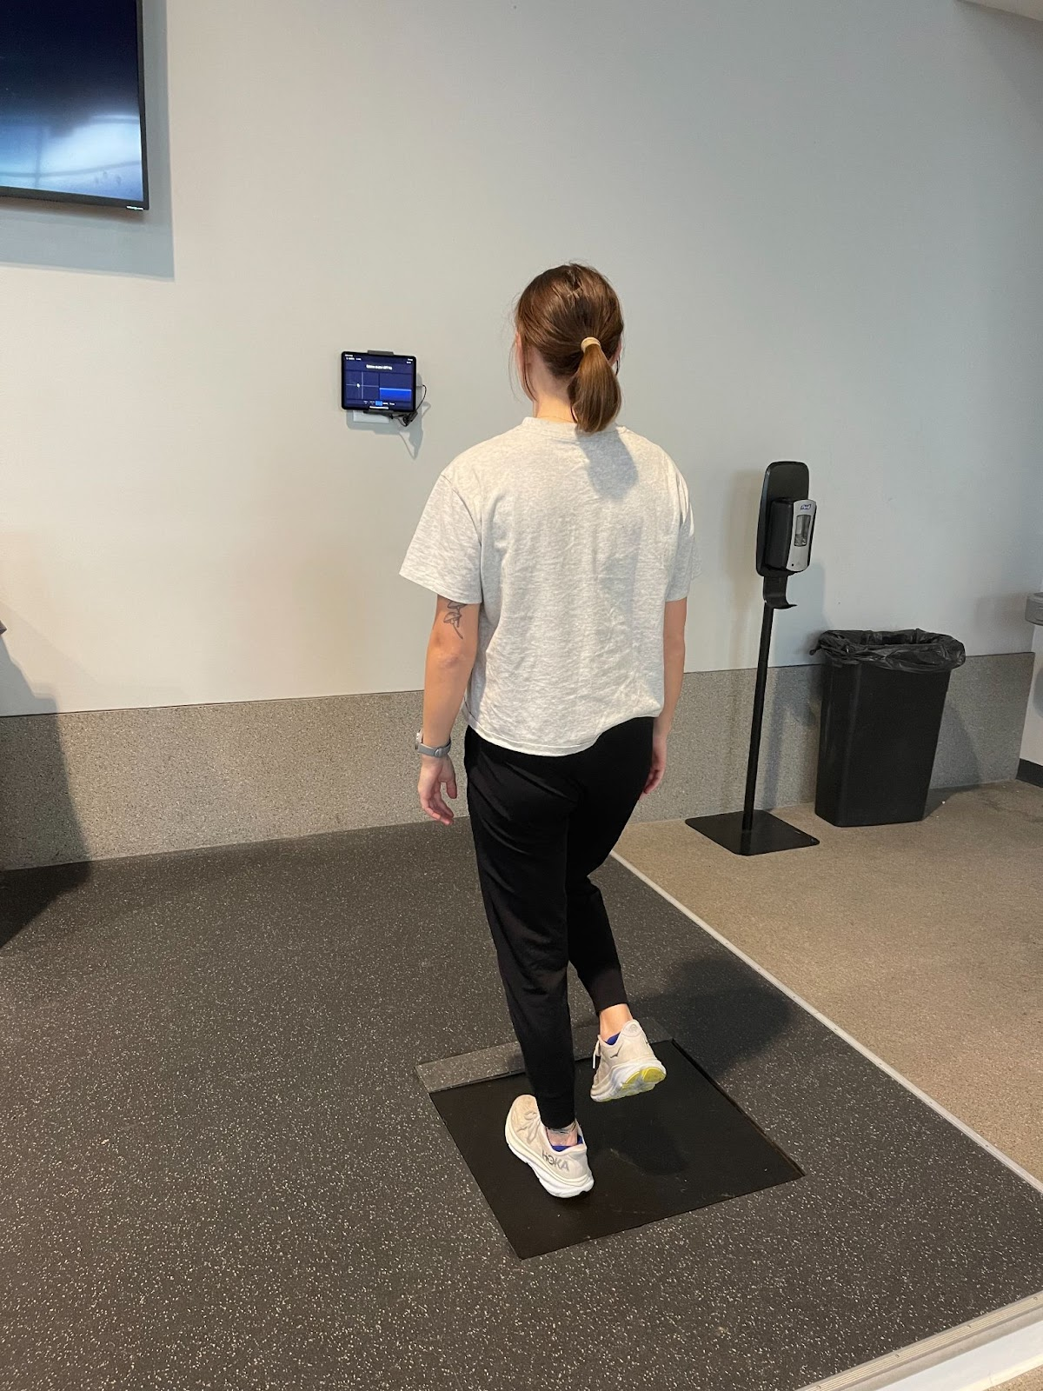
Figure 16. Participant completing single leg test with Sparta software

The data collected pertaining to the participants’ max power was used to test the fourth hypothesis:
H4: The leg that the participant wears the CS on will result in an overall higher max power by session 4 than the control leg.
After these functional tests were completed, steps 6-8 outline the Sprint Protocol. Step 6 prompted the participant with a proper warm-up. It mimicked that of an adapted track and field warmup. The participants self-paced a five-minute jog that was followed up with some dynamic stretches such as ankle circles, arm circles, and trunk circles. The participants then did 20 seconds each of high knees, butt kickers, A-skips, and B-skips in place (Appendix I). After warming up, the participants complete step 7 by donning the CS prototype on the leg that was randomly assigned to them (Figure 18). The other leg acted as a control. The application of a randomized within-subjects design reduced the impact of variations in exercise and activity patterns between subjects (Folppe et al., 2006).
The way the leg was assigned was by having a computerized random number generator pick a number between 1-10. This was repeated 8 times, once for each participant. If it picked a number between 1-5, the participant was assigned the left leg. If it picked a number between 6-10, the participant was assigned the right leg. The CS size was determined by asking the participant what leggings size they typically wore. If the participant tended to wear a size small, then they were given the size small CS.
The compression of the CS was measured using the Kikuhime pneumatic pressure sensor (Figure 17). The probe was placed under the CS in the middle back of the leg at each session, to ensure the pressure on the leg is constant between the sessions.
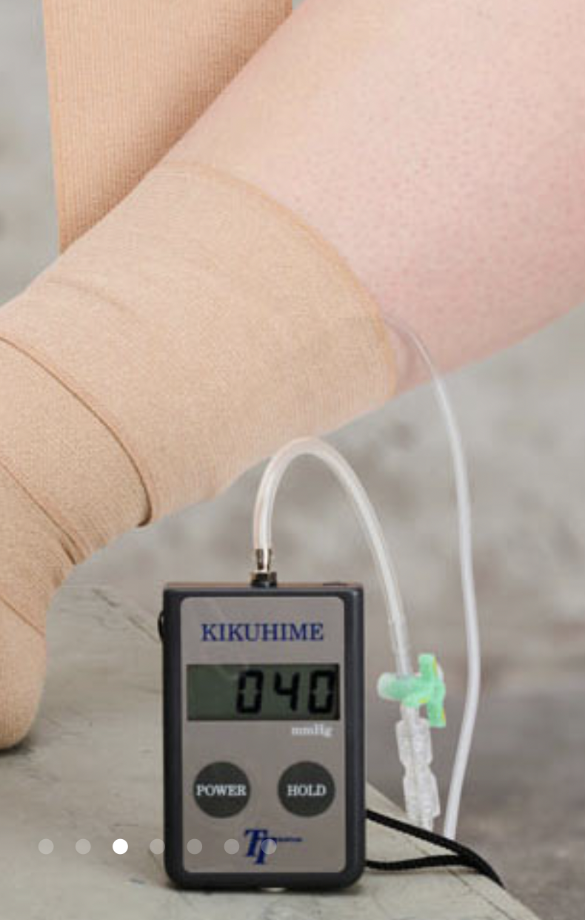
Figure 17. Kikuhime pneumatic pressure sensor (researcher’s image)

The participant then completed Step 8 which was the Sprint Test that was created based on the review of literature, past studies that have investigated DOMS mitigation, as well as the researcher’s background as a former NCAA track and field athlete. By following the layout of a high-intensity interval training (HIIT), the Sprint Test included the participant running at maximum speed for 15 repetitions of 30 meters sprints. Each sprint departed every 65 seconds. A stopwatch was used to ensure that every sprint was within similar range. After the sprint protocol was complete, the participants squatted to a 90-degree angle to engage the leg muscles and held this position for 10 seconds. They then completed Steps 9 and 10 by filling out a Soreness Survey that consisted of 10 questions, and a Comfort Survey (Appendix J) that consisted of 8 questions that prompted questions about the fabric feel and wearing experience of the CS.

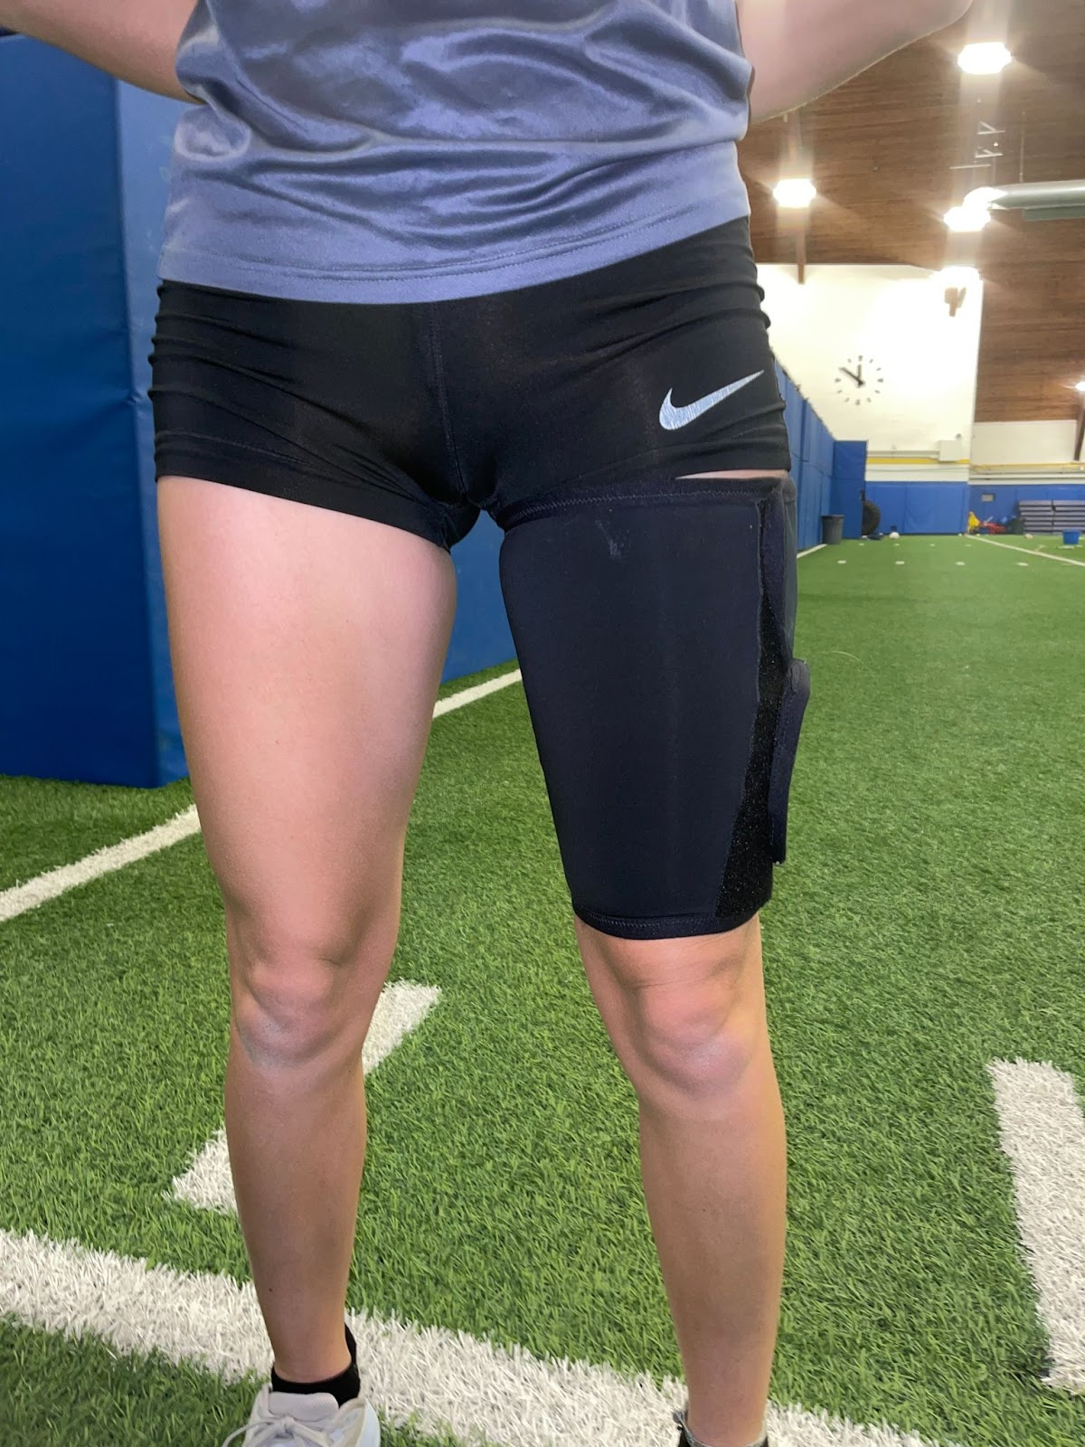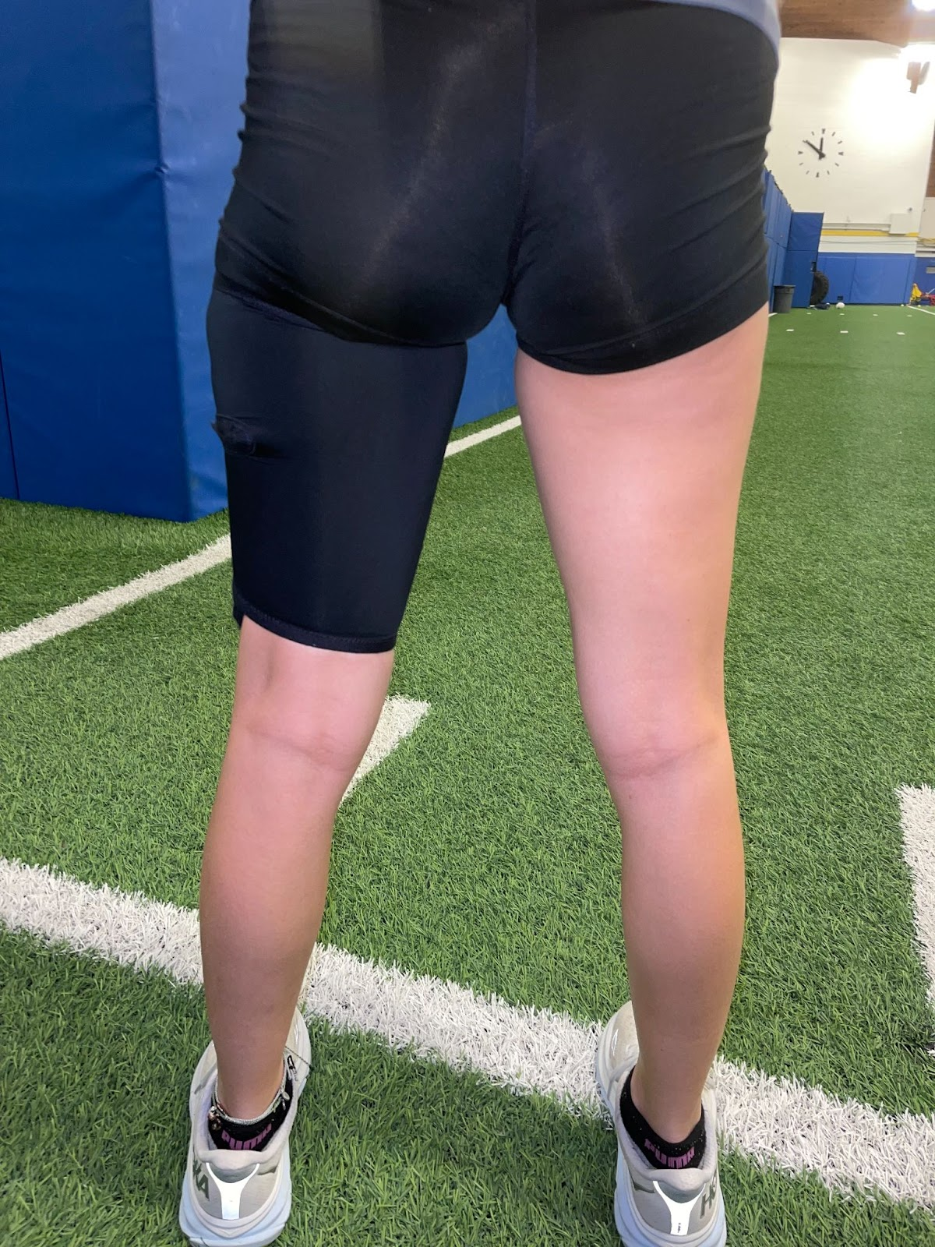
Figure 18. Front and back view of CS on participant

3.5 Stage 5: Assess
RQ3: How does incorporating the science behind KT tape in a custom-made CS affect the recovery time of DOMS, and to what extent is the prototype successful in reducing the impact of DOMS?
For Step 1 of sessions 2, 3, and 4, all participants were asked to fill out a Changes in Health Survey (Appendix K) to ensure they were in similar health to when they completed the Sprint Protocol. Step 2 consisted of a Soreness Survey that was consistent across the three sessions (Appendix L). The data from the Soreness Survey were used to test the fifth hypothesis:
H5: The participant will have a perception of less soreness in the leg that wore the CS compared to the control leg by Session 4.
All the Survey and field data was recorded and stored through University of Delaware RedCap clinical data management system. The variations in data between the four sessions of all participants were compared using Excel and SPSS software, version 29. This helped to determine if there were any significant differences or perceived differences between the effect of CS on muscle soreness (as DOMS mitigation) on the leg wearing the CS and the control leg.

RESULTS

Stage 1: Specify
RQ1: What are the user-needs of female NCAA athletes for CS design aimed at reducing hamstring injuries and recovery time from DOMS?
The demographic data of the 36 respondents to the User-Needs Survey were gathered from questions 1-7. The data showed that 40% of the respondents were between the ages of 22-23, 23% were between the ages 18-19, 35% were between the ages of 20-21, and 2% were between the ages of 24-25. 76% of the respondents were current NCAA athletes, 6% were not, and 19% graduated 1-2 years ago from being an NCAA collegiate athlete. The 6% who were not, did not complete the rest of the Survey since this study was designed to look at NCAA athletes, and their responses to the previous questions were eliminated. In terms of experience in their sport, 4% had 1-2 years of experience, 40% had 3-6 years of experience, and 46% had 7+ years of experience. 88% of the respondents said they had or currently have an injury related to their sport, and 12% did not.
Question 6 asked respondents for sports related injuries that they’ve had in the past or currently have to see what the most prevalent injuries are within this set of respondents. The most common injuries mentioned were “shin splints” and “ankle injuries” accounting for 14.04% of the responses. “Hamstring strains” and “stress fractures” both account for 10.53% of the responses. “Tendonitis” accounted for 8.77% of the responses. “Hip” injuries, and “back problems” and “patellar tendinitis” accounted for 7.02% of the responses. “Quad strain” accounted for 5.26% of the responses. “Knee injuries” and “tibia stress reaction” accounted for 3.51% of responses. “Calf strain”, “concussion”, “shoulder” injury, “labrum tear”, and “bone bruising” accounted for 1.75% of responses.
Questions 8-14 surveyed the respondents’ experience with DOMS in their hamstrings. 85% of the respondents expressed that they have experienced DOMS in their hamstrings following training/ competition, and 15% did not. Question 9 asked if the presence of DOMS has ever been a direct/indirect cause of an injury to your hamstring, and 17 % responded yes, 66% said no, and 17% said they weren’t sure.
Questions 10 and 11 were qualitative questions aimed to learn more about the respondents’ experience with DOMS specifically in their hamstring muscles. Question 10 asked after what kind of workouts respondents are MOST likely to experience DOMS in their hamstrings. The most frequent answer was “weight lifting” and “short sprints” accounted for 36.67% of the responses. “Long sprints” accounted for 23.33% of the responses, and “jumping” accounted for 3.33% of the responses. Question 11 asked respondents what workouts are they LEAST likely to experience DOMS in their hamstrings? (ie: drill work, shakeouts, etc.). “Shakeouts” accounted for 50% of the responses. “Drills” and “long runs” accounted for 15.70% of the responses. “Long sprints” accounted for 10.53% of the responses. “Jumping” “weight lifting”, and “cross training” accounted for 2.63% of the responses.
Question 12 asked what the longest period of time they had experienced DOMS in their hamstring muscles after a workout or competition (days). 5% said a few hours, 38% said 1-2 days, 50% said 3-4 days, 8% said 5-6 days, and 0% said 7+ days. Question 13 asked the respondents to rate on a scale of 1 to 10, with 1 being extremely mild and 10 being severe, the severity of hamstring DOMS they’ve experienced? The average response was 5.3, with a min of 3 and the max of 9.
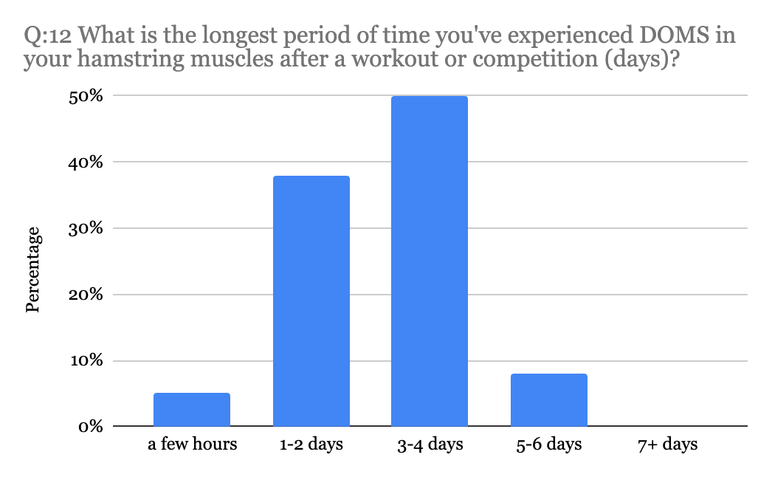
Figure 19. Distribution of responses to Question 12

Question 14 asked the respondents about their biggest challenge during practice when experiencing DOMS in the hamstrings. Multiple answers were able to be selected for this question, and there were a total of 61 answers recorded. The most selected answer was “feeling more prone to injury” at 40% followed by “consistency at practice “(hitting the right time) at 38%, “being able to recover between reps” at 35%, “running/ jumping with correct form” at 20%, “lack of motivation to complete the workout” at 15%, and 5% responded “other”.
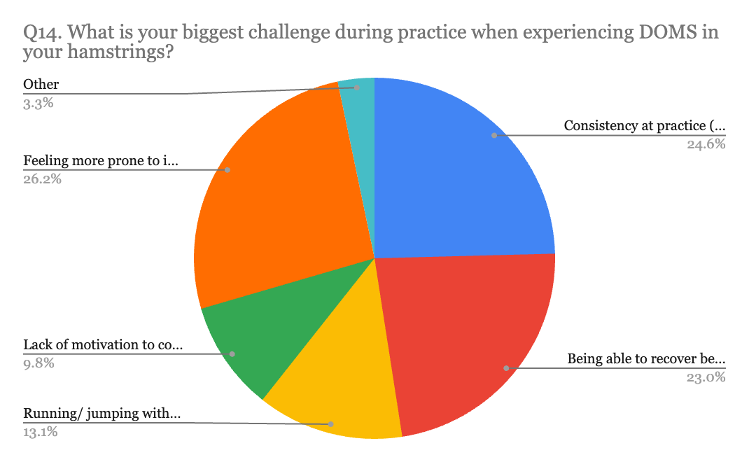
Figure 20. Distribution of responses to Question 14

Questions 15-21 asked the same sequence as the previous six questions but were focused on the quadricep muscles. Even though this study was concentrated on the hamstring muscles, inquiring about the quad muscles gave a good comparison of the effects of DOMS. Question 15 found that 79% of respondents had experienced DOMS in their quads after training/ competition, and 21% had not. In question 16, 10% responded that the presence of DOMS has been a direct/indirect cause of injury to their quad. 71% marked this wasn’t the case, and 19% were not sure.
Questions 17 and 18 were very similar to questions 10 and 11 where the only difference was that the respondents were being asked about their quad muscles. Question 17 asked what kind of workouts are they MOST likely to experience DOMS in their quad muscles? “Weightlifting” had the highest frequency of responses at 48.57%. “Short sprints” accounted for 31.43% of the responses. “Long sprints” accounted for 14.29% of responses. “Functional training” and “jumping” both accounted for 2.86% of the time. Question 18 asked respondents during which workouts they’re least likely to experience DOMS in their quads. “Shakeouts” accounted for 45.45% of the responses. “Drills” accounted for 15.15% of the responses. “Long runs” accounted for 12.12% of the time. “Short sprints” accounted for 9.09% of the responses. “Jumping” accounted for 6.06% of the responses. “Long sprints”, “hills”, “cross training”, and “recovery week” all accounted for 3.03% of the responses.
Question 19 (Figure 21) asked what the longest period was that they’ve experienced DOMS in their quad muscles after a workout or competition (days). 3% responded “a few hours”, 32% responded 1-2 days, 50% responded 3-4 days, 6% responded 5-6 days, and 9% responded 7+ days. Question 20 asked respondents to rate on a scale of 1 to 10, with 1 being extremely mild and 10 being severe, how they would rate the severity of quad muscle DOMS they’ve experienced. The average response was 5.73 with the minimum being 1 and the maximum being 9.
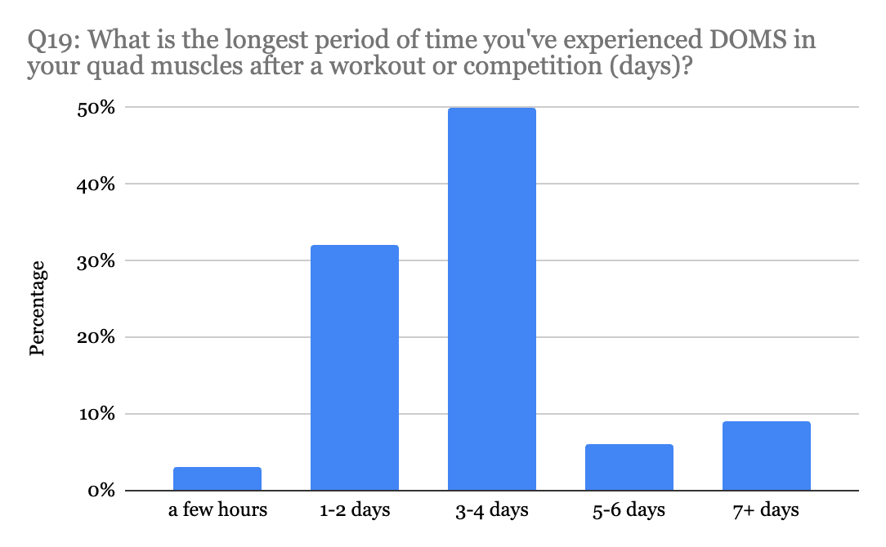
Figure 21. Distribution of responses to Question 19

Question 21 asked about the biggest challenge respondents had during practice when experiencing DOMS in your quad muscles. Multiple answers were able to be selected for this question, and there was a total of 57 answers recorded. “Consistency at practice (hitting the right time)” was recorded the most, at 53%. “Being able to recover between reps” was reported by 32% of respondents. 47% responded that “running/jumping with correct form”, 9% responded it was lack of motivation to complete the workout, 24% responded they felt more prone to injury, and 3% responded (being able to run).
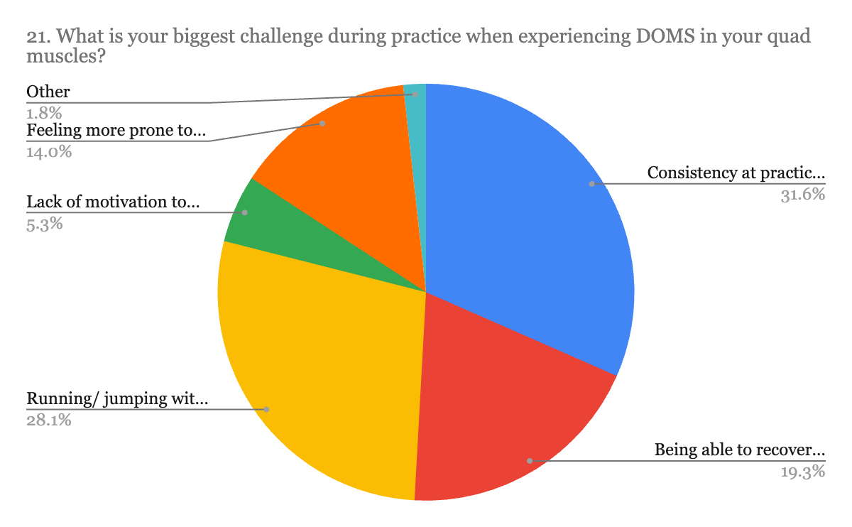
Figure 22. Distribution of responses to Question 21

Question 22 asked about how the participants currently manage or alleviate DOMS in both their hamstring and quad muscles. Multiple answers were able to be selected for this question, and there were a total of 129 answers recorded. 77% responded “rest and recover,” 69% responded stretching, 74% responded foam rolling, 36% responded message therapy, 26% responded over-the-counter pain relievers (ie: ibuprofen), 8% responded cold immersion, and 41% responded other (cupping, heat, and graston). (Figure 23).
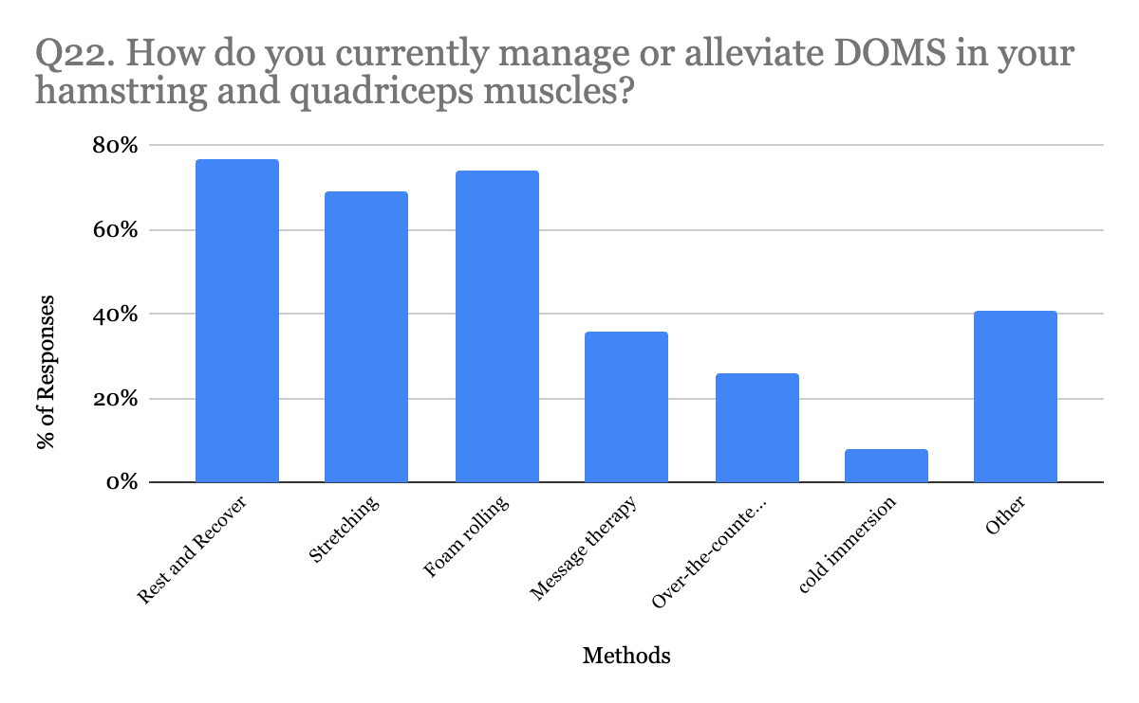
Figure 23. Distribution of Question 22 responses

Question 24 asked respondents to rate the properties of an athletic CS worn around the hamstring/ quad while training/competing, by level of importance, , on a scale of 1-10 “Breathability” averaged 6.48 with an SD of 2.69. “Light in weight” averaged 6.76 and had an SD of 3.1. “Sweat wicking” averaged 5.52, and had an SD of 2.91. “Soft" averaged 5.38, and had an SD of 2.38. “Smooth” averaged 5.71 and had an SD of 2.59. “High level of stretch” averaged 6.62 and had an SD of 3.2. “Durability” averaged 8.38 and had an SD of 2.06.
Question 25 aimed to find any properties that the respondents may find important if they were asked to wear a CS around the upper part of their lower extremities. “None” was recorded 30 times, and “falls down” and “not good” were both mentioned once. When prompted to provide any additional comments, only 2 people responded. One of the comments said, “I found even though stretching hurts, scraping helps to loosen it and get the inflammation down”, and the second respondent that answered stated that:
“In my quads, I find myself having to do more to help my recovery the next day. especially in the mornings after waking up. using a massage gun after a long run or hard practice helps make me feel better in the AM”.

The findings from this survey offer significant insights into the experiences and needs of female NCAA athletes regarding sports-related injuries and Delayed Onset Muscle Soreness (DOMS). With a striking 88% of respondents reporting having experienced sports-related injuries, including common ones like shin splints, ankle injuries, and hamstring strains, the study underscores the substantial risk and prevalence of injuries within this demographic. Moreover, the prevalence of DOMS, particularly in the hamstrings and quadriceps, highlights the importance of understanding its triggers and consequences. The survey reveals that weightlifting and short sprints are primary triggers for hamstring DOMS, impacting athletes' practice sessions by increasing injury susceptibility and consistency issues. To manage DOMS, respondents employ various strategies such as rest, recovery, and foam rolling. Additionally, their preference for compression sleeves prioritizing durability and lightweight design reflects a demand for sports equipment that addresses injury prevention and management needs. Overall, these findings provide valuable guidance for developing targeted interventions, training protocols, and product designs aimed at improving the well-being and performance of female NCAA athletes.

Stage 2: Determine
RQ2: How does a prototype design that satisfies NCAA female athlete user-needs look like when incorporating the science between KT tape and CS?
To determine the material selection of the CS prototype, analysis of the textile testing was conducted. Univariate analysis was run on each individual dependent variable (air permeability, elongation, weight, and thickness). The results are summarized in Table 3.
Table 3. Textile tests Averages and Standard Deviations (SD)
Textile Test | Fabric | Avg (mm/s) | SD
Air Permeability | - Superflex Heavy Compression Spandex | 135.87 | 14.95
 | - Spacer w/ wicking | 313.62 | 18.22
 | - Spacer Scuba Knit | 165.39 | 1.26
 | - Eco-Move Recycled Matte Nylon spandex Tricot Fabric | 1180.41 | 58.34
 | - Ribbed Spandex | 1152.20 | 31.95
 |  | Avg (mm) | SD
Thickness | - Superflex Heavy Compression Spandex | 0.67 | 0.013
 | - Spacer w/ wicking | 0.824 | 0.014
 | - Spacer Scuba Knit | 1.295 | 0.014
 | - Eco-Move Recycled Matte Nylon spandex Tricot Fabric | 0.651 | 0.005
 | - Ribbed Spandex | 0.806 | 0.012
 |  | Avg (g) | SD
Weight | - Superflex Heavy Compression Spandex | 3.321 | 0.023
 | - Spacer w/ wicking | 3.452 | 0.019
 | - Spacer Scuba Knit | 4.138 | 0.038
 | - Eco-Move Recycled Matte Nylon spandex Tricot Fabric | 2.354 | 0.035
 | - Ribbed Spandex | 2.794 | 0.058
 |  | Avg (%) | SD
Elongation | Superflex Heavy Compression Spandex | 463.08% | 0.11
 | Spacer w/ wicking | 263.04% | 0.06
 | Spacer Scuba Knit | 432.84% | 0.1
 | Eco-Move Recycled Matte Nylon spandex Tricot Fabric | 347.14% | 0.05
 | Ribbed Spandex | 440.64% | 0.34

Based on this data, the following observations were made, visualized in Figure 24, that guided the selection of the fabric for the CS prototype:
- The fabric that had the highest air permeability was Eco-Move Recycled Matte Nylon Spandex Tricot Fabric, and the least was Superflex Heavy Compression spandex.
- The fabric that had the highest elongation was Superflex Heavy Compression Spandex, and the least was Spacer with wicking.
- The fabric that had the highest weight was Spacer Scuba knit, and the least was Eco-Move Recycled Matte Nylon Spandex Tricot Fabric.
- The fabric that had the highest thickness was Spacer Scuba Knit, and the least was Eco-Move Recycled Matte Nylon Spandex Tricot Fabric.
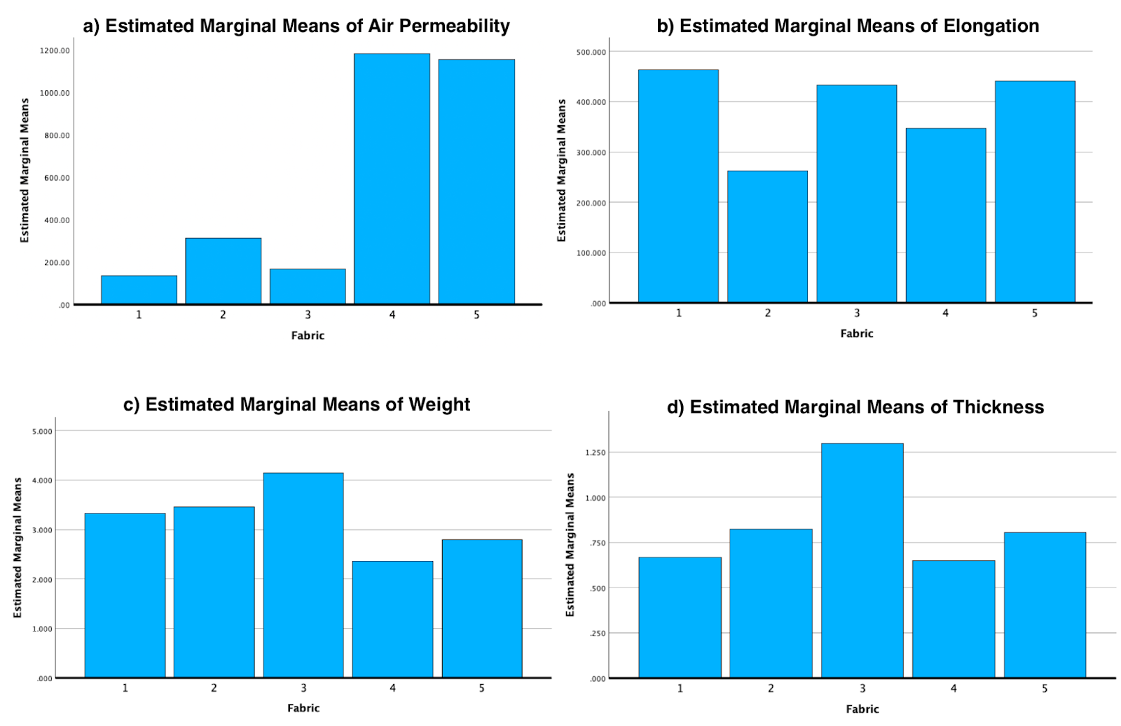
Figure 24. Estimated Marginal Means for a) Air Permeability, b) Elongation, c) Weight, d) Thickness

One-way ANOVA was used to assess the effect of fabric type on air permeability, elongation, weight, and thickness. The independent variable was fabric, and the dependent variables were air permeability, elongation, weight, and thickness. The results are summarized in Table 4.
Table 4. One Way ANOVA analysis of different fabrics and their properties
 |  | Sum of Squares | df | Mean Square | F | Sig.
Permeability | Between Groups | 11274426.2 | 4 | 2828606.558 | 2829.739 | <.001
 | Within Groups | 44822.963 | 45 | 996.066
 | Total | 11319249.2 | 49
Thickness | Between Groups | 2.742 | 4 | 0.686 | 4942.716 | <.001
 | Within Groups | 0.006 | 45 | 0
 | Total | 2.749 | 49
Weight | Between Groups | 9.187 | 4 | 2.297 | 1680.258 | <.001
 | Within Groups | 0.027 | 20 | 0.001
 | Total | 9.214 | 24
Elongation | Between Groups | 138470.286 | 4 | 34617.572 | 123.981 | <.001
 | Within Groups | 5584.336 | 20 | 279.217
 | Total | 144054.622 | 24

The results for air permeability revealed a significant difference between groups (F(4, 45) = 2829.739, p < .001). The between-groups sum of squares was 11274426.231, indicating substantial variability in Air Permeability attributable to differences in fabric types. For thickness, a highly significant effect of Fabric type on thickness was found(F(4, 45) = 4942.716, p < .001). The between-groups sum of squares was 2.742, suggesting considerable variability in thickness across fabric types. Similarly, a significant effect of Fabric type was found (F(4, 20) = 1680.258, p < .001). The between-groups sum of squares was 9.187, indicating notable variability in Weight among different fabric types. The results for Elongation revealed a significant effect of Fabric type on the elongation (F(4, 20) = 123.981, p < .001). The between-groups sum of squares was 138470.286, indicating that the differences in "Elongation" observed between fabric types are likely meaningful and not simply due to random variation.
Since the main goal was to examine the differences between the CS and Control conditions, the primary inference lies in the comparison of these two conditions. Conducting post hoc tests to compare specific fabric types or properties within each condition did not align with the primary research question, which focuses on the effect of wearing compression sleeves overall. Therefore, in this context, the decision not to conduct post hoc tests for the textile analysis was justified, as the main emphasis remains on comparing the physiological effects of wearing compression sleeves versus not wearing them.
The user-needs Survey results highlighted that breathability was one of the more desired traits for a CS. Breathable knit fabrics are usually airy and have high air-permeability measurements, commonly associated with thinner knit fabrics. However, a study conducted by Macrae et al (2011) found that muscle oscillation, the movement of the muscle that happens as the foot hits the ground when vibration ripples through the thigh, was reduced when the participants wore a compression garment that was 4.76 mm thick. Additionally, lower air permeability results indicate that the fabric has tighter weaves or is more densely knit, which can help enhance compression and provide better support to the muscles. This can be particularly beneficial in athletic compression sleeves where the fabric should ideally apply consistent pressure and support to the muscles without allowing excessive airflow that may decrease the garment's effectiveness (Choudhury et al., 2011). Therefore, the fabric with the highest thickness, lower air permeability, and high level of elongation were considered for material selection.

Stage 3: Create
Considering the above stated findings, Spacer Scuba Knit, fabric 3, was chosen for the CS prototype. It had the highest thickness (1.3mm), it had the second lowest air permeability (165.39 mm/s), and a high elongation percentage (432.84%) compared to the other fabrics. Superflex Heavy compression Spandex, fabric 1, also had some notable qualities such as the low air permeability (135.87mm/s) and the high level of stretch presented by the high percentage of elongation (463.08%). After further evaluating these two fabrics, the better hand feel of the Spacer Scuba knit was key to ultimately choose it to create the CS prototypes. Figure 25 shows the specs of the final prototype design that was created using the Spacer
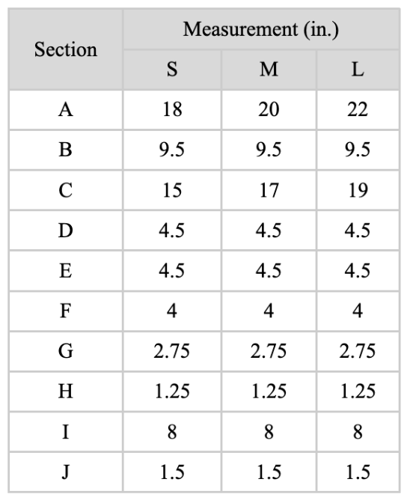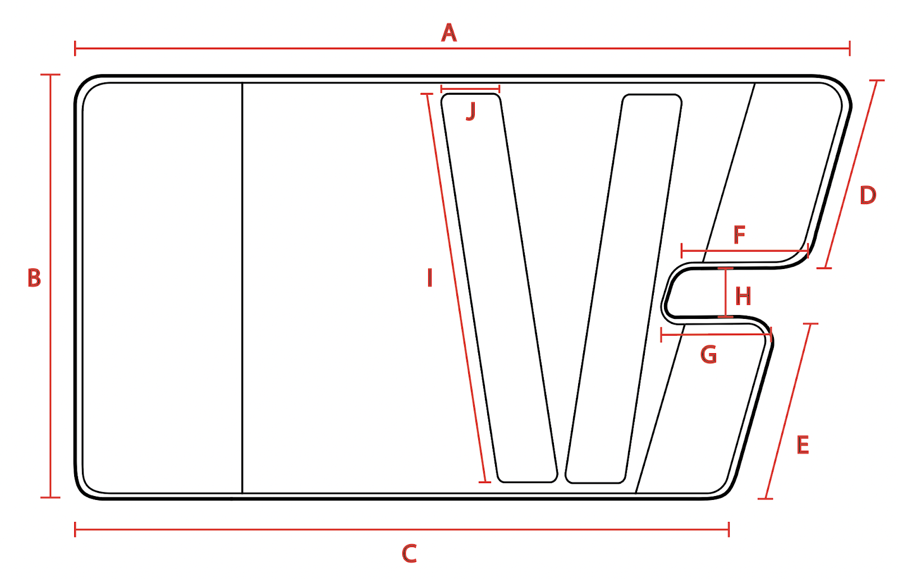
Figure 25. Technical drawing of the final CS prototype and the corresponding measurements.

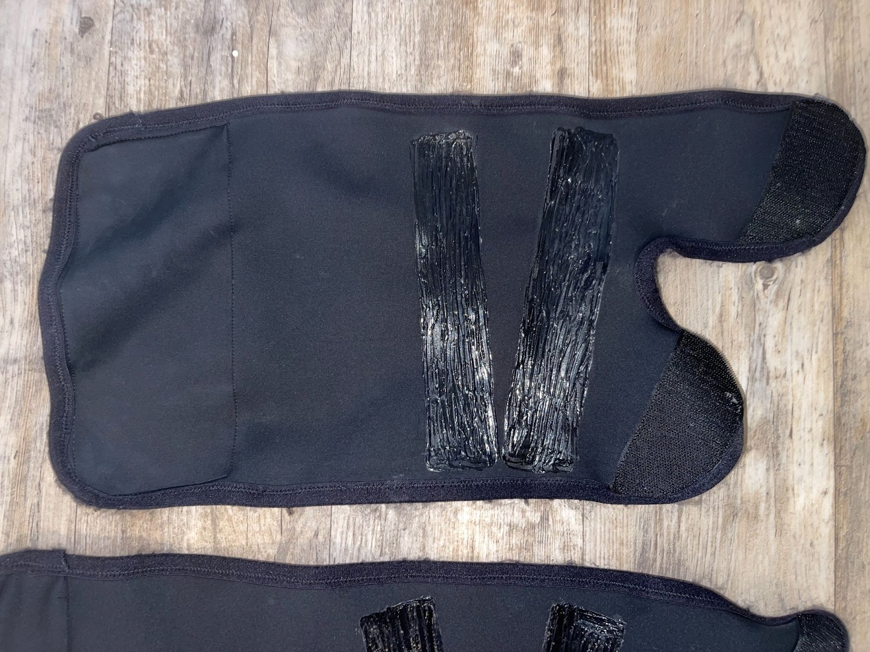
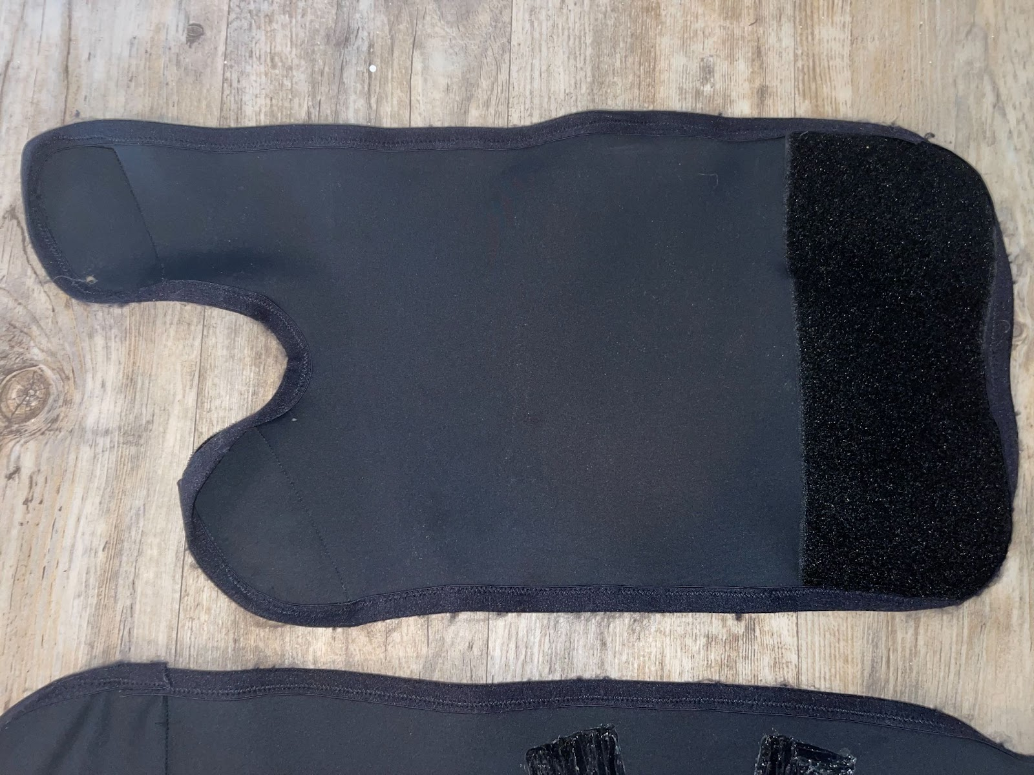
Figure 26. Back (top) and front (bottom) of assembled CS prototype for right leg

Stage 4: Evaluate
RQ3: How does incorporating the science behind KT tape in a custom-made CS affect the recovery time of DOMS, and to what extent is the prototype successful in reducing the impact of DOMS?
The first set of results from the functional testing, comparing the means of hamstring peak force between the control leg and the CS leg across the four sessions show that a similar pattern occurred between the four sessions for both legs, and highlight the following (Figure 27):
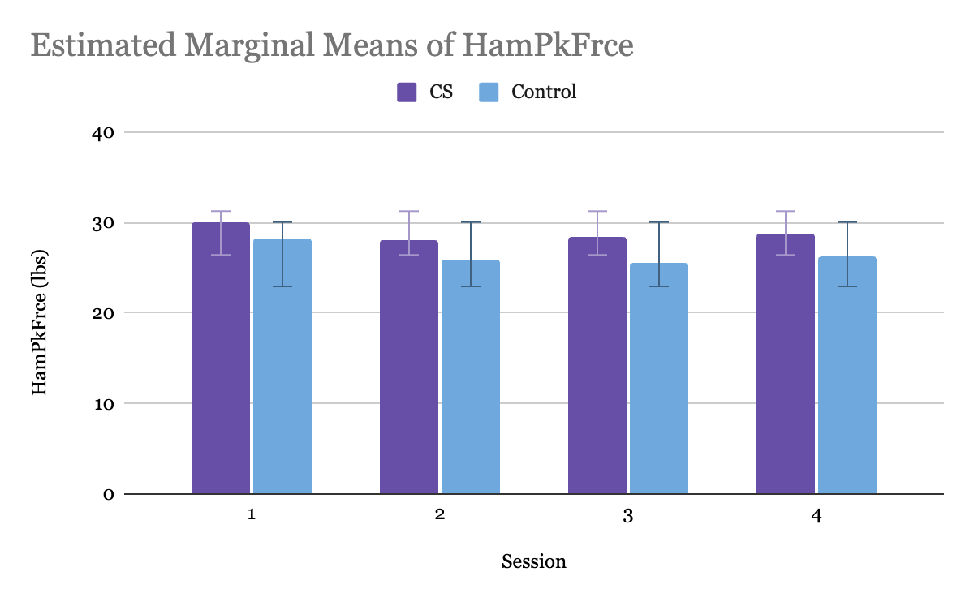
Figure 27. Variations of Estimated Marginal Means of HamPkFrce by Session.

- Between Session 1 and 2: The HamPkFrce for the CS leg decreased by 1.845, and decreased by 2.285 for the control leg.
- Between Session 2 and 3: The HamPkFrce for the CS leg increased by 0.312, and increased by 0.37 for the control leg.
- Between Session 3 and 4: The HamPkFrce for the CS leg increased by 0.384, and increased by 0.7 for the control leg.
- Between Session 1 and 4: The HamPkFrce for the CS leg decreased by 1.149, and decreased by 1.955 for the control leg.
Overall, across all sessions, the mean HamPkFrce decreased slightly less for the CS than the control leg, supporting hypothesis 1 which stated that the CS variable may improve hamstring peak force by Session 4.
However, it's essential to consider factors such as statistical significance, standard errors, and confidence intervals for a comprehensive interpretation. Table 5 shows that no significant differences were found between hamstring peak force between CS leg and control leg. The mean difference of -2.337 for the HamPkFrce measure was calculated by subtracting the mean of the Compression Sleeve (CS) group from the mean of the Control group. In this case, the mean difference represents the difference in HamPkFrce between the CS group and the Control group. Therefore, the mean difference of -2.337 indicates that, on average, the HamPkFrce measure was 2.337 lbs lower in the Control group compared to the CS group. This calculation provides insight into the impact of wearing compression sleeves on HamPkFrce performance.
Table 5. Pairwise Comparison of Hamstring Peak Force Between Control and CS Legs
Measure: HamPkFrce
(I) Leg | (J) Leg | Mean Difference (I-J) | Std. Error | Sig.a | 95% Confidence Interval for Difference
 |  |  |  |  | Lower Bound | Upper Bound
Control | CS | -2.337 | 3.353 | 0.497 | -9.529 | 4.854
CS | Control | 2.337 | 3.353 | 0.497 | -4.854 | 9.529
Note. Adjustments for multiple comparisons were made using the Bonferroni method.

Table 6 presents the results of a repeated measures ANOVA for the variable HamPkFrce, specifically focusing on the within-subjects effects. The within-subjects factor in this analysis is "Time," and there are three levels within this factor. The main effect of "Time" tests whether there are statistically significant differences among the levels of this factor. Across all four tests (Sphericity Assumed, Greenhouse-Geisser, Huynh-Feldt, and Lower-bound), the p-values are all above the conventional threshold of significance (p > .05), indicating that there is no significant main effect of Hamstring on the dependent variable, HamPkFrce. Additionally, the partial eta squared values, which represent effect sizes, are all quite small (around .078), suggesting that the factor or time explains only a small proportion of the variance in HamPkFrce. The interaction between "Time" and "Leg" assesses whether the effect of one variable depends on the level of the other variable. Similar to the main effect, across all tests, the p-values are not significant (p > .05), indicating no significant interaction between Hamstring and Variable.
Table 6. Tests of Within-Subjects Effects for hamstring peak force
Tests of Within-Subjects Effects
Measure: HamPkFrce
Source |  | Type III Sum of Squares | df | Mean Square | F | Sig. | Partial Eta Squared
Time | Sphericity Assumed | 46.456 | 3 | 15.485 | 1.18 | 0.329 | 0.078
 | Greenhouse-Geisser | 46.456 | 2.225 | 20.883 | 1.18 | 0.325 | 0.078
 | Huynh-Feldt | 46.456 | 2.853 | 16.284 | 1.18 | 0.328 | 0.078
 | Lower-bound | 46.456 | 1 | 46.456 | 1.18 | 0.296 | 0.078
Time * Leg | Sphericity Assumed | 2.804 | 3 | 0.935 | 0.071 | 0.975 | 0.005
 | Greenhouse-Geisser | 2.804 | 2.225 | 1.26 | 0.071 | 0.946 | 0.005
 | Huynh-Feldt | 2.804 | 2.853 | 0.983 | 0.071 | 0.971 | 0.005
 | Lower-bound | 2.804 | 1 | 2.804 | 0.071 | 0.793 | 0.005
Error(Hamstring) | Sphericity Assumed | 551.225 | 42 | 13.124
 | Greenhouse-Geisser | 551.225 | 31.145 | 17.699
 | Huynh-Feldt | 551.225 | 39.941 | 13.801
 | Lower-bound | 551.225 | 14 | 39.373

Table 7 presents the results of a between-subjects ANOVA for the variable HamPkFrce, focusing on the effects of the independent variable "leg" on the dependent variable. The intercept term represents the estimated mean of the dependent variable (HamPkFrce) when all independent variables are set to zero. In this analysis, the intercept is highly significant (p < .001), indicating that there is a significant overall effect on HamPkFrce when all other variables are held constant. The large partial eta squared value (.951) suggests that a substantial proportion of the variance in HamPkFrce can be attributed to this intercept term. The main effect of the independent variable "Leg" assesses whether there are significant differences in the dependent variable (HamPkFrce) between the control and CS leg. In this case, the effect of the CS is not significant, as indicated by the non-significant p-value (p = .497).
Table 7. Test of Between-Subjects Effects for Hamstring peak force
Measure: HamPkFrce
Transformed Variable: Average
Source | Type III Sum of Squares | df | Mean Square | F | Sig. | Partial Eta Squared
Intercept | 48942.16 | 1 | 48942.16 | 272.065 | <.001 | 0.951
Leg | 87.399 | 1 | 87.399 | 0.486 | 0.497 | 0.034
Error | 2518.477 | 14 | 179.891

For the Quad Peak Force, Figure 28 displays a visual representation of means between the control leg and the CS leg across sessions, and the following trends can be observed:
- Between Session 1 and 2: The QuadPkFrce for the CS leg decreased by 0.368 and decreased by 0.089 for the control leg.
- Between Session 2 and 3: The QuadPkFrce for the CS leg increased by 0.702 and increased by 1.941 for the control leg.
- Between Session 3 and 4: The QuadPkFrce for the CS leg increased by 0.364 and decreased by 0.955 for the control leg.
- Between Session 1 and 4: The QuadPkFrce for the CS leg increased by 0.698 and increased by 0.897 for the control leg.
Overall, across all sessions, even though the mean QuadPkFrce increased slightly for the CS, the control leg increased more by Session 4. Therefore hypothesis 2 is not supported.
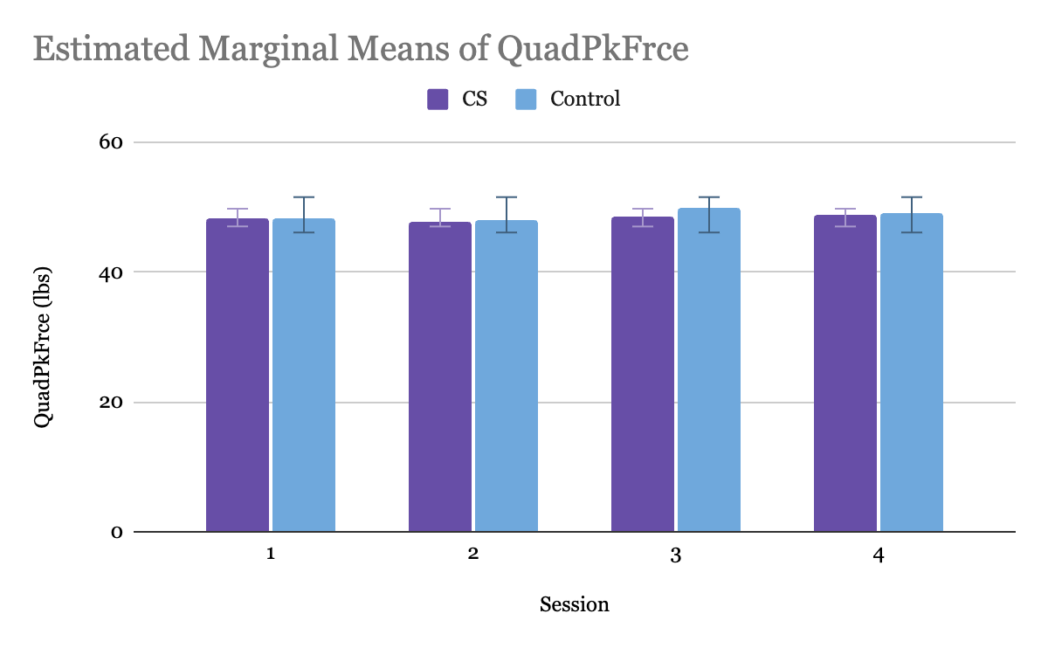
Figure 28. Bar Graph of Variations of Estimated Marginal Means of QuadPkFrce by Session

A detailed comparison of the means, standard errors, and confidence intervals is necessary to draw definitive conclusions regarding the effect of the CS variable on quad peak force. Therefore, pairwise comparisons were conducted to examine the differences in quad peak force between the control and CS legs. Table 8 presents the estimated mean differences, standard errors, significance levels, and 95% confidence intervals for the comparisons. In analyzing the QuadPkFrce measure between the Control and Compression Sleeve (CS) conditions, the mean difference of 0.432 with a standard error of 1.513 suggests a negligible variance between the two conditions. Additionally, the lack of statistical significance (p = 0.779) further supports this conclusion. The confidence interval for the difference (-2.813 to 3.678) encompasses zero, indicating that there is no substantial difference in QuadPkFrce between the Control and CS conditions. Therefore, based on these findings, it can be concluded that the use of compression sleeves does not significantly impact QuadPkFrce compared to the control condition.
Table 8. Pairwise Comparison of Quad Peak Force Between Control and CS Legs
Measure: QuadPkFrce
(I) Leg | (J) Leg | Mean Difference (I-J) | Std. Error | Sig.a | 95% Confidence Interval for Difference a
 |  |  |  |  | Lower Bound | Upper Bound
Control | CS | 0.432 | 1.513 | 0.779 | -2.813 | 3.678
CS | Control | -0.432 | 1.513 | 0.779 | -3.678 | 2.813
Note. Adjustments for multiple comparisons were made using the Bonferroni method
Table 9 presents the results of a repeated measures ANOVA for the variable QuadPkFrce, specifically focusing on the within-subjects effects. The main effect of "Time" assesses whether there are significant differences in QuadPkFrce across different time points.

Table 9. Tests of Within-Subjects Effects for Quad Peak Force
Measure: QuadPkFrce
Source |  | Type III Sum of Squares | df | Mean Square | F | Sig. | Partial Eta Squared
Time | Sphericity Assumed | 19.085 | 3 | 6.362 | 0.321 | 0.81 | 0.022
 | Greenhouse-Geisser | 19.085 | 2.55 | 7.484 | 0.321 | 0.778 | 0.022
 | Huynh-Feldt | 19.085 | 3 | 6.362 | 0.321 | 0.81 | 0.022
 | Lower-bound | 19.085 | 1 | 19.085 | 0.321 | 0.58 | 0.022
Time*Leg | Sphericity Assumed | 5.705 | 3 | 1.902 | 0.096 | 0.962 | 0.007
 | Greenhouse-Geisser | 5.705 | 2.55 | 2.237 | 0.096 | 0.944 | 0.007
 | Huynh-Feldt | 5.705 | 3 | 1.902 | 0.096 | 0.962 | 0.007
 | Lower-bound | 5.705 | 1 | 5.705 | 0.096 | 0.761 | 0.007
Error(Time) | Sphericity Assumed | 832.83 | 42 | 19.829
 | Greenhouse-Geisser | 832.83 | 35.702 | 23.327
 | Huynh-Feldt | 832.83 | 42 | 19.829
 | Lower-bound | 832.83 | 14 | 59.488

Across all four tests (Sphericity Assumed, Greenhouse-Geisser, Huynh-Feldt, and Lower-bound), p > 0.05. This indicates that there is no significant main effect of Time on QuadPkFrce and no significant interaction between Time and Leg.
Table 10 presents the results for QuadPkFrce. The intercept term represents the estimated mean of the dependent variable (QuadPkFrce) when all independent variables are set to zero. In this analysis, the intercept is highly significant (p < .001), indicating that there is a significant overall effect on QuadPkFrce when all other variables are held constant. In this case, the effect of Leg is not significant (p = .779).
Table 10. Tests of Between-Subjects Effects for Quad Peak Force
Measure: QuadPkFrce
Transformed Variable: Average
Source | Type III Sum of Squares | df | Mean Square | F | Sig. | Partial Eta Squared
Intercept | 150997.331 | 1 | 150997.331 | 4121.852 | <.001 | 0.997
Leg | 2.989 | 1 | 2.989 | 0.082 | 0.779 | 0.006
Error | 512.867 | 14 | 36.633

For the Jump Height results, Figure 29 displays the means between the control leg and the CS leg across sessions, and the following trends can be observed:
- Between Session 1 and 2: The JmpHght for the CS decreased by 0.088 and increased by 0.126 for the control leg.
- Between Session 2 and 3: The JmpHght for the CS increased by 0.213 and increased by 0.187 for the control leg.
- Between Session 3 and 4: The JmpHght for the CS increased by 0.212 and increased by 0.038 for the control leg.
- Between Session 1 and 4: The JmpHght for the CS increased by 0.337 and increased by 0.351 for the control leg.
Overall, across all sessions, even though the mean JmpHght increased slightly for the CS, the control leg increased slightly more by session 4. Therefore hypothesis 3 is not supported.
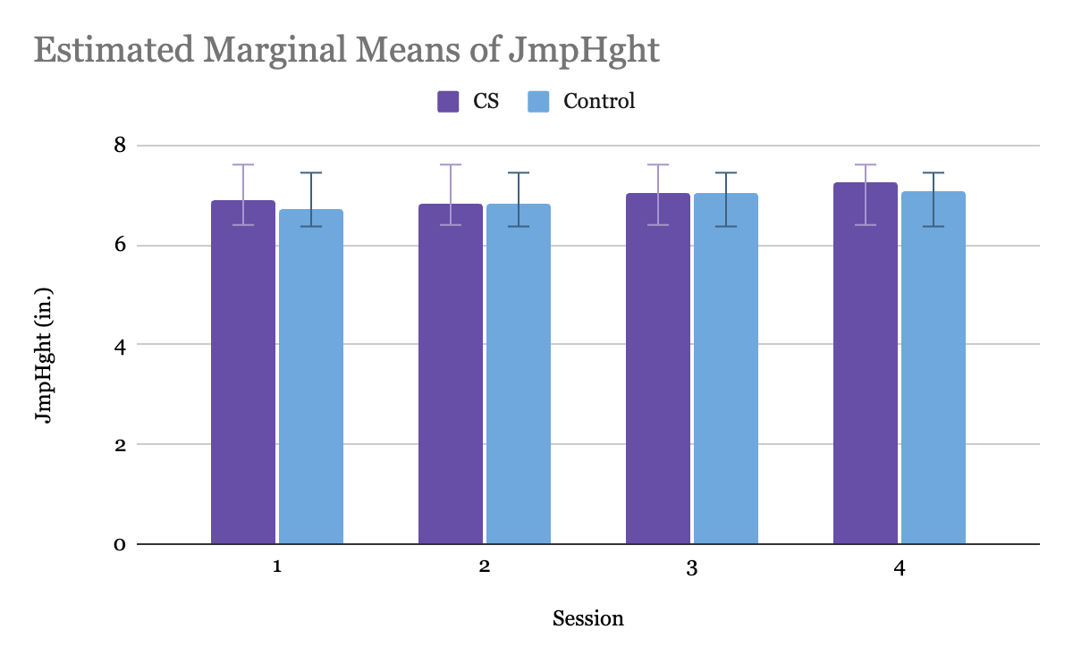
Figure 29. Bar Graph of Variations of Estimated Marginal Means of JmpHght by Session.

Table 11 presents the estimated mean differences, standard errors, significance levels, and 95% confidence intervals for the pairwise comparisons. The mean difference in jump height between the Control and CS legs was found to be -2.337 pounds, indicating a slightly lower jump height in the CS group compared to the Control group. Conversely, the mean difference in jump height between the CS and Control legs was 2.337 pounds, suggesting a slightly higher jump height in the CS group compared to the Control group.
However, it is noteworthy that the differences in jump height between the two groups were not statistically significant, as indicated by the p-values of 0.497 for both comparisons. Therefore, we fail to reject the null hypothesis, suggesting that any observed differences may be due to chance. These findings suggest that the use of compression sleeves did not result in a significant difference in jump height when compared to the control condition.
Table 11. Pairwise Comparison of Jump Height Between Control and CS Legs
Measure: JmpHght
(I) Leg | (J) Leg | Mean Difference (I-J) | Std. Error | Sig.a | 95% Confidence Interval for Differences
 |  |  |  |  | Lower Bound | Upper Bound
Control | CS | -0.097 | 0.354 | 0.788 | -0.855 | 0.662
CS | Control | 0.097 | 0.354 | 0.788 | -0.662 | 0.855
Note. Adjustments for multiple comparisons were made using the Bonferroni method
Table 12 presents the results of a repeated measures ANOVA for the variable JmpHght, specifically focusing on the within-subjects effects. The main effect of "Time" assesses whether there are significant differences in JmpHght across different time points. Across all four tests (Sphericity Assumed, Greenhouse-Geisser, Huynh-Feldt, and Lower-bound), p > 0.05, indicating that there is no significant main effect of Time on JmpHght.
Table 12. Tests Within-Subjects Effects for Jump Height
Measure: JmpHght
Source |  | Type III Sum of Squares | df | Mean Square | F | Sig. | Partial Eta Squared
Time | Sphericity Assumed | 1.31 | 3 | 0.437 | 2.425 | 0.079 | 0.148
 | Greenhouse-Geisser | 1.31 | 2.166 | 0.605 | 2.425 | 0.102 | 0.148
 | Huynh-Feldt | 1.31 | 2.759 | 0.475 | 2.425 | 0.085 | 0.148
 | Lower-bound | 1.31 | 1 | 1.31 | 2.425 | 0.142 | 0.148
Time*Leg | Sphericity Assumed | 0.152 | 3 | 0.051 | 0.281 | 0.839 | 0.02
 | Greenhouse-Geisser | 0.152 | 2.166 | 0.07 | 0.281 | 0.774 | 0.02
 | Huynh-Feldt | 0.152 | 2.759 | 0.055 | 0.281 | 0.823 | 0.02
 | Lower-bound | 0.152 | 1 | 0.152 | 0.281 | 0.605 | 0.02
Error(Time) | Sphericity Assumed | 7.565 | 42 | 0.18
 | Greenhouse-Geisser | 7.565 | 30.319 | 0.25
 | Huynh-Feldt | 7.565 | 38.626 | 0.196
 | Lower-bound | 7.565 | 14 | 0.54

Table 13 presents the results of between-subjects ANOVA for the variable JmpHght. In this analysis, the intercept is highly significant (p < .001), indicating that there is a significant overall effect on JmpHght when all other variables are held constant. The effect of Variable is not significant, as indicated by the p-value (p = .788). Additionally, the partial eta squared value (.005) suggests that the effect size of the CS on JmpHght is very small, and therefore insignificant.

Table 13. Tests of Between-Subjects Effects for Jump Height
Measure: JmpHght
Transformed Variable: Average
Source | Type III Sum of Squares | df | Mean Square | F | Sig. | Partial Eta Squared
Intercept | 3098.314 | 1 | 3098.314 | 1548.138 | <.001 | 0.991
Leg | 0.15 | 1 | 0.15 | 0.075 | 0.788 | 0.005
Error | 28.018 | 14 | 2.001

The results for Max Power are shown in Figure 30, which compares the means between the control leg and the CS leg across sessions, and the following trends can be observed:
- Between Session 1 and 2: The MxPwr for the CS decreased by 0.384 and decreased by 0.151 for the control leg.
- Between Session 2 and 3: The MxPwr for the CS decreased by 0.02 and increased by 0.832 for the control leg.
- Between Session 3 and 4: The MxPwr for the CS increased by 0.895 and decreased by 0.274 for the control leg.
- Between Session 1 and 4: The MxPwr for the CS increased by 0.491 and increased by 0.407 for the control leg.
Overall, across all sessions, the mean MxPwr increased slightly more for the CS than the control leg, supporting hypothesis 4 which stated that the CS variable may improve MxPwr by session 4.
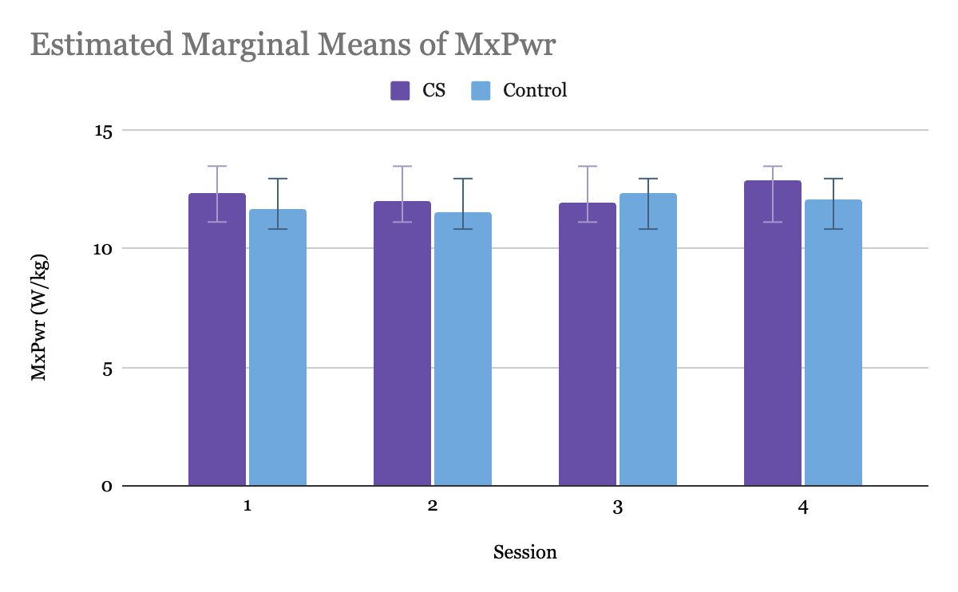
Figure 30. Bar Graph of Variations of Estimated Marginal Means of MxPwr by Session

Pairwise comparisons were conducted to examine the differences in max power between the control and CS legs. Table 14 presents the estimated mean differences, standard errors, significance levels, and 95% confidence intervals for the comparisons. The analysis of the MxPwr measure between the Control and Compression Sleeve (CS) conditions reveals a mean difference of -0.407 with a standard error of 1.01, indicating minimal deviation between the two conditions. Furthermore, the lack of statistical significance (p = 0.693) suggests that any observed difference is not likely to be meaningful. The confidence interval for the difference (-2.572 to 1.759) encompasses zero, indicating that there is no significant impact on MxPwr between the Control and CS conditions. Therefore, based on these findings, it can be concluded that the use of compression sleeves does not significantly affect MxPwr compared to the control condition.
Table 14. Pairwise Comparison of Max Power Between Control and CS Legs
Measure: MxPwr
(I) Leg | (J) Leg | Mean Difference (I-J) | Std. Error | Sig.a | 95% Confidence Interval for Difference
 |  |  |  |  | Lower Bound | Upper Bound
Control | CS | -0.407 | 1.01 | 0.693 | -2.572 | 1.759
CS | Control | 0.407 | 1.01 | 0.693 | -1.759 | 2.572
Note. Adjustments for multiple comparisons were made using the Bonferroni method
Table 15 provides the results of a repeated measures ANOVA for the variable Max Power (MxPwr), focusing on the within-subjects effects of the factors "Time" and the interaction between "Time" and "Leg”. Across all four tests (Sphericity Assumed, Greenhouse-Geisser, Huynh-Feldt, and Lower-bound), p > 0.05, indicating that there is no significant main effect of Time on MxPwr. Across all tests, the p-values are also not significant (p > 0.05), indicating no significant interaction between Time and Leg.
Table 15.Tests Within-Subjects Effects for Max Power
Measure: MxPwr
Source |  | Type III Sum of Squares | df | Mean Square | F | Sig. | Partial Eta Squared
Time | Sphericity Assumed | 4.273 | 3 | 1.424 | 1.268 | 0.298 | 0.083
 | Greenhouse-Geisser | 4.273 | 2.304 | 1.854 | 1.268 | 0.298 | 0.083
 | Huynh-Feldt | 4.273 | 2.981 | 1.433 | 1.268 | 0.298 | 0.083
 | Lower-bound | 4.273 | 1 | 4.273 | 1.268 | 0.279 | 0.083
Time*Leg | Sphericity Assumed | 3.431 | 3 | 1.144 | 1.018 | 0.394 | 0.068
 | Greenhouse-Geisser | 3.431 | 2.304 | 1.489 | 1.018 | 0.382 | 0.068
 | Huynh-Feldt | 3.431 | 2.981 | 1.151 | 1.018 | 0.394 | 0.068
 | Lower-bound | 3.431 | 1 | 3.431 | 1.018 | 0.33 | 0.068
Error(Time) | Sphericity Assumed | 47.174 | 42 | 1.123
 | Greenhouse-Geisser | 47.174 | 32.256 | 1.462
 | Huynh-Feldt | 47.174 | 41.731 | 1.13
 | Lower-bound | 47.174 | 14 | 3.37

Table 16 presents the results of between-subjects ANOVA for the variable MxPwr. The intercept term represents the estimated mean of the dependent variable (MxPwr) when all independent variables are set to zero. In this analysis, the intercept is highly significant (p < .001), indicating that there is a significant overall effect on MxPwr when all other variables are held constant. The partial eta squared value (0.976) suggests that a vast proportion of the variance in MxPwr can be attributed to this intercept term. The effect of the CS is not significant (p = .693).
Table 16. Test of Between-Subjects Effects for Max Power
Measure: MxPwr
Transformed Variable: Average
Source | Type III Sum of Squares | df | Mean Square | F | Sig. | Partial Eta Squared
Intercept | 9341.464 | 1 | 9341.464 | 572.761 | <.001 | 0.976
Leg | 2.645 | 1 | 2.645 | 0.162 | 0.693 | 0.011
Error | 228.333 | 14 | 16.31

Stage 5: Assess
RQ3: How does incorporating the science behind KT tape in a custom-made CS affect the recovery time of DOMS, and to what extent is the prototype successful in reducing the impact of DOMS?
The Soreness Survey that participants took at the end of field-testing during Session 1, and the beginning of Sessions 2, 3, and 4 was used to measure the perception of muscle soreness across all four sessions. According to the Demographic Survey the eight participants took, their ages ranged from 21-23. Only one of the eight participants had worn a CS prior to the study, because of a strained quad. She used it when returning to run but stated that she didn’t notice much of a difference. Six out of the eight participants had experience competing in Track and Field at the NCAA level. The other two participants had collegiate rowing experience at the NCAA level. Participants did not exhibit any adverse effects such as skin allergic reactions or discomfort from previously wearing CSs. When the CS was donned before the sprint protocol, the pressure was taken by placing the sensor between the back of the thigh, and the CS. The average pressure was 10.125 with a standard deviation of 1.25. This is slightly higher than the ideal pressure as recommended by Gokarneshan (2017) which was between 8-10.
The CS Comfort Survey consisted of 8 questions. Question 1 asked participants to rate how easy it was for them to put on the CS prototype by themselves on a scale of 1-10 with 1 being extremely easy, and 10 being extremely difficult. The average rating was 1.13 (SD=1.55).
Question 2 asked participants to “Rate how easy it was to put on the compression hamstring sleeve by yourself, Additional Comments”. Themes that emerged were “easy” (27.3%), “comfortable” (18.2%), and “aligning challenges” (18.2%). Question 3 asked participants to rate their comfort wearing the CS prototype while running (fabric feel) with 1 being very uncomfortable, and 10 being very comfortable. The average was 7 (SD=3.55).
Question 4 asked participants “Did you feel that the CS inhibited your ability to run at all? Explain.” All participants answered no, and some elaborated into further detail. Themes that emerged from this question were “comfortable” (12.5%) and “natural feeling” (12.5%). Question 5 asked participants to rate the comfort based on compression with 1 being too loose and 10 being too tight. The average was 5.25 and the (SD=0.89).
Question 6 asked participants, “Do you have any additional comments based on the comfort of compression? “. Only 3 participants gave feedback, and the themes that emerged from their responses were “compression” (11.1%), “adjustable” (22.2%), “comfortable” (22.2%), and “slipped” (33.3%). Question 7 asked participants” Do you have any additional comments based on the overall compression sleeve (style, design, etc)?”. Five of the participants responded to this question, and the themes that emerged were “adjustable” (25%), “slipped” (12.5%), “liked the design” (37.5%), and “velcro straps” (25%).
Table 17. Qualitative Answers from CS Comfort Survey
Rate how easy it was to put on the CS prototype by yourself. Additional Comments | "Had to do it seated, but could get it aligned with some practice"
 | "Somewhat hard to align"
 | "I like how it was adjustable within the sizes"
 | "it was really easy to put on. I like how it felt and how it mimicked the feel of tape. The material was super comfortable and I think it would be easy to wash and look after"
 | "very soft, very comfortable, easy to self administer"
 | "I needed a little help to get it to be tight enough to have enough compression"
Did you feel that the compression sleeve inhibited your ability to run at all? Explain. | "No, felt very comfortable running in the sleeve"
 | "Not at all. I feel like it helped to keep my legs fresher for longer!"
 | "No it felt really natural while I was running"
Do you have any additional comments based on the comfort of compression? | "It slipped during the first sprint, but after I adjusted it, it stayed in place for the rest of the protocol."
 | "It was perfect and I like how I was able to adjust the pressure of the sleeve with the velcro."
 | "Was slipping a bit, but very comfortable"
Do you have any additional comments based on the overall compression sleeve (style, design, etc)? | "I liked how it was adjustable and I could readjust it by alternating the velcro pieces."
 | "Sleeve shifted down while running, but not completely off."
 | "The design was clever and I liked how I could adjust it to myself. I like that it couldn't really be seen and that it blended in and if i wore leggings no one could tell I would be wearing it. I would like it in different colors too so i can plan my outfits with it!"
 | "Style and design were very nice"
 | "I liked that it was black. The middle of the two straps gapped a little bit, but I think that it was smart to have two parts to tighten the sleeve. Once I started sweating, it started to fall a little bit, but not an extensive amount. I really liked how it felt when I was running"

Table 18. Session 1-4 Soreness Survey averages and Standard Deviations
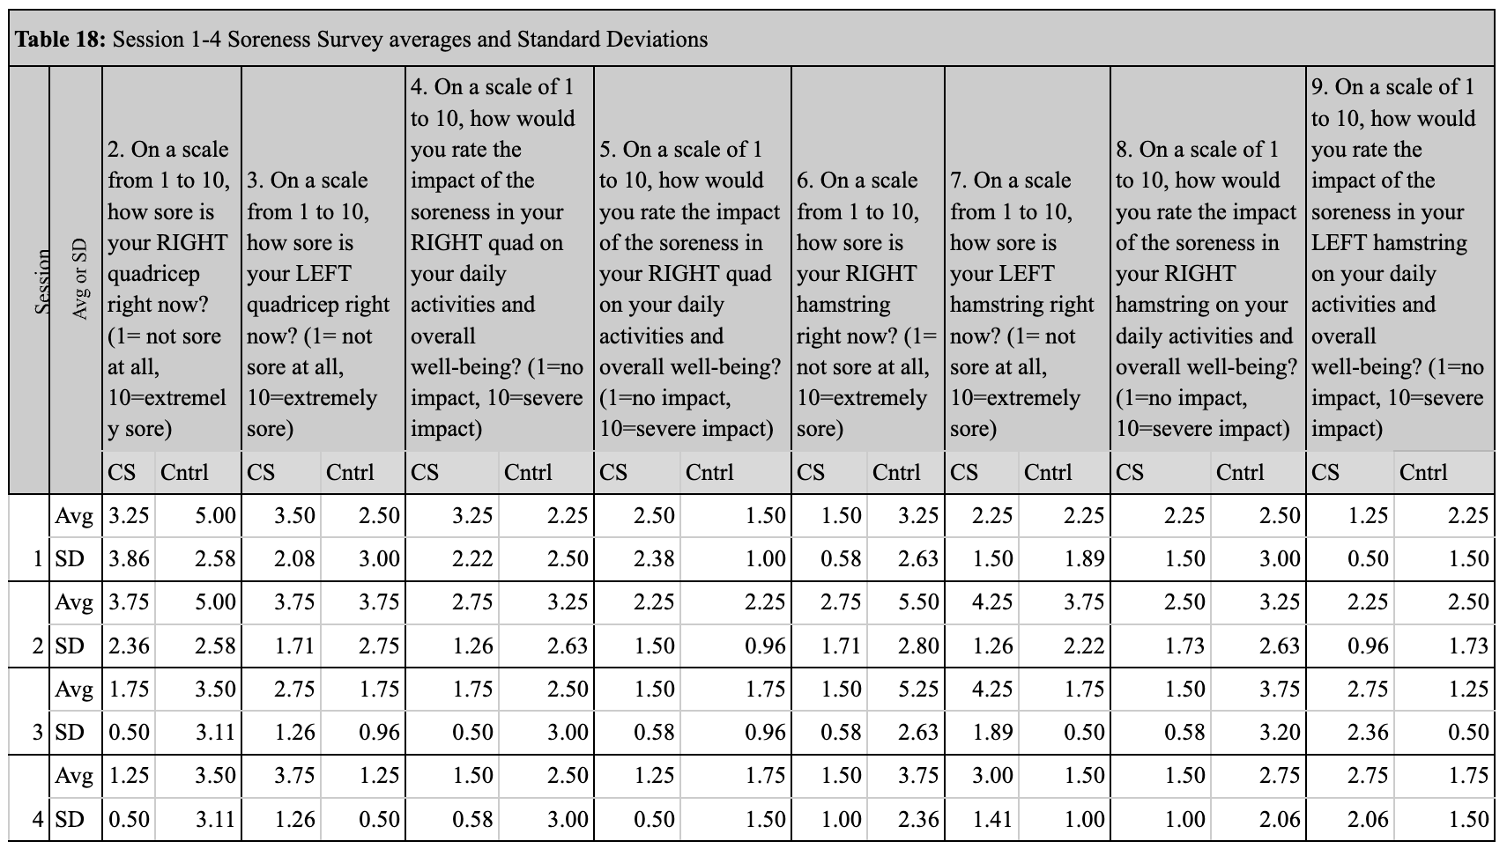

The Baseline Soreness Survey taken at the end of session 1, and the Soreness Survey taken at the beginning of Sessions 2, 3, and 4 required both quantitative and qualitative analysis. In the table above for all questions, CS pertains to data taken from participants who wore the CS prototype on the leg that is being asked about in the question. ‘Cntrl’ refers to participants who did not wear the prototype on the leg being referred to in the question (ie: if the question is asking participants to rate how sore your RIGHT quadricep is right now, CS is participants who wore the CS on the right leg, and ‘Cntrl’ is participants who wore the CS on the left leg). Four participants wore the CS prototype on the right leg, and four participants wore the CS prototype on the left leg.
A paired samples t-test was conducted to evaluate the potential impact of wearing a Compression Sleeve (CS) on participants' soreness ratings compared to a Control (Cntrl) condition between sessions 1 and 4 (Table 19). Analysis of the paired differences revealed that the mean soreness rating difference between the CS and Cntrl conditions was 0.06250, with a standard deviation of 1.522 and a standard error mean of 0.538. The 95% confidence interval for the difference ranged from -1.210 to 1.335. The t-test yielded a t-value of 0.116 with 7 degrees of freedom, resulting in one-sided and two-sided p-values of 0.455 and 0.911, respectively. In this context, since both the one-sided and two-sided p-values exceed the commonly used significance level of 0.05, we fail to reject the null hypothesis. This suggests that there is no statistically significant difference in soreness ratings between the Compression Sleeve and Control conditions. Therefore, based on these findings, it appears that wearing a Compression Sleeve does not significantly affect soreness ratings compared to the Control condition.
Table 19. Paired Samples T-test
Paired Samples Test
 | Paired Differences |  |  |  |  |  |  |  | Significance
 |  | Mean | Std. Deviation | Std. Error Mean | 95% Confidence Interval of the Difference
 |  |  |  |  | Lower | Upper | t | df | One-Sided p | Two-Sided p
Pair 1 | Compression Sleeve - Control | 0.0625 | 1.522 | 0.538 | -1.210 | 1.335 | 0.116 | 7 | 0.455 | 0.911

Question 13 asked participants, “Is there anything besides the sprint protocol that may be impacting your level of soreness?” Since all the participants are competitive athletes or graduated one year ago from being competitive athletes, most of the notable responses were “having practice”, working out daily, or jogging throughout the week.
Question 14 asked participants if they had any other notes based on their level of soreness at this moment in time. Five participants said no to all three following sessions. During Session 2, a participant who wore the CS on the left leg stated that “my right side feels much tighter than the left side. I think that's from the sprinting”. Another participant who wore the CS on the left leg stated during the same session: “I'm kind of surprised at how sore my hamstrings are because when I was sprinting, I felt like I was using my quads more prominently”. The same participant stated that “I'm surprised at how sore my hamstrings still are. I thought they were going to be less sore today. I was walking down the steps today, and I was surprised at how sore my hamstrings felt” during Session 3. During Session 4 the participant stated, “I'm surprised that I'm still a little sore, but I can tell that there's a noticeable difference in hamstring soreness. My right (the one I didn't wear the sleeve on) is still more sore than the left hamstring”.

DISCUSSION

Summary of Findings
The literature review highlighted that, while many studies have explored the topic of Delayed Onset Muscle Soreness (DOMS) and the athletes’ recovery process, the way that DOMS was induced is not relevant to the training of NCAA level female athletes. The purpose of this study was to investigate the user-needs of female NCAA athletes in regard to recovery from DOMS in their lower extremity muscles and create a wearable soft device that could aid in their recovery. This investigation aimed at answering the following research questions:
RQ1 aimed to elucidate what are the user-needs of female NCAA athletes for CS design aimed at reducing hamstring injuries and recovery time from DOMS? The user-needs expressed by the 36 respondents allowed the researcher to make informed decisions throughout the design process regarding what fabrics to use, what kind of design would be most suitable, and what elements needed to be integrated in order to make a successful CS. The most important elements of a CS that were expressed from the Survey were durability which averaged an importance rating of 8.38/10, light weight (6.76/10), breathability (6.48/10), and high level of stretch (6.62/10).
These findings align with the previous literature on user-needs for compression sleeves, but also highlight the design challenges of trading off fabric properties and prioritize the ones that are feasible for construction.
RQ2 aimed to explain, what does a prototype design that satisfies NCAA female athlete user-needs look like when incorporating the science between KT tape and CS. The results of user-needs analysis guided the selection of 5 fabrics. Textile testing reduced the choices to two fabrics: Superflex Heavy compression Spandex and Spacer Scuba Knit. The two fabric choices had similar properties except that Superflex Heavy compression Spandex was one of the thinnest fabrics, and the Spacer Scuba Knit was the thickest. Based on the comfort surveys at the end of the study, it is unclear if using the Superflex Heavy compression spandex fabric instead of the Scuba would have led to a different outcome of the study. The design solution was focused on integrating the KT science along with compressive properties. The KT tape element for Prototypes 1 (Figure 5) and 2 (Figure 6) were created by sewing an elastic strip that had silicone dots on it directly onto the CS. This created issues such as bunching and stretching of the fabric which resulted in a warped end product. Therefore, the silicone solution was implemented to troubleshoot these problems. The silicone was thought to provide the most grip without irritating the skin of the wearer, but it should be noted that the grip of the silicone can’t provide the same adhesion properties that KT tape can give. For future design iterations, the CS could be re-engineered with a different material that can more closely mimic the adhesive properties of KT tape.
RQ3 asked, how does incorporating the science behind KT tape in a custom-made CS affect the recovery time of DOMS, and to what extent is the prototype successful in reducing the impact of DOMS? While numerous studies demonstrated that KT tape reduces discomfort stemming from muscle soreness by improving muscular function, reducing muscle activity, and boosting lymphatic and blood flow (Kanik et al., 2019), the possible effects of KT tape on DOMS have not been thoroughly studied, with just a small number of studies having investigated it (Kirmizigil et al., 2019). Stage 4: Evaluate and Stage 5: Assess helped answer this question through the field testing and the prompted hypotheses.
Hypothesis 1 stated that the leg that the participant wears the CS on will result in an overall higher hamstring peakforce by session 4 than the control leg. Based on the findings of the Repeated Measures Tests, while there are significant differences in hamstring peakforce overall, these differences are not attributable to wearing a CS compared to not wearing it. Therefore, the hypothesis that the CS variable would significantly improve Hamstring peak force by session 4 was not supported.
Hypothesis 2 stated that the leg that the participant wears the CS on will result in an overall higher quad peakforce by session 4 than the control leg. Based on the results presented in the Repeated Measures Tests, the findings suggested that while there are significant differences in QuadPkFrce overall, these differences are not attributable to wearing a CS compared to not wearing it. Therefore, the hypothesis that the CS variable would significantly improve quad peak force by session 4 was not supported by the findings of this study.
Hypothesis 3 stated that the leg that the participant wears the CS on will result in an overall higher Jump Height by session 4 than the control leg. Based on the results presented in the Repeated Measures Tests, the findings suggested that while there are significant differences in JmpHght overall, these differences are not attributable to wearing a CS compared to not wearing it. Therefore, the hypothesis that the CS variable would significantly improve Jump Height by session 4 was not supported by the findings of this study.
Hypothesis 4 stated that the leg that the participant wears the CS on will result in an overall higher Max Power by session 4 than the control leg. The findings from the different Repeated Measures Tests suggest that while there are significant differences in MxPwr overall, these differences are not attributable to wearing a CS compared to not wearing it. Therefore, the hypothesis that the CS variable would significantly improve max power was not supported by the findings of this study.
Hypothesis 5 stated that the participant will have a perception of less soreness in the leg that wore the CS compared to the control leg by session 4. In the subsequent soreness Survey conducted at sessions 2, 3, and 4, participants compared the soreness of each leg to the previous session. The results did not consistently support the hypothesis that participants would perceive less soreness in the leg wearing the CS. The mean soreness ratings varied across sessions and legs, with no clear pattern indicating a significant difference between the control and CS legs.
Furthermore, qualitative analysis from the Soreness Surveys provided additional insights into participants' experiences. Notably, some participants expressed surprise at the level of soreness in their hamstrings and noted differences between their legs. This aligns with Frank et al (2021) who found that nearly 90% of those aiming to reduce recurrent injuries reported perceived positive effects of CG use, and that athletes using CGs for recovery of sports performance improvement perceived faster recovery and sports performance improvement, but these qualitative observations did not consistently align with the quantitative soreness ratings. Conversely, qualitative analysis from the CS Comfort Survey displayed feedback that demonstrated a positive perception of the CS. Even though this does not align with the results of the physiological responses (peak force, jump height, and max power), studies such as Leabeater et al. (2022) and Franke et al. (2021) suggest there to be significance in considering the user’s perceived benefits of a compression garment even if there is no statistically significant evidence of physiological benefits.

Significance
Despite no significant findings pertaining to the use of the CS, there are many implications resulting from this study. There have been studies such as Xue et al (2023) and Kanik et al (2019) that concluded a reduction in quadricep muscle soreness following KT tape intervention. Therefore, there is foundational evidence that a CS could have the potential to reduce DOMS after some alterations to the design or technique that is used to mimic KT tape. Even though there isn’t much evidence expressing the detriments of KT tape, it can be inferred that KT tape, like most athletic tape, is creating a large amount of waste since the adhesive isn’t meant to last forever or be reusable after it’s removed from the skin. Therefore, this research is important to continue due to the potential of KT tape waste reduction.
Additionally, even if the CS design does not alleviate DOMS, it may still offer other benefits such as improved circulation, muscle stabilization, or injury prevention. The study results could also provide insights into how female athletes respond differently to certain recovery interventions compared to male athletes. This could lead to a deeper understanding of the physiological mechanisms underlying DOMS and recovery in women, informing future research and practice in sports science.
Furthermore, coaches, trainers, and athletes may need to manage their expectations regarding the effectiveness of hamstring CS for DOMS management. Clear communication about the limitations of compression garments in this regard and can help athletes make informed decisions about their recovery strategies.

Limitations
Firstly, this study has a rather small sample size. Expanding the research population, growing the sample size, and closely observing the immediate and long-term impacts as well as the underlying processes of KT tape and CS application schemes are all important to improve generalization. Because most of the participants were track athletes and therefore accustomed to workouts like the protocol, it seemed a little harder to induce DOMS. In the future to measure the effectiveness of the CS, maybe non athletes should be used so they are more likely to be sore from a similar protocol. Or make a protocol that the athletes are less likely to be accustomed to so that it’s easier to induce DOMS. Regarding the functional testing, it might be crucial to consider having the participants do a trial run of each of the tests before recording baseline data. This should be a consideration because none of the participants were experienced with the single leg SPARTA testing, and many of them did not have experience being tested with the handheld dynamometer. For some of the participants it seemed like their results were higher for each of the tests during the second session because they were more accustomed to the tests even though they did state that they were sore in the Surveys.
Regarding the prototyping, time was a huge limitation. The timeline of making the CS prototypes was contingent upon when the materials were shipped and arrived. Therefore, there was very limited time between the turnaround of making the initial prototypes, and the final CS prototype. The binding that was used to finish the edges of the CS was susceptible to pilling which wasn’t discovered until after all the CS prototypes were constructed, and the velcro easily stuck to the binding (Figure 31).
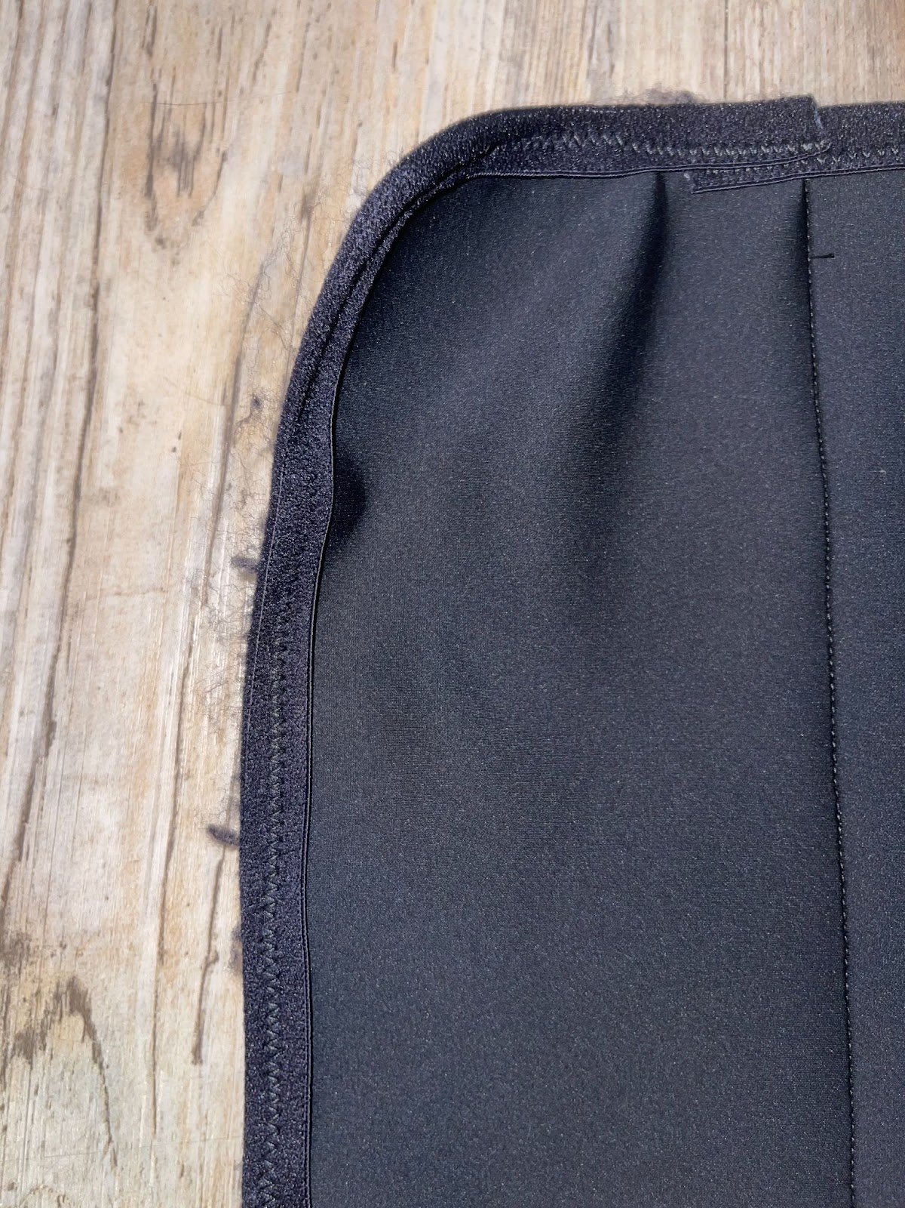
Figure 31. Pilling of binding on CS

The original protocol that was submitted to the IRB stated that the CS would be worn after the sprinting protocol was completed, and before each succeeding session, but after further literature review, the researcher decided to have the participants only wear the CS during the sprint protocol. For this reason, Moisture management testing (MMT) was not conducted on the five fabrics before selecting which fabric would make the CS. Many of the participants verbally expressed off the record to the researcher after completing the sprint protocol that the CS was sweaty after doffing it even though it didn’t feel sweaty while they were wearing it. When observed, there only seemed to be moisture presence in the velcro area of the CS. This would suggest that the CS allowed for enough breathability, but in the areas of the velcro, the velcro inhibited air to come through the CS, and trapped moisture to the inside of it. Because of this, in future studies, MMT should be conducted on the fabrics being considered to make the CS. Additionally, there should be considerations of different velcro placements, or a different method for keeping the CS fastened.
In regard to the silicone mixture used to mimic KT tape, there should be further consideration into how to apply it to the fabric. In this study, the mixture was applied using a cotton swab since the mixture would melt anything made of plastic. This in turn resulted in a textured surface rather than a smooth one (Figure 12). Since the actual surface of KT tape is smooth, this could have influenced the wearer's perceptions of comfort as well as the field trial results. Furthermore, it should be considered to conduct the elongation tests on strips of fabric that has the silicone already on it and see if this affects the elongation or stretchability of the fabric. This is important to see how or if the silicone affects the fabric’s level of stretch.

Conclusion
While many studies have explored the topic of DOMS and the athletes’ recovery process, many of the studies focused on male participants, and just generalized the findings for men and women rather than considering the difference in female biology that may alter how they experience DOMS. Therefore, this interdisciplinary mixed methods experimental study looked at a female athlete population to see what their needs were in terms of a new type of device that could theoretically mitigate DOMS.
From the initial User Needs Survey, when asked about the biggest challenge faced during practice when experiencing DOMS in their hamstrings, 40% of respondents answered, “feeling more prone to injury”. This emphasizes a crucial need for a device that can reduce the level of DOMS experienced so athletes are able to go all out during practice without being worried of getting injured. When asked how they currently manage or alleviate DOMS, 77% of the respondents said, “rest and recovery”. This underscores the importance of a CS due to its potential to mitigate the effects of DOMS during the athlete’s workout. Rather than having to try and recover after the fact, there is a way to inhibit DOMS from occurring to the extent that it would without the CS.
While there is select data that indicates the users’ perception of mitigated DOMS, the overall findings from the Functional Tests, and Soreness Surveys do not strongly support the hypothesis that wearing a CS would result in reduced soreness in the legs. The mixed results suggest that factors other than the CS may influence perceived soreness levels, highlighting the complexity of soreness perception in athletic contexts. This reveals that focusing solely on the user when designing a medical device might not be in the best interest in terms of efficacy. The possible reason for this is because user insights aren’t always scientifically or data driven, but rather more experience based. This means that there most likely needs to be another element added to the UCD framework in order for the CS design to be effective. This step could include insight from healthcare professionals, athletic trainers, or even coaches.
Incorporating insights from healthcare professionals, athletic trainers, and coaches into the User-Centered Design (UCD) framework could significantly enhance the effectiveness of designing a Compression Sleeve (CS) for managing soreness in athletes. One approach could involve organizing focus groups or interviews with these stakeholders to gather their perspectives on the potential benefits and limitations of compression garments for soreness management. Collaborative design workshops could then facilitate brainstorming sessions where designers and stakeholders could work together to co-create solutions tailored to athletes' needs. Additionally, involving healthcare professionals, athletic trainers, and coaches in usability testing sessions with athletes would allow for valuable feedback on the suitability, ease of use, and integration of the CS into athletes' routines. Throughout the design process, seeking expert review and feedback from these stakeholders would ensure that the CS aligns with best practices in sports medicine and athletic training. Providing educational resources and training materials could further support stakeholders in understanding the benefits and proper use of the CS. By integrating insights from these diverse perspectives, designers could develop a CS that effectively meets the needs of athletes while adhering to scientific evidence and practical considerations in soreness management.

REFERENCES
Abdessalem, S. B., Abdelkader, Y. B., Mokhtar, S., & Elmarzougui, S. (2009). Influence of elastane consumption on plated plain knitted fabric characteristics. Journal of Engineered Fibers and Fabrics, 4(4), 155892500900400411.
Abras, C., Maloney-Krichmar, D., & Preece, J. (2004). User-centered design. Bainbridge, W. Encyclopedia of Human-Computer Interaction. Thousand Oaks: Sage Publications, 37(4), 445-456.
Ali, A., Creasy, R. H., & Edge, J. A. (2011). The effect of graduated compression stockings on running performance. The Journal of Strength & Conditioning Research, 25(5), 1385-1392.
Barker, R. L. (2002). From fabric hand to thermal comfort: the evolving role of objective measurements in explaining human comfort response to textiles. International Journal of Clothing Science and Technology, 14(3/4), 181–200.
Bauerfeind. (n.d.). Home. Bauerfeind. Retrieved from https://www.bauerfeind.com
Bezuglov, E., Lazarev, A., Khaitin, V., Chegin, S., Tikhonova, A., Talibov, O., .. & Waśkiewicz, Z. (2021). The prevalence of use of various post-exercise recovery methods after training among elite endurance athletes. International journal of environmental research and public health, 18(21), 11698.
Bringard, A., Perrey, S., & Belluye, N. (2006). Aerobic energy cost and sensation responses during submaximal running exercise-positive effects of wearing compression tights. International journal of sports medicine, 27(05), 373-378.
Brooks, J. H., Fuller, C. W., Kemp, S. P., & Reddin, D. B. (2006). Incidence, risk, and prevention of hamstring muscle injuries in professional rugby union. The American journal of sports medicine, 34(8), 1297-1306.
Brubacher, K. (2020). Comparison and Evaluation of Sizing Systems Used in Commercial Women’s Compression Sportswear. In Proceedings (Vol. 49, No. 1, p. 140). MDPI.
Camp, C. L., Dines, J. S., van der List, J. P., Conte, S., Conway, J., Altchek, D. W., .. & Pearle, A. D. (2018). Summative report on time out of play for Major and Minor League Baseball: an analysis of 49,955 injuries from 2011 through 2016. The American journal of sports medicine, 46(7), 1727-1732.
Chandran, A., Morris, S. N., Roby, P. R., Boltz, A. J., Robison, H. J., & Collins, C. L. (2021). Epidemiology of Injuries in National Collegiate Athletic Association Women's Track and Field: 2014–2015 Through 2018–2019. Journal of athletic training, 56(7), 780-787.
Chen, H. Y., Chen, Y. C., Tung, K., Chao, H. H., & Wang, H. S. (2019). Effects of caffeine and sex on muscle performance and delayed-onset muscle soreness after exercise-induced muscle damage: A double-blind randomized trial. Journal of Applied Physiology, 127(3), 798-805.
Cheung, K., Hume, P. A., & Maxwell, L. (2003). Delayed onset muscle soreness. Sports medicine, 33(2), 145-164.
Choudhury, A. R., Majumdar, P. K., & Datta, C. (2011). Factors affecting comfort: human physiology and the role of clothing. In Improving comfort in clothing (pp. 3-60). Woodhead Publishing.
Coetzee, A. C. (2020). The prevalence and risk factors for hamstring injuries among field hockey players at a hockey club in Pretoria, South Africa (Doctoral dissertation).
Croisier, J. L. (2004). Factors associated with recurrent hamstring injuries. Sports medicine, 34, 681-695.
Croisier, J. L., Camus, G., Forthomme, B., Maquet, D., Vanderthommen, M., & Crielaard, J. M. (2003). Delayed onset muscle soreness induced by eccentric isokinetic exercise. Isokinetics and exercise science, 11(1), 21-29.
Cross, K. M., Gurka, K. K., Saliba, S., Conaway, M., & Hertel, J. (2013). Comparison of hamstring strain injury rates between male and female intercollegiate soccer athletes. The American journal of sports medicine, 41(4), 742-748.
De Oliveira, F., Paz, G. A., Corrêa Neto, V. G., Alvarenga, R., Marques Neto, S. R., Willardson, J. M., & Miranda, H. (2023). Effects of Different Recovery Modalities on Delayed Onset Muscle Soreness, Recovery Perceptions, and Performance Following a Bout of High-Intensity Functional Training. International Journal of Environmental Research and Public Health, 20(4), 3461.
DeWeese, B. H., Hornsby, G., Stone, M., & Stone, M. H. (2015). The training process: Planning for strength–power training in track and field. Part 1: Theoretical aspects. Journal of sport and health science, 4(4), 308-317.
Dias, T., & Delkumburewatte, G. B. (2008). Changing porosity of knitted structures by changing tightness. Fibers and Polymers, 9, 76-79.
DOAN, B., Kwon, Y. H., NEWTON, R., Shim, J., Popper, E. V. A., ROGERS, R., .. & KRAEMER, W. (2003). Evaluation of a lower-body compression garment. Journal of sports sciences, 21(8), 601-610.
Driller, M. W., & Brophy-Williams, N. (2016). The use of compression garments in elite Australian athletes: A survey. Journal of Athletic Enhancement, 2016.
Dwivedi, M. S. K. D., Upadhyay, M. S., & Tripathi, A. (2012). A working framework for the user-centered design approach and a survey of the available methods. International Journal of Scientific and Research Publications, 2(4), 12-19.
Engel, F. A., Holmberg, H. C., & Sperlich, B. (2016). Is there evidence that runners can benefit from wearing compression clothing?. Sports medicine, 46, 1939-1952.
Ertekin, G., Oğlakcioğlu, N., & Marmarali, A. (2018). Strength and comfort characteristics of cotton/elastane knitted fabrics. Tekstil ve Mühendis, 25(110), 146-153.
Folpp, H., Deall, S., Harvey, L. A., & Gwinn, T. (2006). Can apparent increases in muscle extensibility with regular stretch be explained by changes in tolerance to stretch?. Australian Journal of Physiotherapy, 52(1), 45-50.
Franke, T. P., Backx, F. J., & Huisstede, B. M. (2021). Lower extremity compression garments use by athletes: why, how often, and perceived benefit. BMC Sports Science, Medicine and Rehabilitation, 13, 1-14.
Ghorbani, E., Hasani, H., Rafeian, H., & Hashemibeni, B. (2013). Analysis of the thermal comfort and impact properties of the neoprene-spacer fabric structure for preventing joint damages. International journal of preventive medicine, 4(7), 761.
Gobbi, R. G., Hinckel, B. B., Teixeira, P. R. L., Giglio, P. N., Lucarini, B. R., Pécora, J. R., & Demange, M. K. (2019). The vastus medialis insertion is more proximal and medial in patients with patellar instability: a magnetic resonance imaging case-control study. Orthopaedic Journal of Sports Medicine, 7(12), 2325967119880846.
Gokarneshan, N. (2017). Design of compression/pressure garments for diversified medical applications. Biomedical Journal of Scientific & Technical, 1(3), 1-8.
Gupta, D. (2011). Functional clothing—Definition and classification.
Handler, A., & Ginty, D. D. (2021). The mechanosensory neurons of touch and their mechanisms of activation. Nature Reviews Neuroscience, 22(9), 521-537.
Heiderscheit, B. C., Sherry, M. A., Silder, A., Chumanov, E. S., & Thelen, D. G. (2010). Hamstring strain injuries: recommendations for diagnosis, rehabilitation, and injury prevention. Journal of orthopaedic & sports physical therapy, 40(2), 67-81.
Heiss, R., Lutter, C., Freiwald, J., Hoppe, M. W., Grim, C., Poettgen, K., .. & Hotfiel, T. (2019). Advances in delayed-onset muscle soreness (DOMS)–part II: treatment and prevention. Sportverletzung· Sportschaden, 33(01), 21-29.
Howatson, G., & Milak, A. (2009). Exercise-induced muscle damage following a bout of sport specific repeated sprints. The Journal of Strength & Conditioning Research, 23(8), 2419-2424.
Hill, J., Howatson, G., van Someren, K., Leeder, J. & Pedlar, C. Compression garments and recovery from exercise-induced muscle damage: A meta-analysis. Br. J. Sports Med. 48, 1340–1346 (2014).
Ivan, Z. (2012). Anatomy, physiology and biomechanics of hamstrings injury in football and effective strength and flexibility exercises for its prevention. Journal of Human Sport and Exercise, 7(1), S208-S217.
Jhanji, Y. (2021). Sportswear: acumen of raw materials, designing, innovative and sustainable concepts. Textiles for Functional Applications, 261-286.
Jones, A., Jones, G., Greig, N., Bower, P., Brown, J., Hind, K., & Francis, P. (2019). Epidemiology of injury in English Professional Football players: A cohort study. Physical therapy in sport, 35, 18-22.
Jun, Y., Park, C. H., Shim, H., & Kang, T. J. (2009). Thermal comfort properties of wearing caps from various textiles. Textile Research Journal, 79(2), 179–189.
Kandhavadivu, P., & Gopalakrishnan, D. (2021). Localized compression clothing for improved sports performance. In Recent Trends in Traditional and Technical Textiles: Select Proceedings of ICETT 2019 (pp. 73-87). Springer Singapore.
Kanik, Z. H., Citaker, S., Demirtas, C. Y., Bukan, N. C., Celik, B., & Gunaydin, G. (2019). Effects of kinesio taping on the relief of delayed onset muscle soreness: A randomized, placebo-controlled trial. Journal of sport rehabilitation, 28(8), 781-786.
Karaguzel B., (2004) Characterization and Role of Porosity in Knitted Fabrics, MSc Thesis, North Carolina State University
Kase, K. (2003). Clinical therapeutic applications of the Kinesio (! R) taping method. Albuquerque.
Keane, K. M., Salicki, R., Goodall, S., Thomas, K., & Howatson, G. (2015). Muscle damage response in female collegiate athletes after repeated sprint activity. The Journal of Strength & Conditioning Research, 29(10), 2802-2807.
Kirmizigil, B., Chauchat, J. R., Yalciner, O., Iyigun, G., Angin, E., & Baltaci, G. (2019). The effectiveness of kinesio taping in recovering from delayed onset muscle soreness: A crossover study. Journal of Sport Rehabilitation, 29(4), 385-393.
Kraemer, W. J., French, D. N., Barry, M. & Spiering, A. Compression in the treatment of acute muscle injuries in sport. Int. Sport. J. 5, 200–208 (2004).
KTTape (n.d.) " KT Tape PRO". Retrieved from kttape.com
Kundu, A., Marchetta, S., Peek, L., Schrier, E., Thaker, N., Tomlinson, C., & Ma, J. (2022). Using Machine Learning to Predict Injury Risk From Athlete Kinetic Patterns. In 2022 IEEE MIT Undergraduate Research Technology Conference (URTC) (pp. 1-5). IEEE.
Kyzymchuk, O., Kyosev, Y., Melnyk, L., & Boll, J. (2023). THE ADVANCED TECHNOLOGY FOR COMPRESSION GARMENT DESIGN. In BOOK OF ABSTRACTS (p. 114).
Leabeater, A. J., James, L. P., & Driller, M. W. (2022). Tight margins: Compression garment use during exercise and recovery—A systematic review. Textiles, 2(3), 395-421.
MacRae, B. A., Cotter, J. D., & Laing, R. M. (2011). Compression garments and exercise: garment considerations, physiology and performance. Sports medicine, 41, 815-843.
Matusiak, M. (2010). Thermal comfort index as a method of assessing the thermal comfort of textile materials. Fibres & Textiles in Eastern Europe, 18(2), 79.
Mavruz, S., Oğulata R. T., (2010), Taguchi approach for the optimisation of the bursting strength of knitted fabrics, Fibres & Textiles in Eastern Europe, 18(2), 79: 78-83.
McGuire, C. (2023) “A look at trends for women in college sports.” Retrieved from NCAA.org https://www.ncaa.org/news/2023/3/1/media-center-a-look-at-trends-for-women-in-college-sports.aspx
McLoughlin, J., & Sabir, T. (2018). High-Performance Apparel: Materials. Development and Applications. (Elsevier Ltd., 2018), 24-25.
Meeusen, R., Duclos, M., Foster, C., Fry, A., Gleeson, M., Nieman, D., .. & Urhausen, A. (2013). Prevention, diagnosis, and treatment of the overtraining syndrome: joint consensus statement of the European College of Sport Science and the American College of Sports Medicine. Medicine and science in sports and exercise, 45(1), 186-205.
Morris, K., Park, J., & Sarkar, A. (2017). Development of a nursing sports bra for physically active breastfeeding women through user-centered design. Clothing and Textiles Research Journal. 35(4) 290-306.
Mullins, K., Mac Colgáin, D., & Carton, P. (2022). Incidence and severity of hamstring injuries in female athletes who play field sports: a systematic review with meta-analysis of prospective studies. Journal of orthopaedic & sports physical therapy, 52(11), 740-A5.
Norman, D. (1988). The design of everyday things. New York: Doubleday.
NCAA (n.d.) “A look at trends for women in college sports” Retrieved from - NCAA.org
Opar, D. A., Williams, M. D., & Shield, A. J. (2012). Hamstring strain injuries: factors that lead to injury and re-injury. Sports medicine, 42, 209-226.
O'Riordan, S. F., McGregor, R., Halson, S. L., Bishop, D. J., & Broatch, J. R. (2021). Sports compression garments improve resting markers of venous return and muscle blood flow in male basketball players. Journal of Sport and Health Science.
O’Sullivan, L., Preszler, J., & Tanaka, M. (2022). Hamstring injury rehabilitation and prevention in the female athlete. International Journal of Sports Physical Therapy, 17(6), 1184.
Ozmen, T., Aydogmus, M., Dogan, H., Acar, D., Zoroglu, T., & Willems, M. (2016). The effect of kinesio taping on muscle pain, sprint performance, and flexibility in recovery from squat exercise in young adult women. Journal of sport rehabilitation, 25(1), 7-12.
Parsons, K. (2014). Human thermal environments: The effects of hot, moderate, and cold environments on human health, comfort, and performance. CRC Press.
Paul, R. W., Sonnier, J. H., Johnson, E. E., Hall, A. T., Osman, A., Connors, G. M., .. & Bishop, M. E. (2023). Inequalities in the evaluation of male versus female athletes in sports medicine research: a systematic review. The American Journal of Sports Medicine, 51(12), 3335-3342.
Perrey, S. (2008). Compression garments: evidence for their physiological effects. The Engineering of Sport, 7, 319-328.
Rahulan, M., Troynikov, O., Watson, C., Janta, M., & Senner, V. (2015). Consumer behavior of generational cohorts for compression sportswear. Journal of Fashion Marketing and Management, 19(1), 87-104.
Rider, B. C., Coughlin, A. M., Hew-Butler, T. D., & Goslin, B. R. (2014). Effect of compression stockings on physiological responses and running performance in division III collegiate cross-country runners during a maximal treadmill test. The Journal of Strength & Conditioning Research, 28(6), 1732-1738.
Roe, M., Murphy, J. C., Gissane, C., & Blake, C. (2018). Time to get our four priorities right: an 8-year prospective investigation of 1326 player-seasons to identify the frequency, nature, and burden of time-loss injuries in elite Gaelic football. PeerJ, 6, e4895.
Saghiv, M. S., Sagiv, M. S., Saghiv, M. S., & Sagiv, M. S. (2020). Skeletal Muscles. Basic Exercise Physiology: Clinical and Laboratory Perspectives, 407-436.
Seçkin, A. Ç., Ateş, B., & Seçkin, M. (2023). Review on Wearable Technology in Sports: Concepts, Challenges and Opportunities. Applied Sciences, 13(18), 10399.
Silvers-Granelli, H. J., Cohen, M., Espregueira-Mendes, J., & Mandelbaum, B. (2021). Hamstring muscle injury in the athlete: state of the art. Journal of ISAKOS, 6(3), 170-181.
Star Health. (n.d.). Hamstring Muscles: Functions & Structure. Star Health. Retrieved from https://www.starhealth.in/blog/hamstring-muscles-functions-structure
Thompson, J. A., Chaudhari, A. M., Schmitt, L. C., Best, T. M., & Siston, R. A. (2013). Gluteus maximus and soleus compensate for simulated quadriceps atrophy and activation failure during walking. Journal of biomechanics, 46(13), 2165-2172.
Troynikov, O., Ashayeri, E., Burton, M., Subic, A., Alam, F., & Marteau, S. (2010). Factors influencing the effectiveness of compression garments used in sports. Procedia Engineering, 2(2), 2823-2829.
Tseng, K. W., Tseng, W. C., Lin, M. J., Chen, H. L., Nosaka, K., & Chen, T. C. (2016). Protective effect by maximal isometric contractions against maximal eccentric exercise-induced muscle damage of the knee extensors. Research in Sports Medicine, 24(3), 228-241.
TT Meditrade (November 20, 2023). “Kikuhime”. Retrieved from https://www.ttmeditrade.dk/en/about-tt-meditrade
Ünal, Z. B., & Eren, E. R. (2018). The use of neoprene fabric evaluation in terms of comfort in child tracksuit production. Industria Textila, 69(5), 400-405.
Venkatraman, P., & Tyler, D. (2015). Applications of compression sportswear. Materials and technology for sportswear and performance apparel, 195.
Weber, M. G., Dias, S. S., de Angelis, T. R., Fernandes, E. V., Bernardes, A. G., Milanez, V. F., .. & de Paula Ramos, S. (2021). The use of BCAA to decrease delayed-onset muscle soreness after a single bout of exercise: a systematic review and meta-analysis. Amino acids, 53(11), 1663-1678.
Wiewelhove, T., Raeder, C., Meyer, T., Kellmann, M., Pfeiffer, M., & Ferrauti, A. (2015). Markers for routine assessment of fatigue and recovery in male and female team sport athletes during high-intensity interval training. PloS one, 10(10), e0139801.
Wikholm, J. B., & Bohannon, R. W. (1991). Hand-held dynamometer measurements: tester strength makes a difference. Journal of Orthopaedic & Sports Physical Therapy, 13(4), 191-198.
Williams, S., Whatman, C., Hume, P. A., & Sheerin, K. (2012). Kinesio taping in treatment and prevention of sports injuries: a meta-analysis of the evidence for its effectiveness. Sports medicine, 42, 153-164.
Wilson, G. J., & Murphy, A. J. (1996). The use of isometric tests of muscular function in athletic assessment. Sports medicine, 22, 19-37.
WorldBrace. (n.d.). Sports Brace Manufacturing Process. WorldBrace. Retrieved from https://www.worldbrace.com/sports-brace-manufacturing-process/
Xiong, Y., & Tao, X. (2018). Compression garments for medical therapy and sports. Polymers, 10(6), 663.
Xue, X., Hao, Y., Yang, X., Zhang, C., Xu, J., Wu, X., .. & Li, N. (2023). Effect of Kinesio tape and Compression sleeves on delayed onset of muscle soreness: a single-blinded randomized controlled trial. BMC Musculoskeletal Disorders, 24(1), 1-15.
Yeung, S. S., Yeung, E. W., Sakunkaruna, Y., Mingsoongnern, S., Hung, W. Y., Fan, Y. L., & Iao, H. C. (2015). Acute effects of kinesio taping on knee extensor peak torque and electromyographic activity after exhaustive isometric knee extension in healthy young adults. Clinical journal of sport medicine, 25(3), 284-290.
Yip, J., & Chan, W. Y. (2020). Textile fibers and fabrics. In Latest Material and Technological Developments for Activewear (pp. 47-72). Woodhead Publishing.

APPENDICIES
IRB board action for Initial User Needs Survey
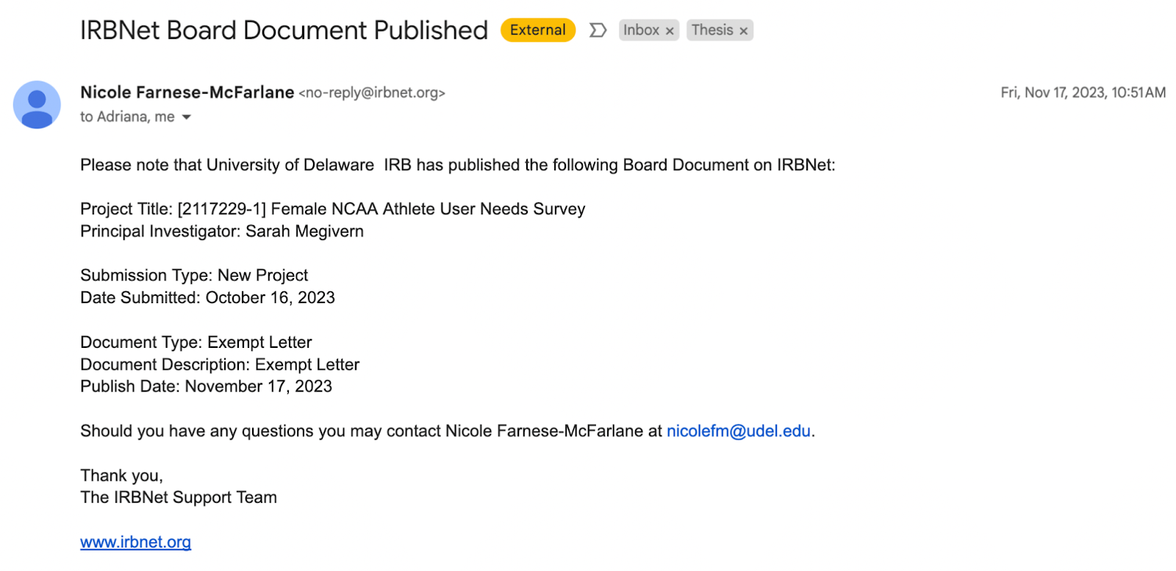
Female NCAA athlete User Needs Survey
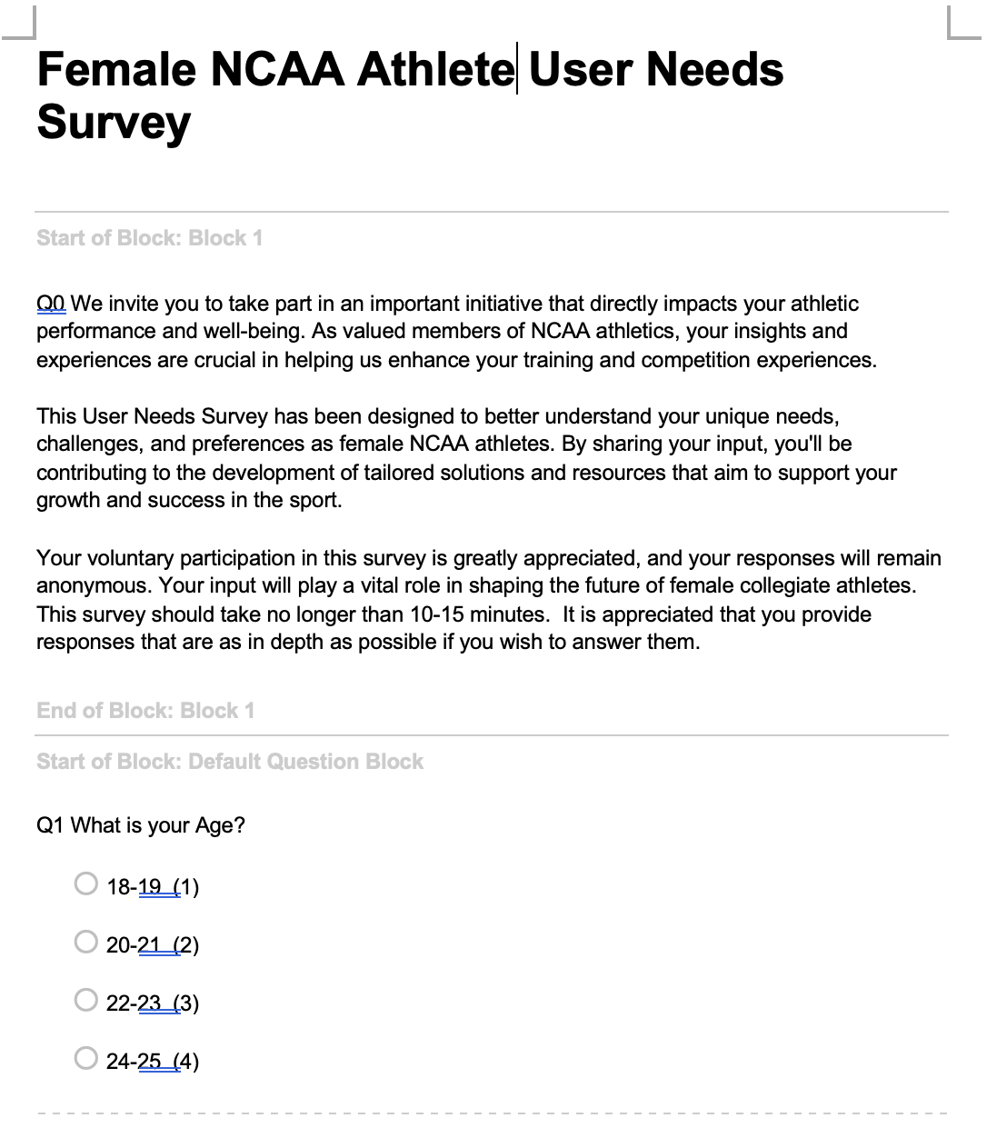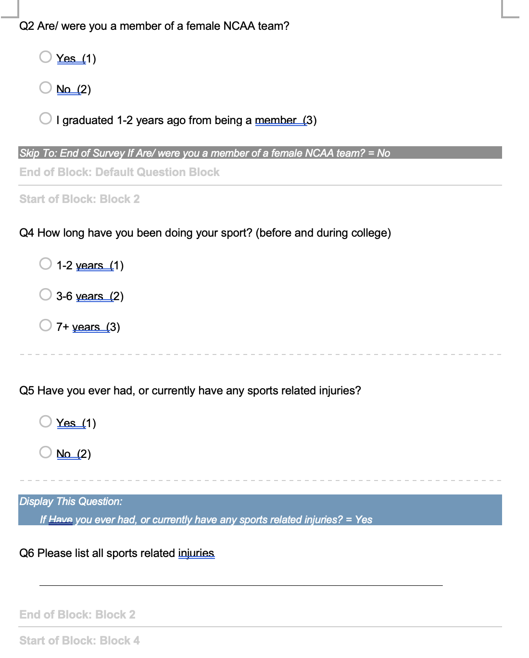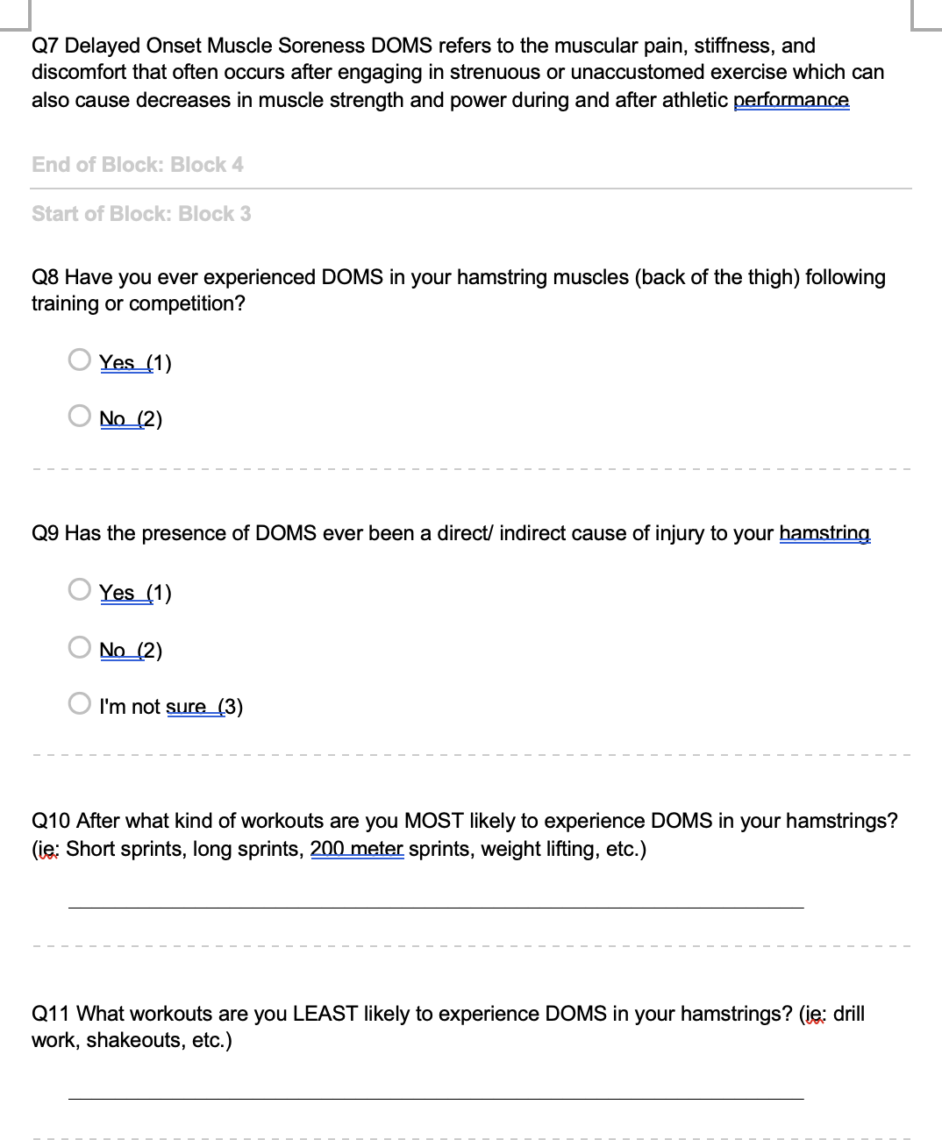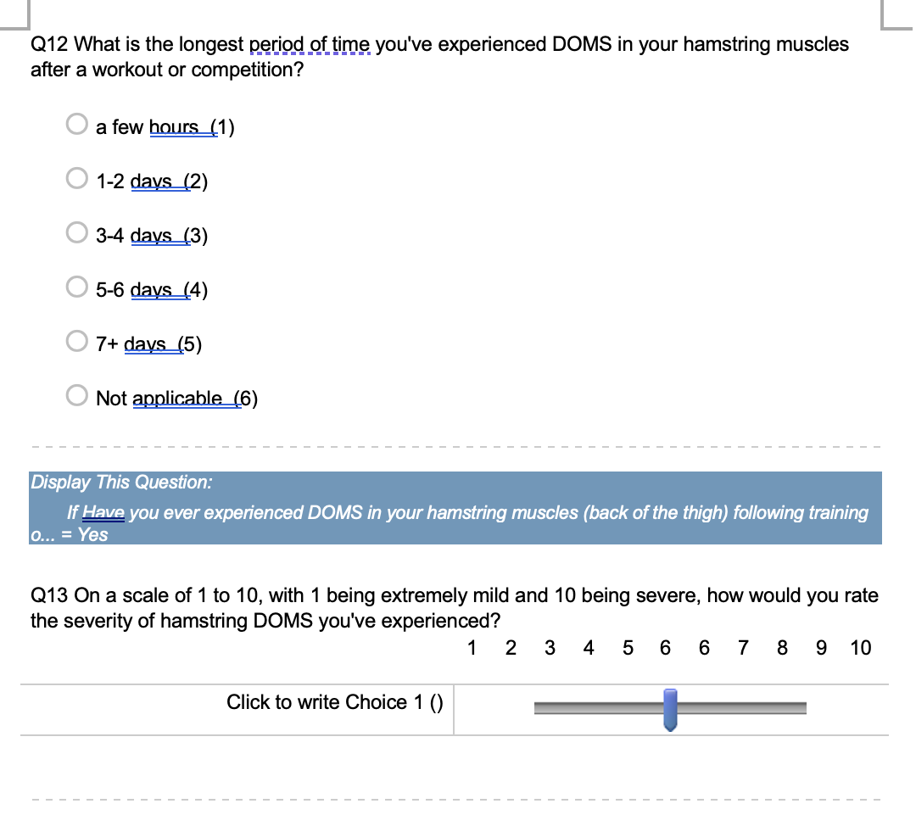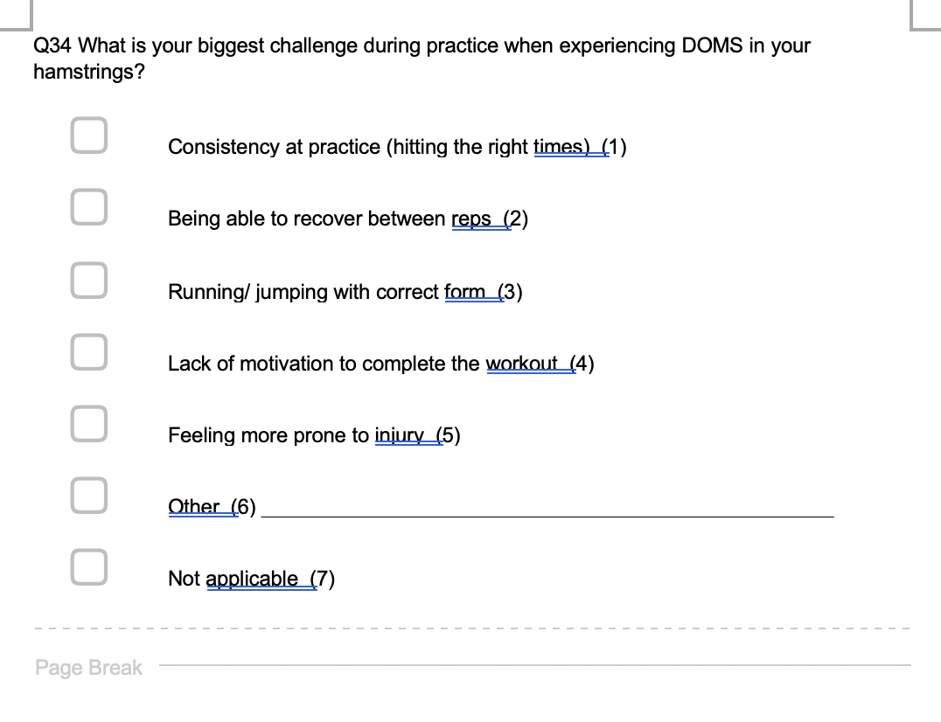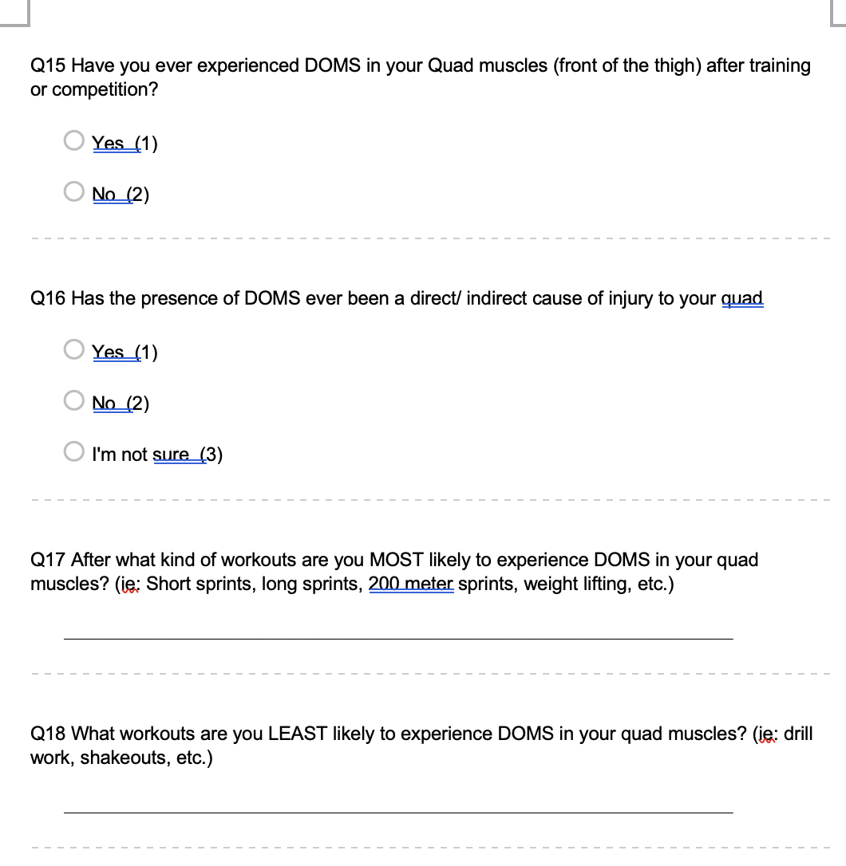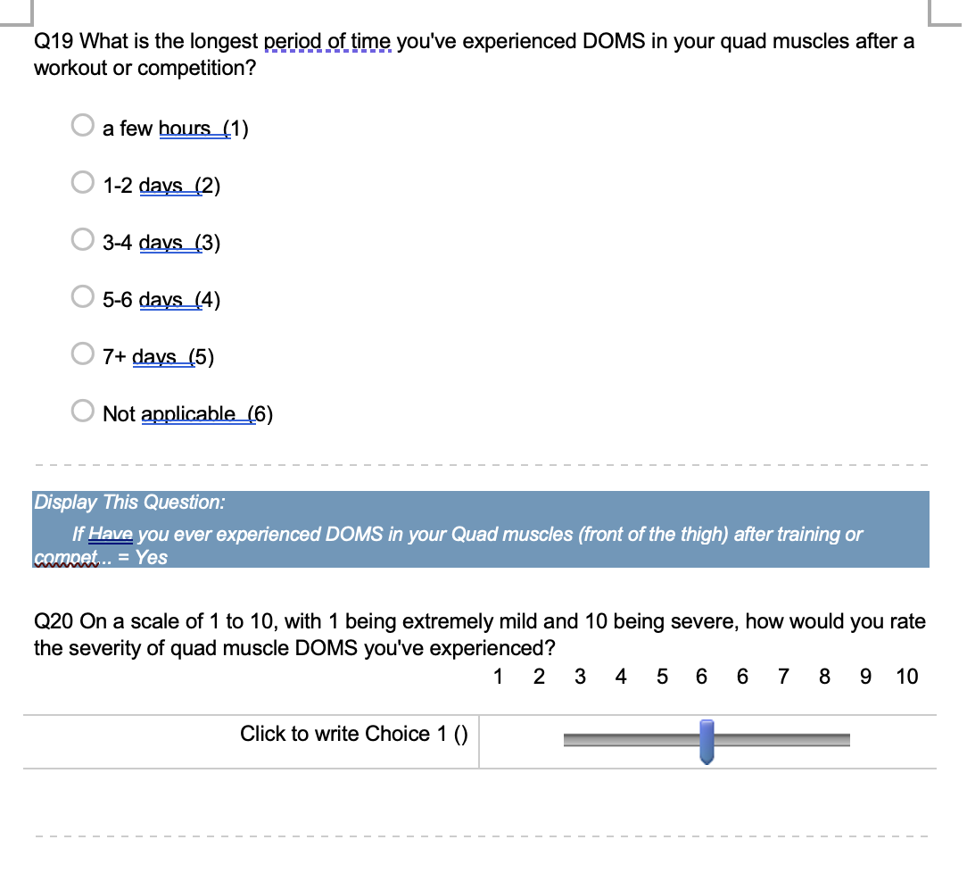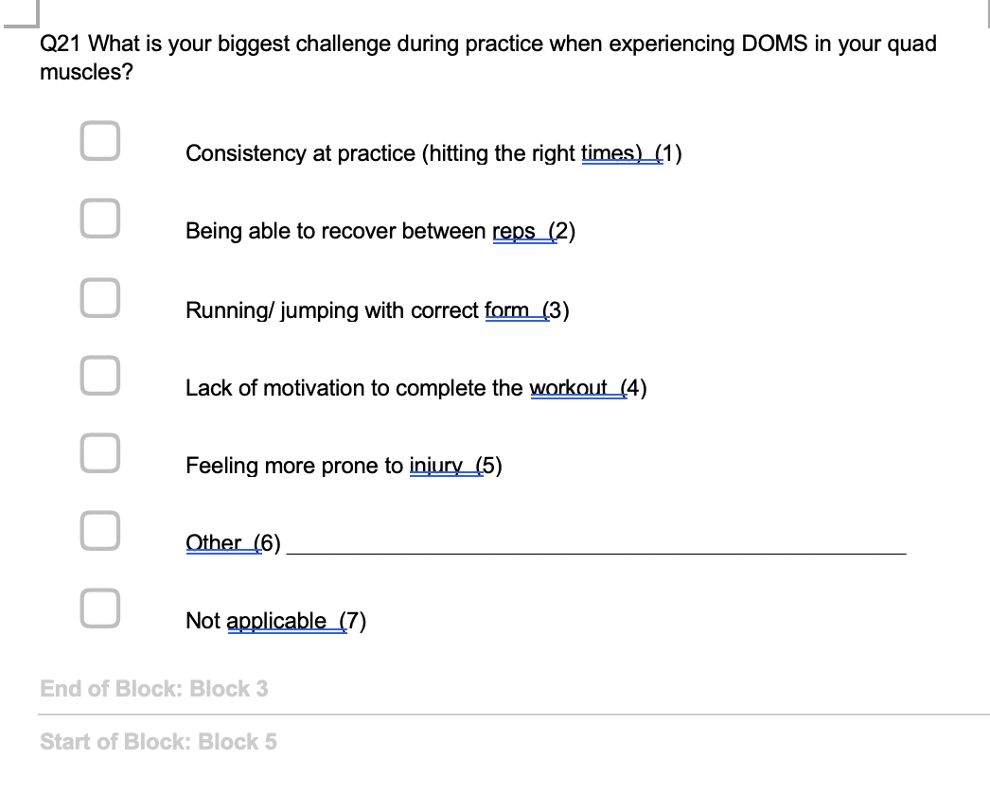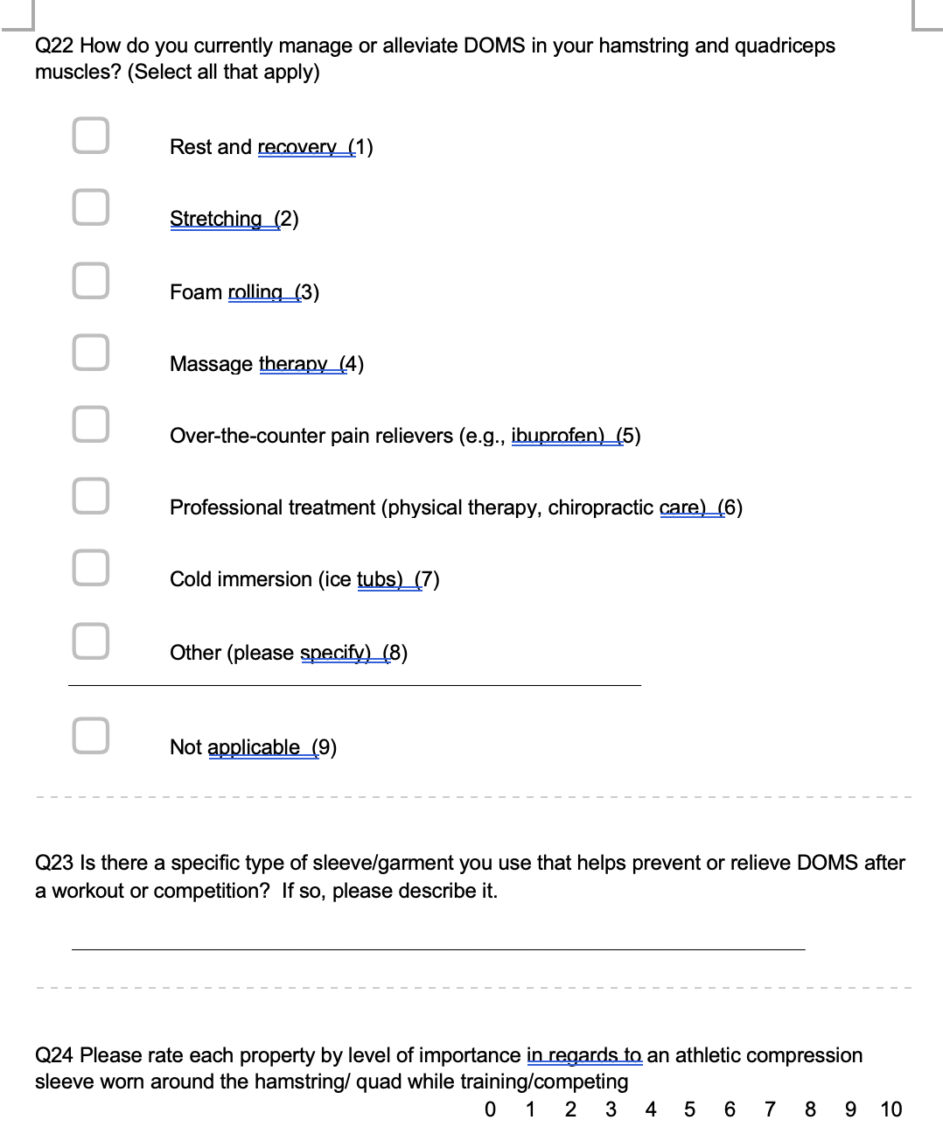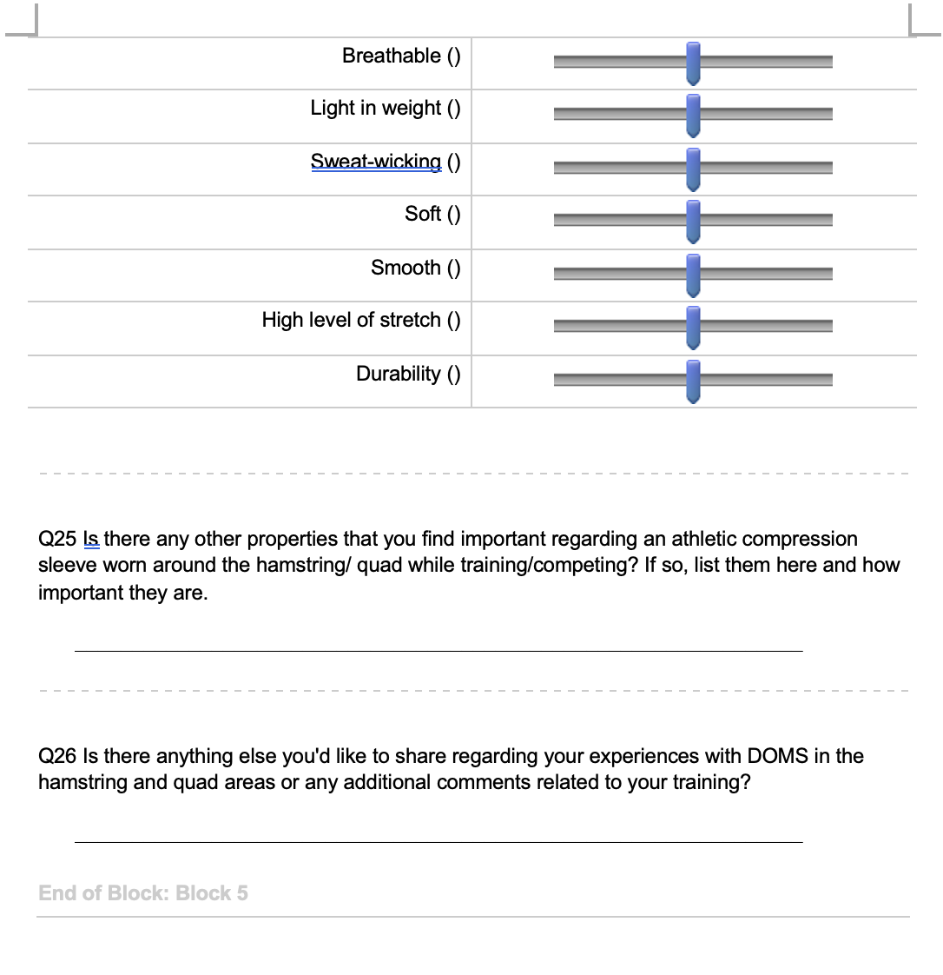
Prototype Sketches and Notes
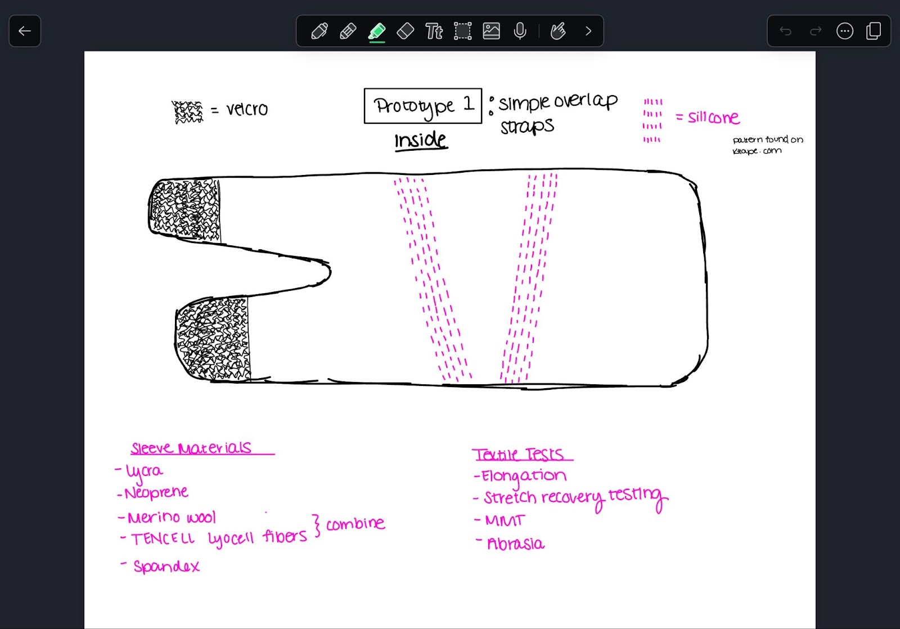
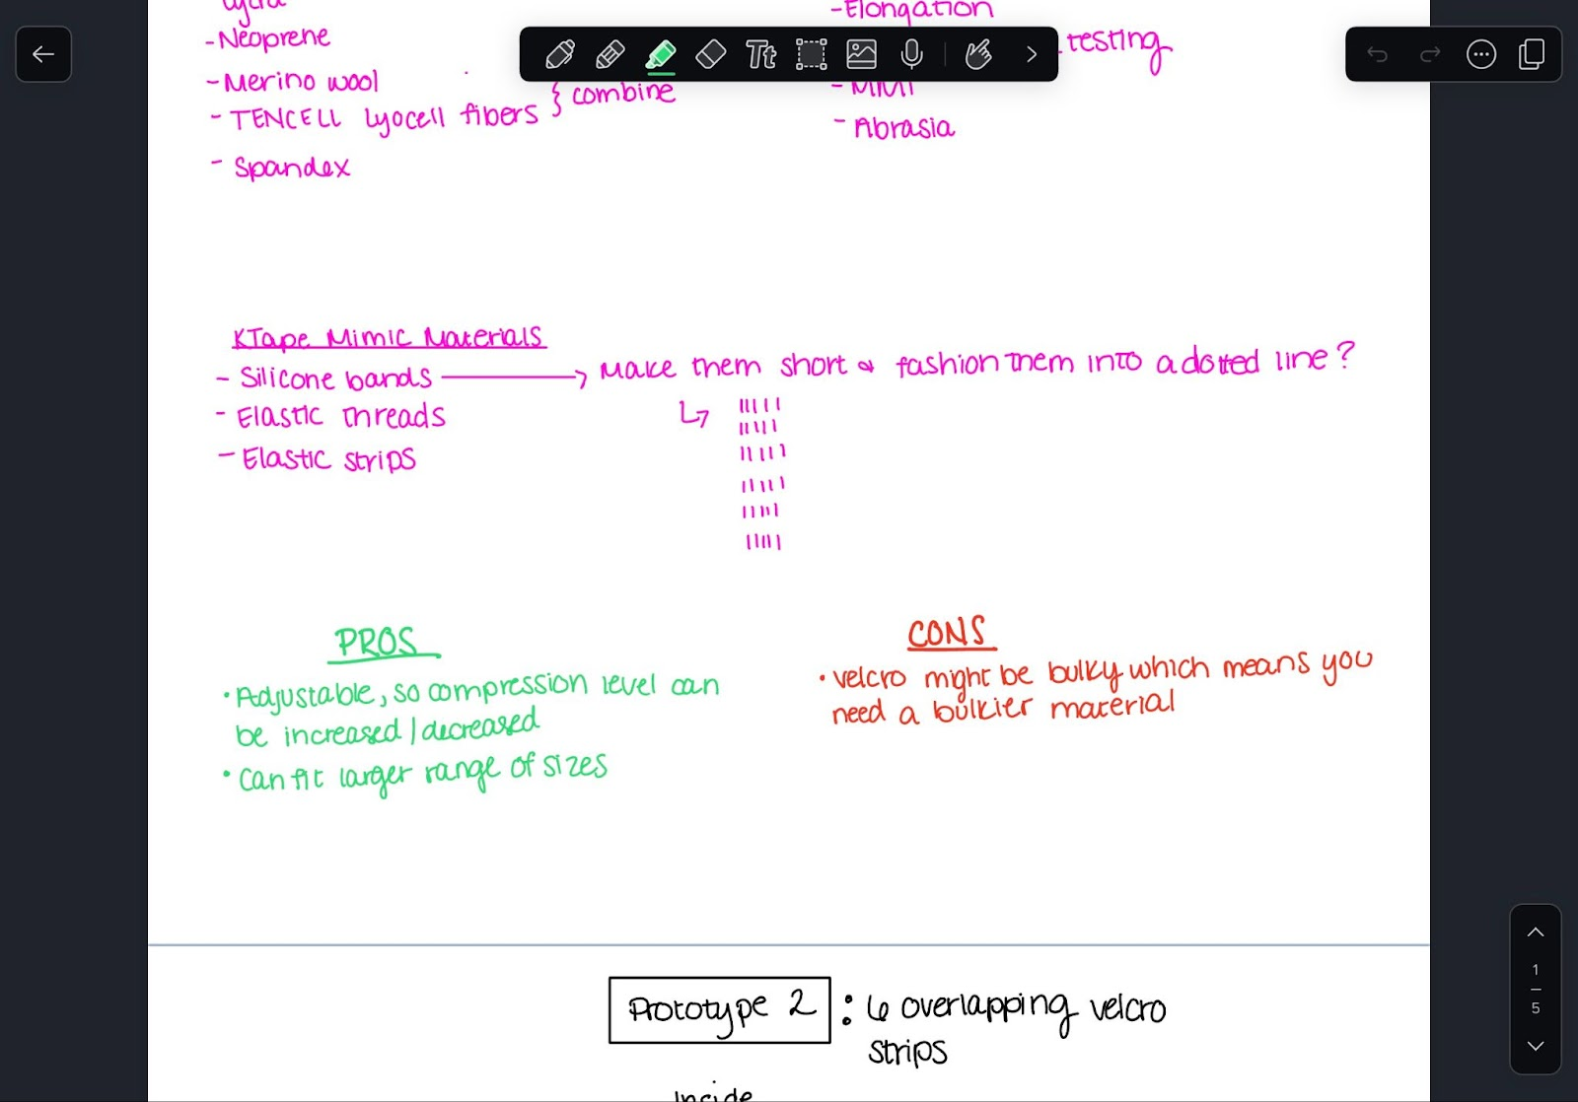
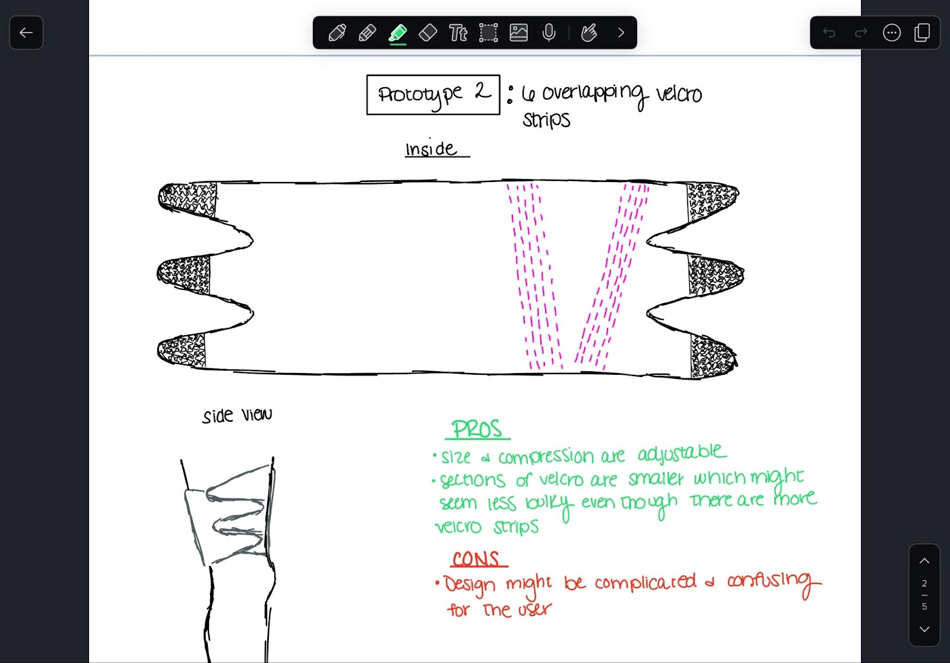
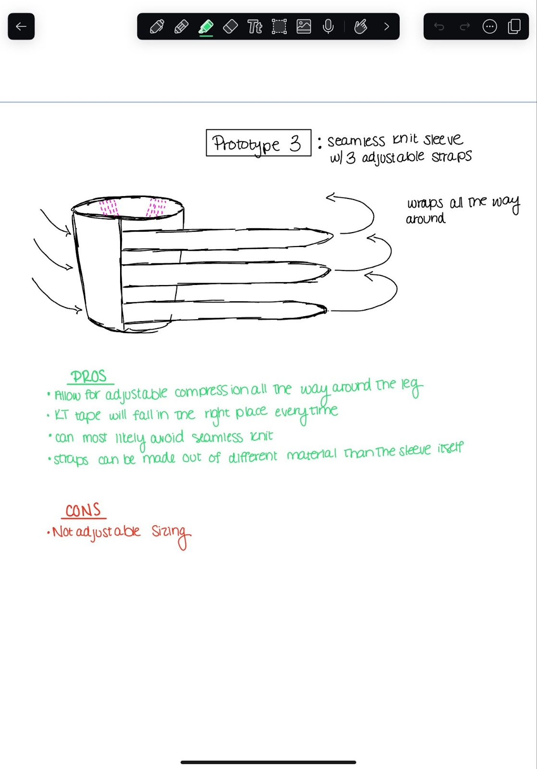
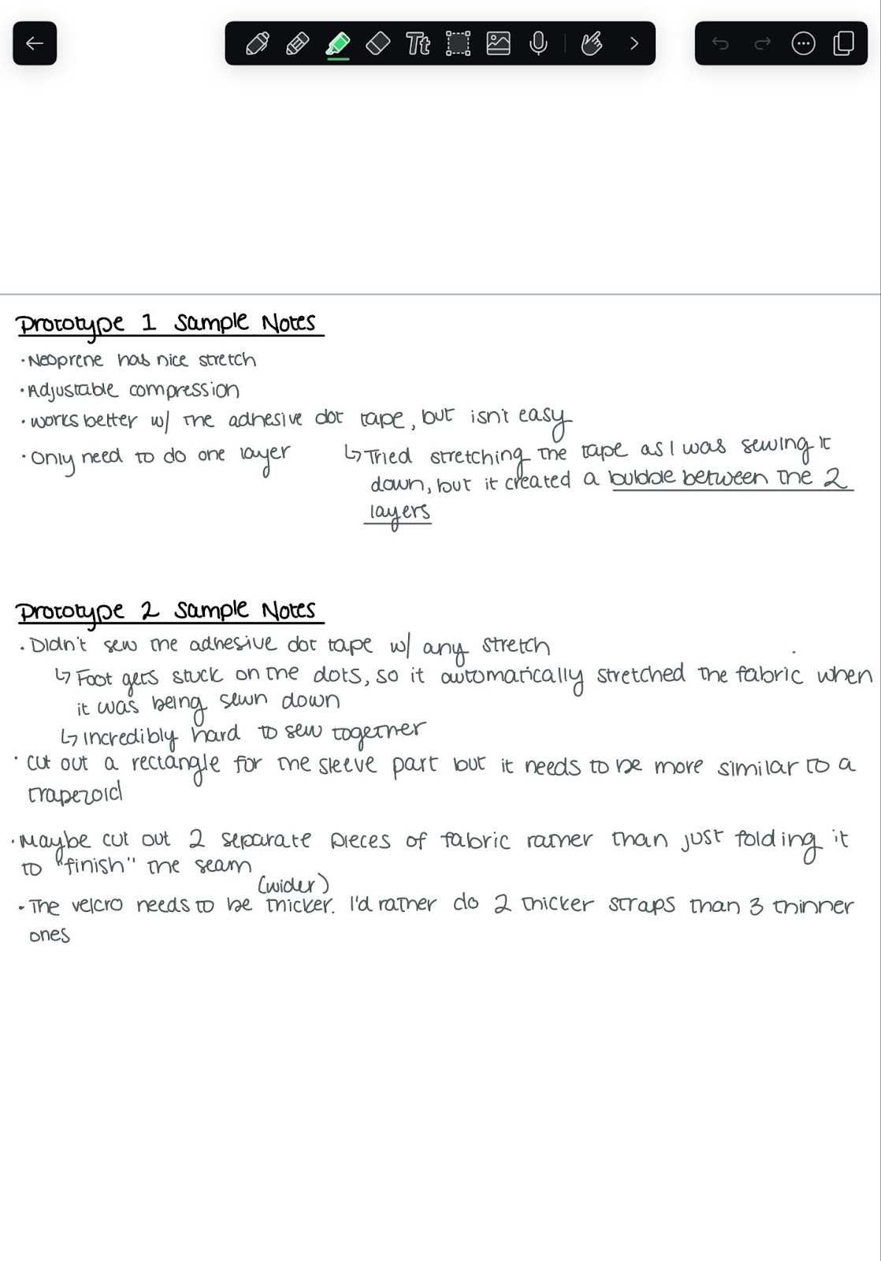
Sizing Guide
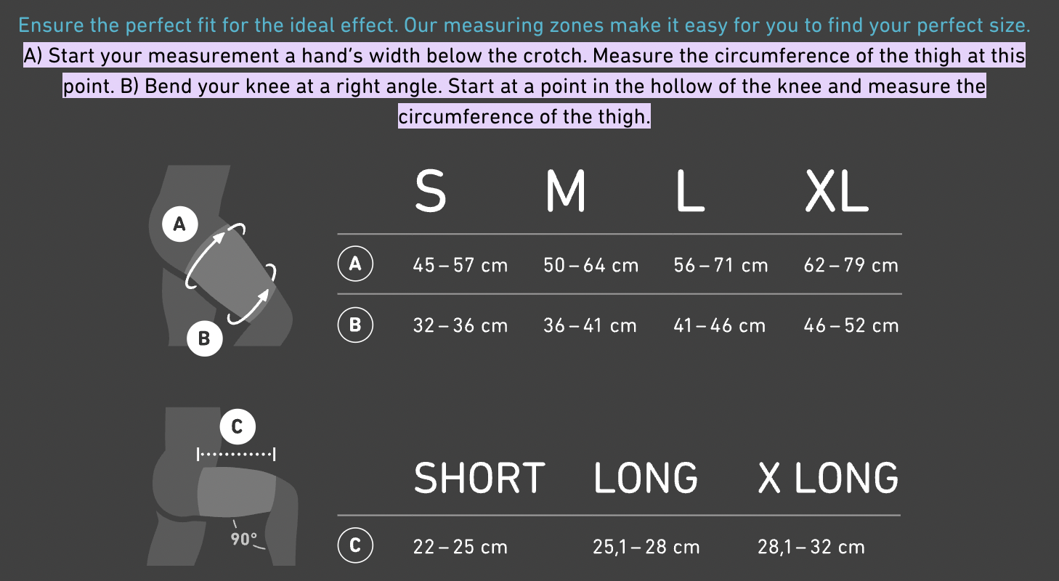
(Bauerfeind, n.d.)
Low odor mineral spirits and silicone caulking gun
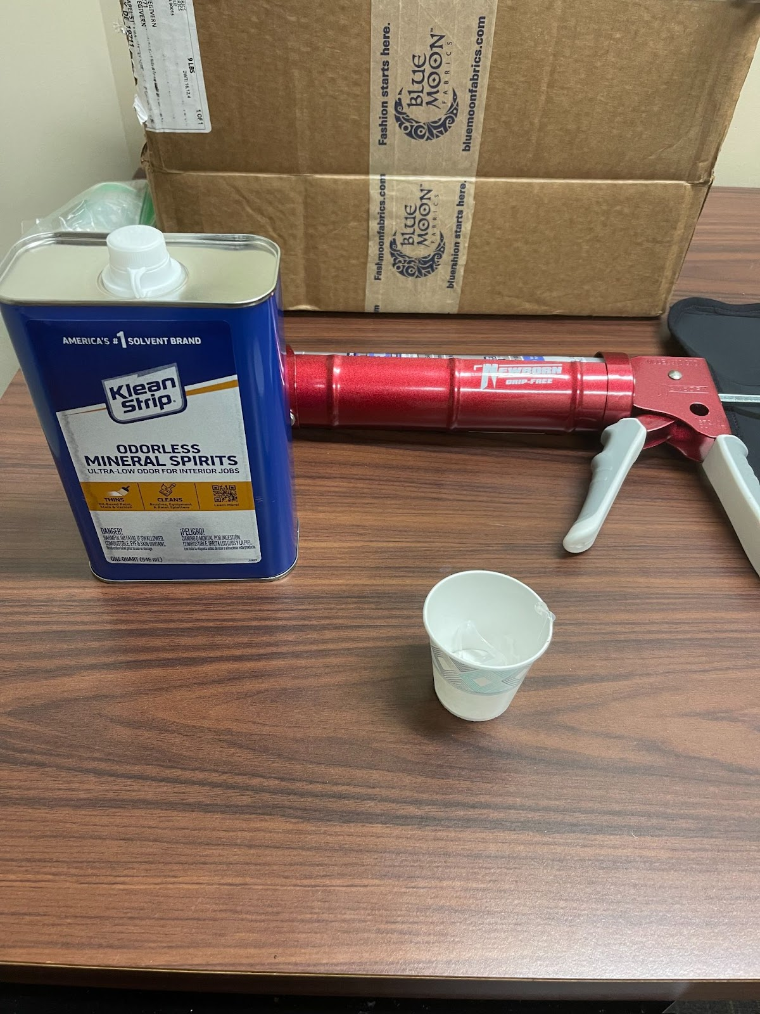
IRB actions for field tests
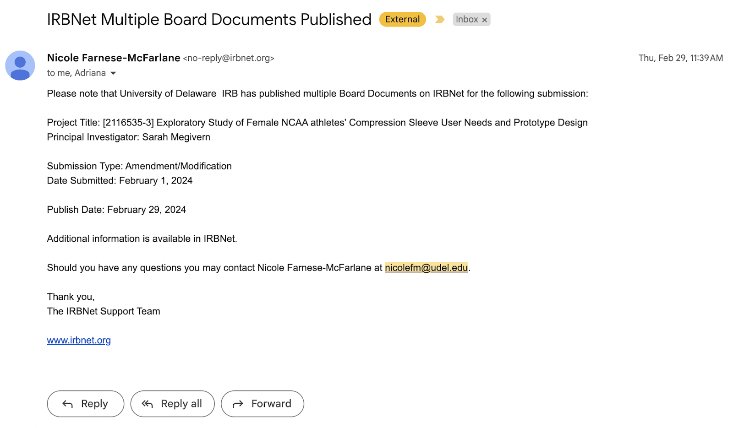
Demographic Survey
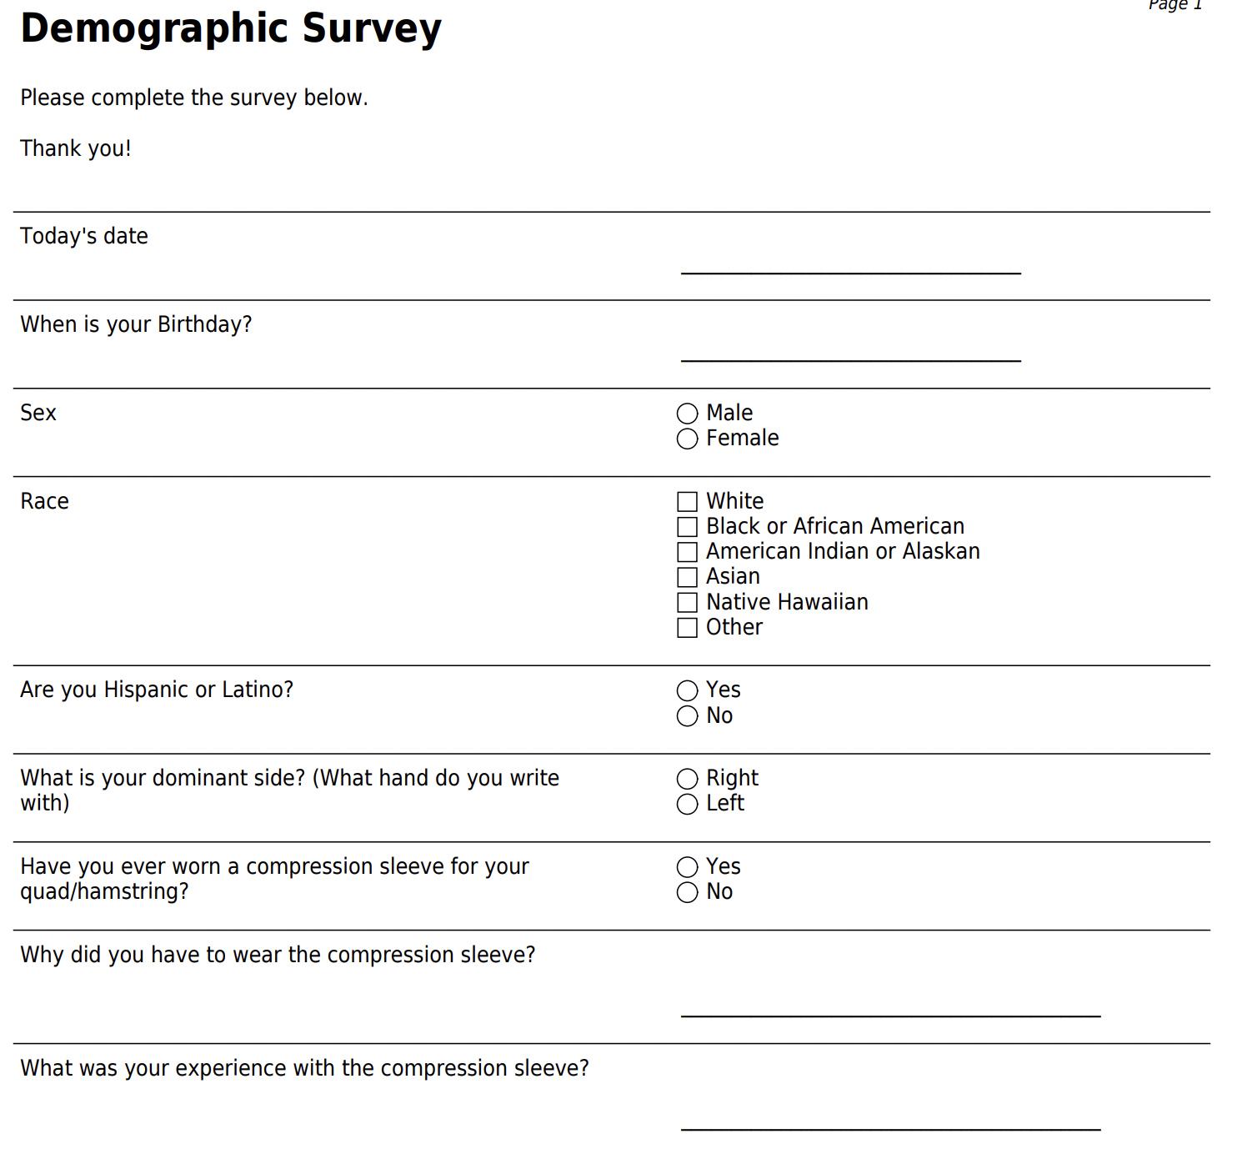
Pre-Screening Survey
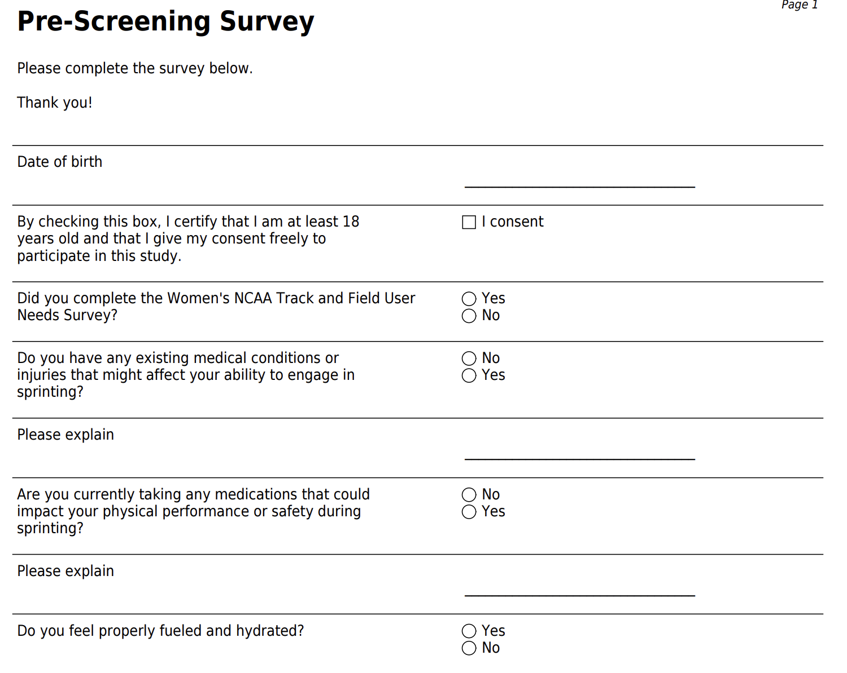
A-skip and B-skip Demonstration
A-skip
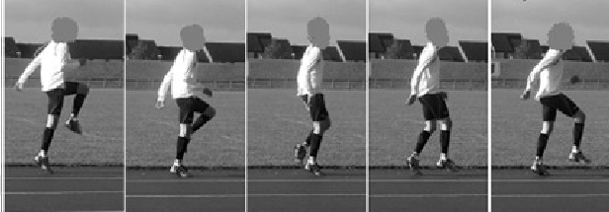
Adapted from Whelan et al. (2016)
- Start by standing tall with your feet hip-width apart and your arms relaxed by your sides.
- Begin to jog slowly in place, lifting your knees high toward your chest with each step.
- As you lift your knee, simultaneously drive the opposite arm upward, keeping your elbows bent at approximately 90 degrees.
- Focus on maintaining an upright posture and a quick, light foot strike.
- Continue to alternate legs, driving the knees and arms upward rhythmically.

B-skip
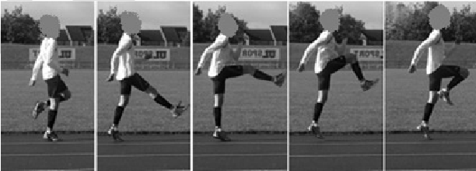
Adapted from Whelan et al. (2016)
- Begin in a similar starting position as A-skips, standing tall with your feet hip-width apart and your arms relaxed by your sides.
- Start jogging slowly in place, lifting one knee toward your chest as you drive the opposite arm upward, similar to A-skips.
- As you extend the raised leg forward, straighten it out in front of you and quickly pull your toes up toward your shin.
- Simultaneously, drive the opposite arm downward, emphasizing the action of "pulling" the arm back.
- Land lightly on the ball of the foot of the support leg, maintaining a slight forward lean with the torso.
- Alternate legs and arms rhythmically, focusing on maintaining proper form and quick turnover.

CS Comfort Survey
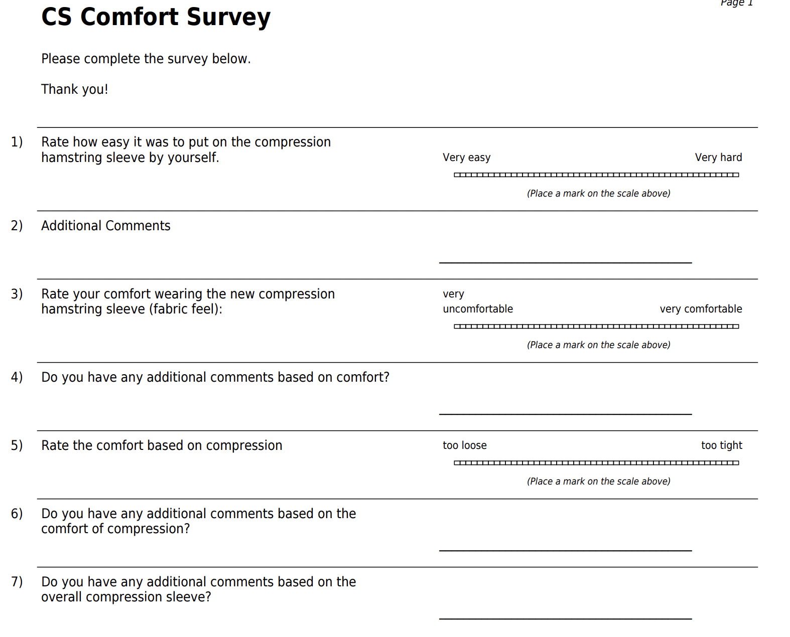
Changes in Health Survey
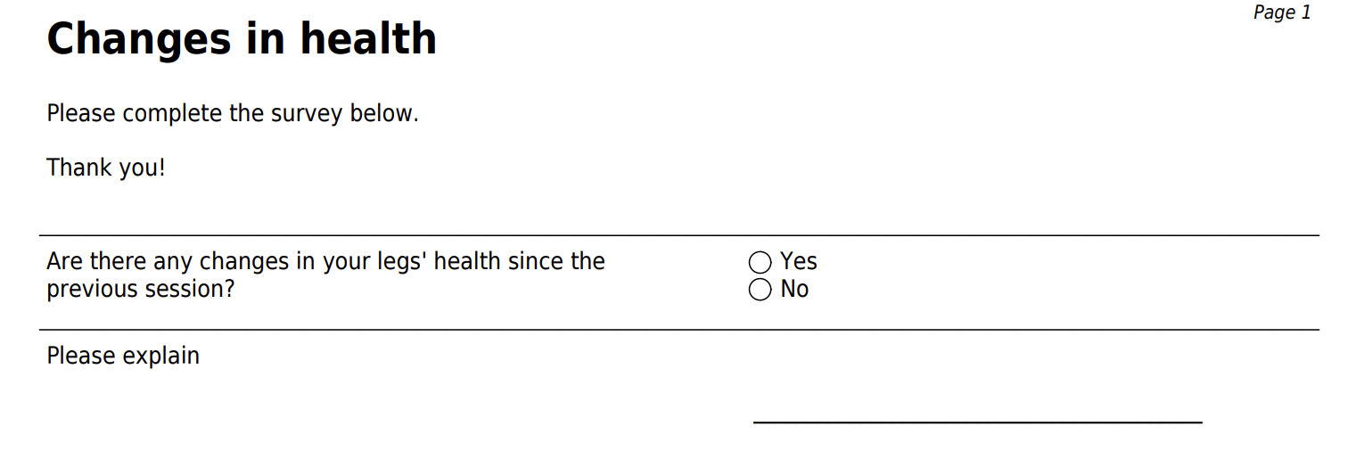
Soreness Survey
